WORKSHEET 3 | Present simple: to be
Name |  | No. | Class

1. Complete the text with am, is or are.

Hello! My name (1) ________________ Brenda.
I (2) _____________12 years old. I (3) ___________
from the UK. I (4) __________________ British.
I (5) ___________ a student and I (6) ____________
in year 6. My parents (7) ______________ Amy and
Jack and my sister (8) ________________ Margaret.
She (9) ____________ nine and she (10) __________
in year 4. We (11) ________________a happy family.

Jack and my sister (8) Margaret.
She (9) nine and she (10)
in year 4. We (11) a happy family.



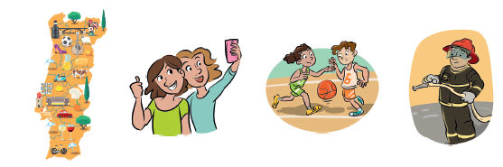
2. Look at the pictures and write the verb to be in the affirmative or negative form.

1. I_________ from Portugal. I_________ from Spain.
2. We _________ good friends. We_________ rivals.
3. The children _________ in the gym. They_________ in the classroom.
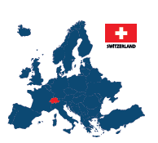
4. My father _________a firefighter. He_________ a police officer.
3. Ask and answer. Follow the example.
1. Are_____ you American? Yes, I am_____.
2. ________he Australian? No, _________.
3. ________they Greek? Yes, ________.
4. ________ she Spanish? Yes, ________.
5. ________ Switzerland a big country? No, _________.

ANSWERS

1. Complete the text with am, is or are.

Hello! My name (1) is Brenda.
I (2) am 12 years old. I (3) am from the UK.
I (4) am British. I (5) am a student and I (6) am in year 6.
My parents (7) are Amy and Jack and my sister
(8) is Margaret. She (9) is nine and she (10) is in year 4.
We (11) are a happy family.

Jack and my sister (8) Margaret.
She (9) nine and she (10)
in year 4. We (11) a happy family.

2. Look at the pictures and write the verb to be in the affirmative or negative form.

1. I am from Portugal. I am (’m) not from Spain.
2. We are good friends. We are not (aren’t) rivals.
3. The children are in the gym. They are not (aren’t) in the classroom.
4. My father is a firefighter. He is not (isn’t) a police officer.
3. Ask and answer. Follow the example.
1. Are you American? Yes, I am.
2. Is he Australian? No, he isn’t.
3. Are they Greek? Yes, they are.
4. Is she Spanish? Yes, she is.
5. Is Switzerland a big country? No, it isn’t.

