WORKSHEET 31 | Reading and writing – Holiday plans
Name |  | No. | Class

- Match the texts and the pictures.
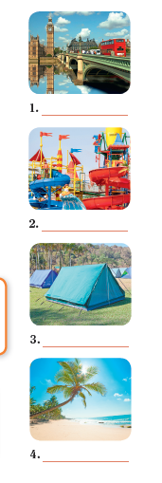




Hello! My name is Julie. This summer I’m going to spend my holidays at the beach.
Hi! I’m Jack. In my holidays,
I’m going to visit the beautiful
city of London.
Hello! I’m Maria. This holiday, I’m going to have a lot because
I am going to a theme park.
My name is Kevin. My family
and I love nature, so we are
going camping this summer.

2. Write about your holiday plans. Follow the examples above.

Stick your
photo here

Answers

- Match the texts and the pictures.
Hello! My name is Julie. This summer I’m going to spend my holidays at the beach.
Hi! I’m Jack. In my holidays,
I’m going to visit the beautiful
city of London.
Hello! I’m Maria. This holiday, I’m going to have a lot because
I am going to a theme park.
My name is Kevin. My family
and I love nature, so we are
going camping this summer.

- Jack

- Maria

- Kevin

- Julie

2. Write about your holiday plans. Follow the examples above.

Personal answers

Stick your
photo here

