WORKSHEET 32 | Means of transport / At the train station
Name |  | No. | Class

1. Identify the means of transport.
car bicycle taxi ambulance plane air balloon

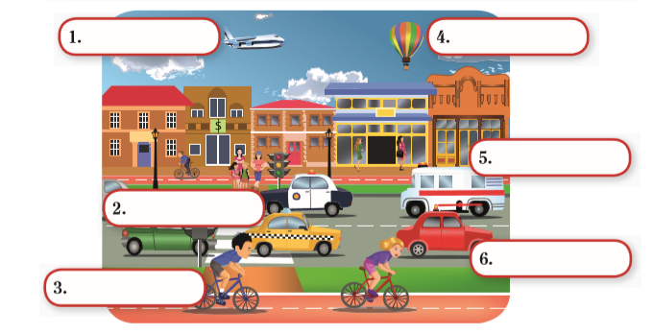
2. Complete the dialogue with the words in the box.
single time much please help thank platform

At the train station
Clerk: Can I (1) ____________ you?
Jack: I’d like a train ticket to London, (2) _______________.
Clerk: Do you want (3) _____________ or return?
Jack: Return, please. What (4) ________________is the train?
Clerk: There’s one every 20 minutes.
Jack: What platform is it?
Clerk: (5) _________________ 3.
Jack: How (6) ________________ is it?
Clerk: That’s £22.
Jack: Here you are. (7) _____________ you.

Clerk: That’s £22. Jack: Here you are. (7) you.

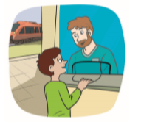

Answers

1. Identify the means of transport.
car bicycle taxi ambulance plane air balloon

car
taxi
bicycle
air balloon
ambulance
plane

2.Complete the dialogue with the words in the box.

single time much please help thank platform

At the train station
Clerk: Can I (1) help you?
Jack: I’d like a train ticket to London, (2) please.
Clerk: Do you want (3) single or return?
Jack: Return, please. What (4) time is the train?
Clerk: There’s one every 20 minutes.
Jack: What platform is it?
Clerk: (5) Platform 3.
Jack: How (6) much is it?
Clerk: That’s £22.
Jack: Here you are. (7) Thank you.

Clerk: That’s £22. Jack: Here you are. (7) you.

