WORKSHEET 33 | Prepositions of movement
Name |  | No. | Class

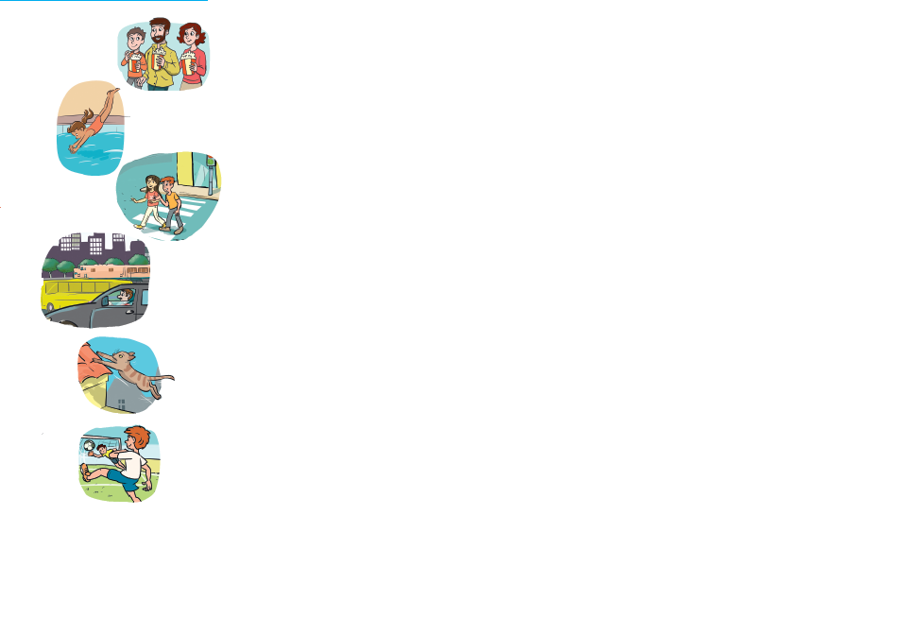
- Circle the right answer.

1. The family is going_________ the cinema.
a. to
b. through

2. She is diving_________ the pool.
a. towards
b. into

3. The children are walking_________ the street.
a. across
b. through

4. He drove_________ the city.
a. through
b. to

5. The cat jumped_________ the roof.
a. onto
b. into

6. He kicked the ball_________ the goal.
a. onto
b. towards

Answers
1. Circle the right answer.

1. The family is going to the cinema.
a. to
b. through
2. She is diving into the pool.
a. towards
b. into
3. The children are walking across the street.
a. across
b. through
4. He drove through the city.
a. through
b. to
5. The cat jumped onto the roof.
a. onto
b. into
6. He kicked the ball towards the goal.
a. onto
b. towards

