WORKSHEET 35 | Comparatives
Name |  | No. | Class

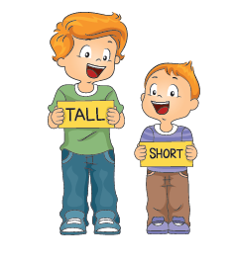
- What’s the comparative form?

1. tall –_____________________________
2. short –____________________________
3. big –___________________________
4. pretty – ___________________________
5. good –___________________________
6. bad –___________________________
7. expensive –___________________________
8. modern –___________________________

- Complete the sentences with the comparative form of the adjectives.

1. Summer is_______________________________ than winter. (hot)
2. The plane is________________________ than the helicopter. (comfortable)
3. Camping holidays are________________________ than city holidays. (relaxing)
4. New York is_________________ than Lisbon. (busy)
5. The bus is_______________ than the plane. (cheap)
6. Michael is__________________ than his friends. (fast)
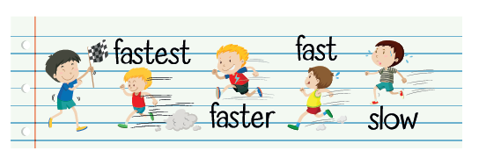

Answers
- What’s the comparative form?

1. tall – taller
2. short – shorter
3. big – bigger
4. pretty – prettier
5. good – better
6. bad – worse
7. expensive – more expensive
8. modern – more modern

- Complete the sentences with the comparative form of the adjectives.

1. Summer is hotter than winter. (hot)
2. The plane is more comfortable than the helicopter. (comfortable)
3. Camping holidays are more relaxing than city holidays. (relaxing)
4. New York is busier than Lisbon. (busy)
5. The bus is cheaper than the plane. (cheap)
6. Michael is faster than his friends. (fast)

