WORKSHEET 36 | Comparatives
Name |  | No. | Class

1. Look at the calendar and answer the questions below.
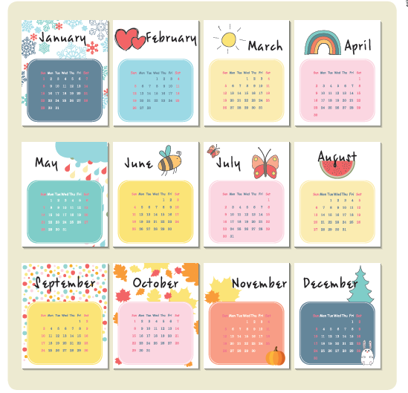

Which month of the year is_________________?
1. the hottest _______________________________________________
2. the coldest _______________________________________________
3. the shortest _______________________________________________
4. the longest _______________________________________________
5. the most flowery _______________________________________________

Answers

1. Look at the calendar and answer the questions below.

Which month of the year is________________?
1. the hottest (Suggestion) July and August.
2. the coldest (Suggestion) December and January.
3. the shortest February.
4. the longest January, March, May, July, August, October and December.
5. the most flowery (Suggestion) May.

