WORKSHEET 5 | Present simple: have got
Name |  | No. | Class

1. Match the letters (A-D) with the numbers (1-4) according to the instructions.

• John has got a cat.
• Carol has got a twin sister.
• The boys have got a computer.
• The girls have got new bicycles.

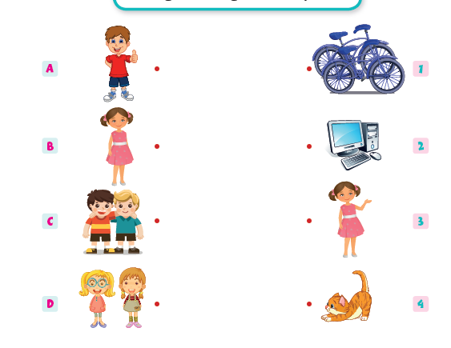

2. Complete the sentences with the verb have got.
1. You_______________________ big, blue eyes.
2. She_______________________ (not) long hair.
3. The Smiths_______________________ (not) any children.
4. Paul___________________ a big family.
5.______________ you__________ any brothers or sisters?
6. ______________Ann_________ any pets?
Answers

1. Match the letters (A-D) with the numbers (1-4) according to the instructions.

• John has got a cat.
• Carol has got a twin sister.
• The boys have got a computer.
• The girls have got new bicycles.

2. Complete the sentences with the verb have got.
1. You have got big, blue eyes.
2. She hasn’t got (not) long hair.
3. The Smiths haven’t got (not) any children.
4. Paul has got a big family.
5. Have you got any brothers or sisters?
6. Has Ann got any pets?

