WORKSHEET 6 | Adjectives
Name |  | No. | Class


1. Match the adjectives with their translation.
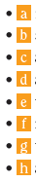
active 1 inteligente
bossy 2 b severo/a
friendly 3 autoritário/a
hard-working 4 ativo/a
intelligent 5 tímido/a
shy 6 meigo/a
strict 7 trabalhador/a
sweet 8 amigável

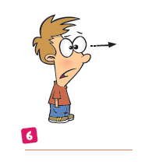
2. How are they feeling?


angry
hungry
surprised
tired
happy
sad


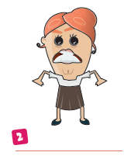

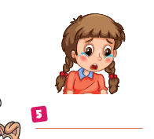



Answers

1. Match the adjectives with their translation.
active 1 inteligente
bossy 2 b severo/a
friendly 3 autoritário/a
hard-working 4 ativo/a
intelligent 5 tímido/a
shy 6 meigo/a
strict 7 trabalhador/a
sweet 8 amigável

2. How are they feeling?

angry
hungry
surprised
tired
happy
sad

6. surprised

- happy

5.
5.
5. sad

- angry 3. tired 4. hungry

