WORKSHEET 8 | Daily routines
Name |  | No. | Class

1. Describe Birdie’s daily morning routine. Follow the example.
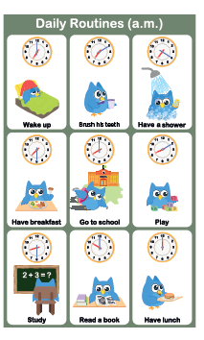
At 7 o’clock, he wakes up.
_____________________________________________
_____________________________________________
_____________________________________________
_____________________________________________
_____________________________________________
____________________________________________
_____________________________________________
_____________________________________________
____________________________________________
_____________________________________________
2. Look at Birdie’s afternoon routine. Answer the questions.
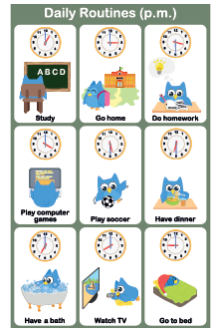
- What time does Birdie go home?
__________________________________________
- Does he do his homework?
__________________________________________
- What does he do before dinner?
__________________________________________
- Does he have a shower after dinner?
__________________________________________
- What time does he go to bed?
__________________________________________

Answers

1. Describe Birdie’s daily morning routine. Follow the example.
At 7 o’clock, he wakes up.

At ten past seven, he brushes his teeth.
At twenty past seven, he has a shower.
At half past seven, he has breakfast.
At eight o’clock, he goes to school.
At ten past eight, he plays.
At half past eight, he studies.
At ten o’clock, he reads a book.
At midday, he has lunch.

2. Look at Birdie’s afternoon routine. Answer the questions.
- What time does Birdie go home?
He goes home at 3 o’clock.
- Does he do his homework?
Yes, he does.
- What does he do before dinner?
Before dinner, he plays soccer.
- Does he have a shower after dinner?
No, he doesn’t. He has a bubble bath.
- What time does he go to bed?
He goes to bed at 9 o’clock.

