WORKSHEET 9 | Present simple
Name |  | No. | Class

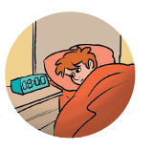
1. Underline the correct form.
1. Phil get / gets up early in the morning.
2. He and his brother go / goes to school on foot.
3. The English teacher explain / explains the present simple.
4. The boys eat / eats in the school canteen.
5. Phil do / does homework in his bedroom.
6. His parents watch / watches TV after dinner.

2. Rewrite the sentences in the negative.
1. I like milk and toast for breakfast.
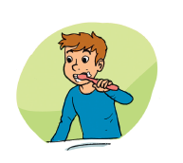
_____________________________________________

2. He brushes his teeth after dinner.
_____________________________________________

3. Their lessons finish at 1 p.m.
_____________________________________________

4. The family has dinner together.

_____________________________________________


3. Complete the questions with do or does.
1. _____________ you go to school by bus?
2. _____________ Cindy like her schoolmates?
3. _____________ the students have English on Mondays?
4. _____________ he play the guitar?
5. _____________ their school have a music room?
6. _____________ they walk their dog in the evenings?

Answers
1. Underline the correct form.
1. Phil get / gets up early in the morning.
2. He and his brother go / goes to school on foot.
3. The English teacher explain / explains the present simple.
4. The boys eat / eats in the school canteen.
5. Phil do / does homework in his bedroom.
6. His parents watch / watches TV after dinner.

2. Rewrite the sentences in the negative.
1. I like milk and toast for breakfast.
I don’t like milk and toast for breakfast.

2. He brushes his teeth after dinner.
He doesn’t brush his teeth after dinner.

3. Their lessons finish at 1 p.m.
Their lessons don’t finish at 1 p.m.

4. The family has dinner together.
The family doesn’t have dinner together.

3. Complete the questions with do or does.
1. Do you go to school by bus?
2. Does Cindy like her schoolmates?
3. Do the students have English on Mondays?
4. Does he play the guitar?
5. Does their school have a music room?
6. Do they walk their dog in the evenings?

