
Look at the English-speaking countries on the map. Then match the countries to the nationalities.
English-speaking countries
(Olha para o mapa dos países de língua inglesa. De seguida, liga os países às nacionalidades.)

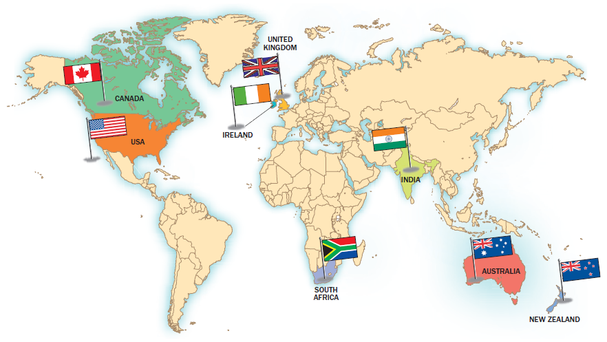

COUNTRY |  | NATIONALITY
1. Canada  2. The USA  3. The UK  4. Ireland  5. South Africa  6. India  7. Australia  8. New Zealand |  | a. South African  b. Australian  c. New Zealander  d. Indian  e. Canadian  f. Irish  g. American  h. British

1. | 2. | 3. | 4. | 5. | 6. | 7. | 8.


A Look at the map of the British Isles and complete the table.
The British Isles
Then colour the flags. (Olha para o mapa das ilhas britânicas e completa a tabela. Depois pinta as
bandeiras.)
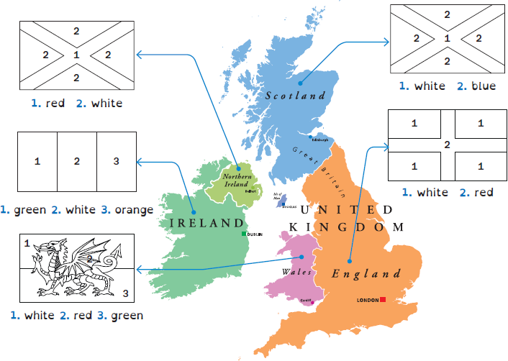
THE BRITISH ISLES
Country | S…………..……………. | E…………..……………. | W…………..……………. | N…………..…………….  I…………..……………. | I…………..…………….
Capital  city | E…………..……………. | L…………..……………. | C…………..……………. | B…………..……………. | D…………..…………….

B What nationality are they? Complete the sentences with the words below.
(Qual é a nacionalidade deles? Completa as frases com as palavras abaixo.)
1. People from England are …………..………………………..…………………..…………….…………..…………….…………..…………….………………..………...
2. People from Scotland are …………..………………………..…………..…………….…………..…………….…………..…………….………………………..…….….
3. People from Wales are …………..………………………..………………..…………….…………..…………….…………..…………….……….…………..…………….
4. People from Ireland are …………..………………………..…………………..…………….…………..…………….…………..……………….…………..……………....
PERSONAL PRONOUNS
 |  | SINGULAR |  |  |  | PLURAL
I  eu | you  tu | he  ele | she  ela | it  ele/ela  (objetos/animais) | we  nós | you  vós | they  eles/elas
POSSESSIVE DETERMINERS
my  meu | your  teu | his  dele | her  dela | its  dele/dela  (objetos/animais) | our  nosso | your  vosso | their  deles/delas

Personal pronouns / Possessive determiners
A Look at the pictures. Circle the correct personal pronoun.
(Observa as imagens. Faz um círculo na palavra correta.)
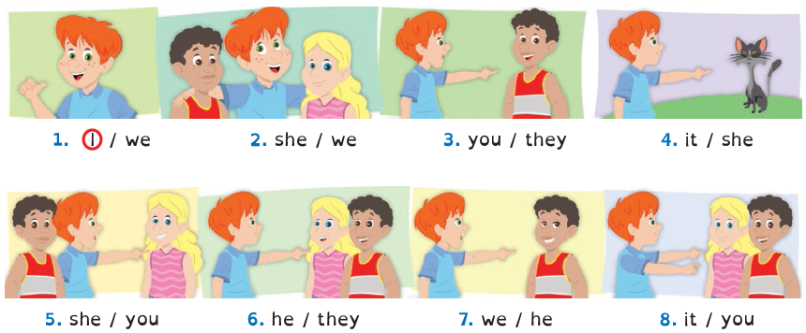

B Circle the correct option. (Faz um círculo na opção correta.)
1. He / We is an excellent student.
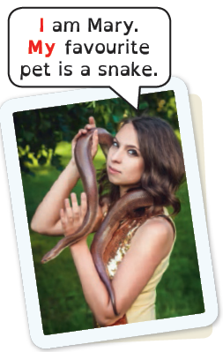
2. It / You are my best friend.
3. They / It are my cousins Betty and Robert.
4. Who is that girl? We / She is an American singer.

C Circle the correct possessive determiner.
(Faz um círculo no determinante possessivo correto.)
1. I am Kate. My / Its favourite colour is blue.
2. We are Mark and Tom. His / Our school is great.
3. It is my pet. Their / Its name is Rex.
4. He has got a tablet. His / Her tablet is black.
5. They are in the park. Your / Their hats are yellow.


A Look at the verb to be and complete the sentences.
Verb to be
(Observa o verbo to be e completa as frases.)
VERB TO BE
1. I am ten.
2. ……… you Welsh?
3. She ……… eleven.
4. ……… he your brother?
5. It ……… (not) my pen.
6. We ……… friends.
7. ……… they German?
8. You ……… (not) in 6B.
 | Affirmative | Negative |  | Interrogative
I | am | am not  ’m not |  | Am | I | …?
You | are | are not  aren’t |  | Are | you | …?
He  She  It | is | is not  isn’t |  | Is | he  she  it | …?
We  You  They | are | are not  aren’t |  | Are | we  you  they | …?

B Circle the correct option.
(Faz um círculo na opção correta.)
1. Susan ............... very intelligent. a. am b. is c. are
2. ............... you from Italy? a. Am b. Is c. Are
3. Sally and Thomas ............... brother and sister. a. am b. is c. are
4. Tim’s surname ............... Brown. a. am b. is c. are
5. ............... I at the hospital? a. Am b. Is c. Are

C Fill in the blanks with ’m not, isn’t and aren’t.
(Preenche os espaços com ’m not, isn’t e aren’t.)
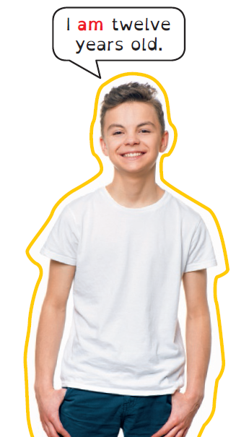
1. Peter isn’t eleven years old. He is twelve.
2. They ……………… in the classroom. They are in the park.
3. My brother ……………… in year 6.
4. I ……………… Italian. I’m Portuguese.
5. We ……………… at the party.
6. She ……………… in the laboratory.
7. She is fifteen. She ……………… fourteen.
8. We ……………… new students.

NUMBERS 1-100
1 one |  | 20 twenty
2 two |  | 21 twenty-one
3 three |  | 30 thirty
4 four |  | 40 forty
5 five |  | 50 fifty
6 six |  | 60 sixty
7 seven |  | 70 seventy
8 eight |  | 80 eighty
9 nine |  | 90 ninety
10 ten |  | 100 one hundred

Numbers 1-100
A Match the numbers to the words. Use different colours.
(Liga os números às palavras. Usa cores diferentes.)
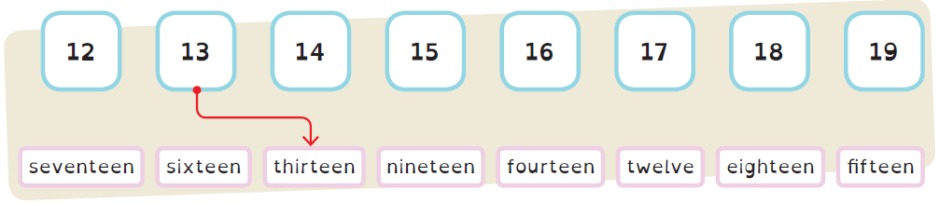
B Circle the correct number.
(Faz um círculo no número correto.)

20 – twenty
53 – forty-three
45 – forty-five
37 – thirteen
98 – eighty-eight
13 – three
twelve
sixty-three
fourteen
thirty-seven
ninety-eight
thirteen
two
fifty-three
fifty-four
seventy-three
ninety
thirty

C Write the numbers.
(Escreve os números.)
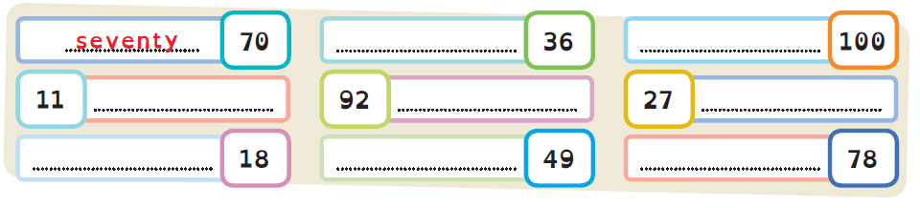

A Read the text and complete the student card.
Personal identification
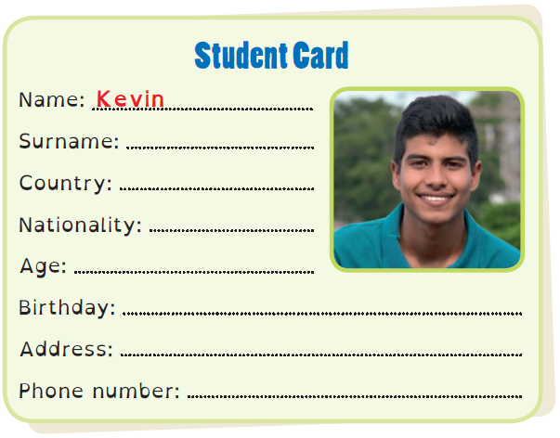
(Lê o texto e completa o cartão de estudante.)
My name is Kevin and
my surname is Clark.
I’m from Canada, so
I’m Canadian. I’m
thirteen years old and
my birthday is on 24th
March. My address is
45, Pine St., Toronto.
My phone number is
416-535-7645.

B Fill in your student card and complete the text about you.
(Preenche o teu cartão de estudante e completa o texto sobre ti.)
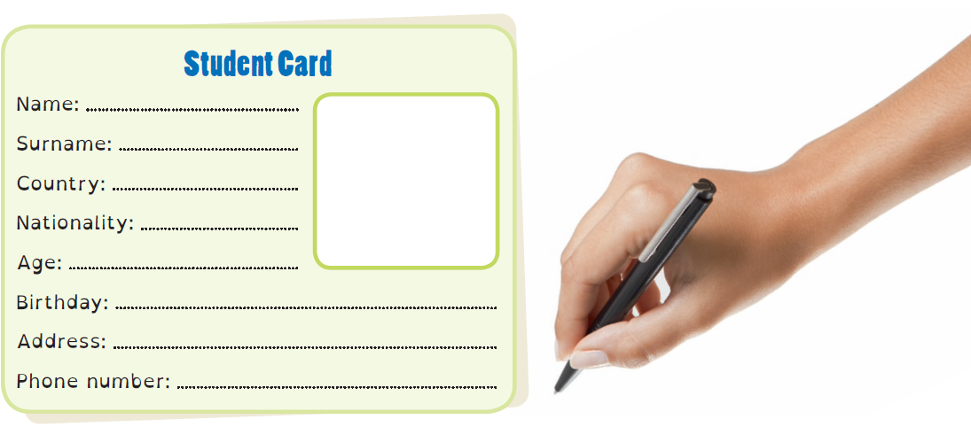
My name is (1) ……………………..…………… and my surname is (2) ………………………………… .
I’m from (3) ……………………………..…….………… , so I’m (4) ………………………….……..…………… .
I’m (5) ……………………………… years old and my birthday is on (6) ……………………………… .
My address is (7) ……………………………………………………………………………….……………………… .
My phone numbers is (8) ……………………………………………………………..…………………………… .

