
Find the words in the word search and complete the parts of the body.
Parts of the body
(Encontra as palavras na sopa de letras e completa as partes do corpo.)
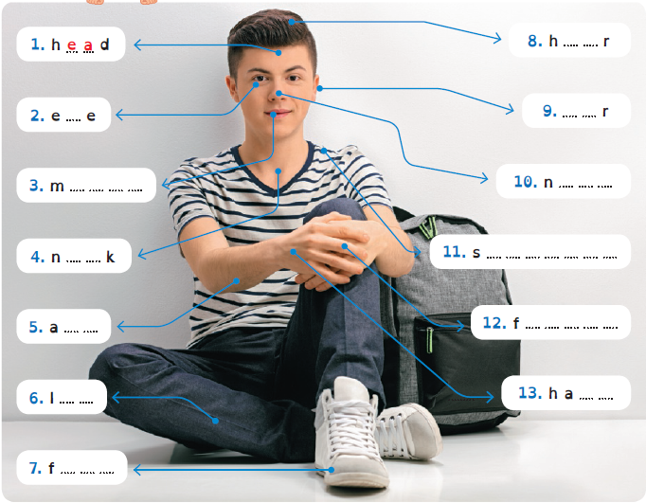
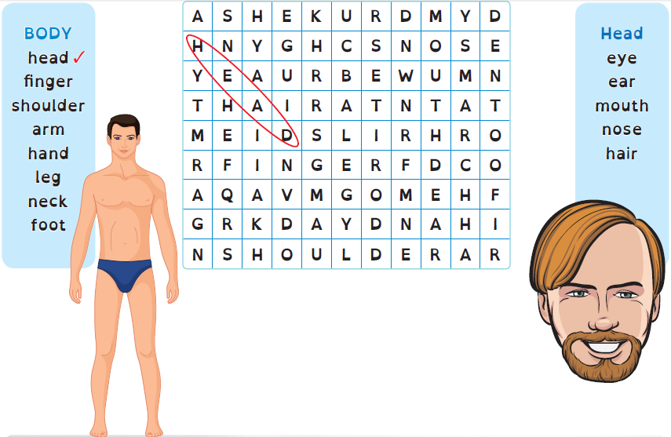


A Look at the table and complete the texts.
Physical appearance: describing people
(Observa a tabela e completa os textos.)

Hair  (cabelo) |  |  | Eyes  (olhos) | Height  (altura)
long  short  shoulder-length | curly  wavy  straight | blond(e)  black  brown | black  brown  blue  green | short  tall  average-height

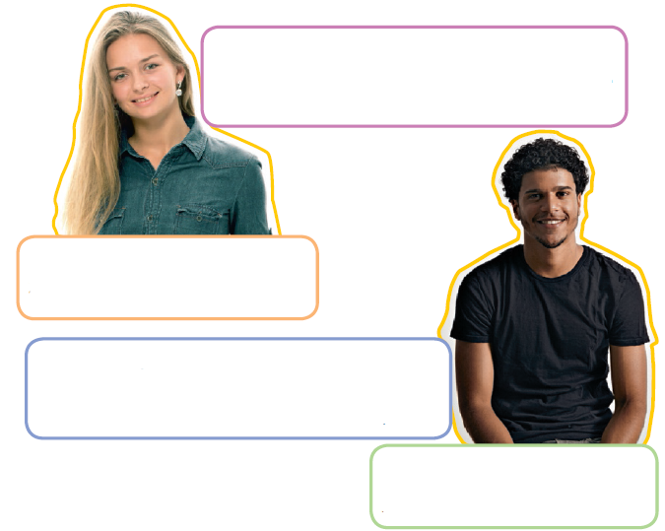
HAIR: short, curly, black
EYES: black
HEIGHT: tall
He has got (4) …………………………………… ….…………..…………………….
….…………..……………………. hair and (5) ….…………..……………………. eyes.
He is (6) ….…………..…………….…………..…………………………..…………..
HAIR: long, straight, blonde
EYES: blue
HEIGHT: medium-height
She has got (1) …………………………………… ….…………..…………………….
….………………………………. hair and (2) ….………………………………. eyes.
She is (3)…………………………………….……………….……………………..

B Fill in the information and write about you.
(Preenche com as informações e escreve sobre ti.)
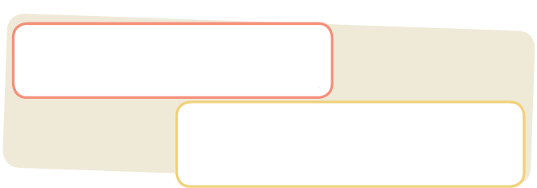
I have got (1) ….…………..…………….……………… …………………..…………………………
……….………………………… hair and (2) ……………………..…..……………………… eyes.
I’m (3) ….…………..…………….……………………………...…….………………..………………………… .
HAIR: ….…………..…………….…………..………………………………………………...…………..
EYES: ….…………..…………….………………………………..…………………………..…………..
HEIGHT: ….…………..…………….…………..…………………………………………..…………..


Have got
A Look at the verb have got.
(Observa o verbo have got.)

HAVE GOT ter

 | Affirmative | Negative |  | Interrogative
I  You | have got | haven’t got |  | Have | I  you | got…?
He  She  It | has got | hasn’t got |  | Has | he  she  it | got…?
We  You  They | have got | haven’t got |  | Have | we  you  they | got…?

B Complete the sentences with have got and has got.
(Completa as frases com have got e has got.)
1. Sophie …………..……………. a new English dictionary.
2. My parents …………..……………. a new house.
3. …………..……………. your father …………..……………. a new computer?
4. I …………..……………. a new pink T-shirt.
5. …………..……………. they …………..……………. a science test today?
6. We …………..……………. new skateboards.

C Write the sentences in the negative and interrogative.
(Escreve as frases na negativa e interrogativa.)
1. You have got a brother. 3. I have got a new hobby.
You haven’t got a brother. …………..…………………..…………….…………..………………….
Have you got a brother? …………..…………………..…………….…………..………………….

2. Max has got a new job. 4. Louis and Tom have got iPhones.
…………..…………………..…………….…………..…………………. …………..…………………..…………….…………..………………….
…………..…………………..…………….…………..…………………. …………..…………………..…………….…………..………………….


Describing personality
A Read the words and their meanings. Look at the pictures
and write the correct adjective.
(Lê as palavras e os seus significados. Observa as imagens e escreve o adjetivo correto.)
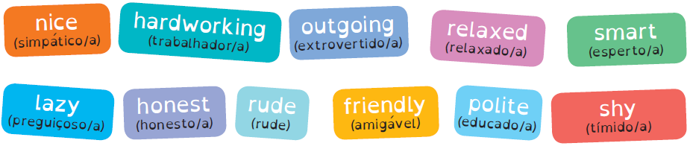
 |  | 
1. ………….…………..…..…………..…...….. | 2. …………………..…..…………..…..…..….. | 3. ………………..…..…………..…..……..…..
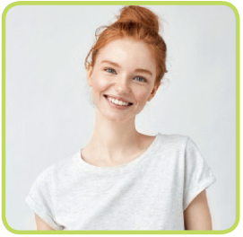 |  | 
4. ………….…………..…..…………..…...….. | 5. …………………..…..…………..…..…..….. | 6. ………………..…..…………..…..……..…..

B Match the adjectives to their Portuguese meaning.
(Liga os adjetivos ao significado em português.)

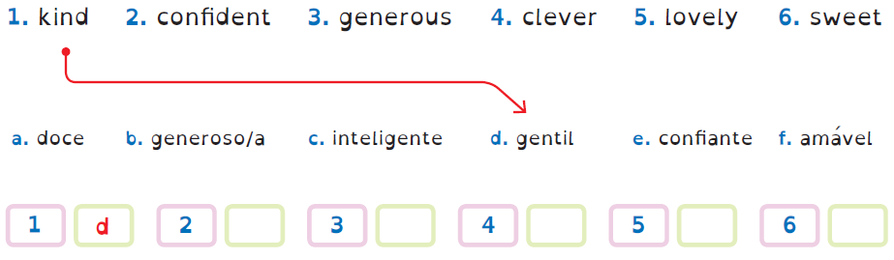


Reflexive pronouns
A Look at the table and the example.
(Observa a tabela e o exemplo.)
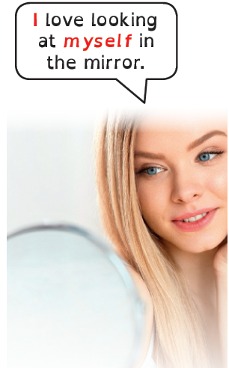
 | Subject pronouns | Reflexive pronouns
Singular | I  (eu) | myself  (eu próprio/a)
Singular | you  (tu) | yourself  (tu próprio/a)
Singular | he  (ele) | himself  (ele próprio)
Singular | she  (ela) | herself  (ela própria)
Singular | it  (ele/ela) | itself  (ele/a próprio/a)
Plural | we  (nós) | ourselves  (nós próprios/as)
Plural | you  (vós) | yourselves  (vós próprios/as)
Plural | they  (eles/elas) | themselves  (eles/as próprios/as)

B Look at the pictures and circle the correct reflexive pronoun.
(Observa as imagens e faz um círculo no pronome reflexo correto.)

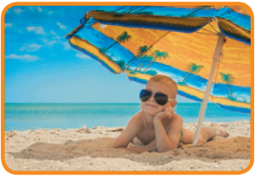 | 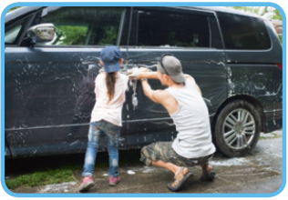
1. He is protecting yourself / himself  from the sun. | 2. They are washing the car themselves  / ourselves.
 | 
3. My father and I are preparing dinner  ourselves / yourselves. | 4. My mother usually does the shopping  itself / herself.

A Complete the definition of selfie with the words below.
Selfies
(Completa a definição de selfie com as palavras abaixo.)
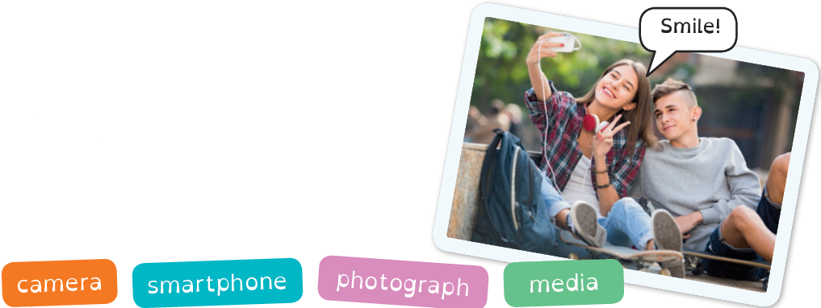
Selfie
A (1) …………………..…..…………..…..…..….. that a person takes
of oneself with a (2) …………………..…..…………..…..…..….. or a
digital (3) …………………..…..…………..…..…..….. and shares on
social (4) …………………..…..…………..…..…..….. .
(https://en.oxforddictionaries.com/definition/selfie)

B Look at the picture and complete the text with the words below.
(Observa a imagem e completa o texto com as palavras abaixo.)
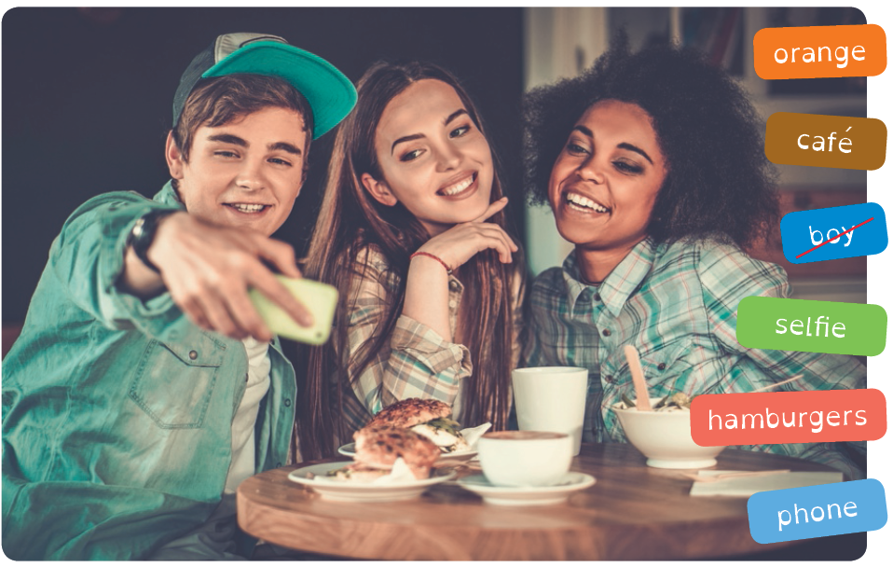
There are two girls and a (1) boy in a (2) …………………..…..…………..…..…..….. . They
are taking a (3) …………………..…..…………..…..…..….. using the boy’s (4) …………………..…..…………..…..…..….. .
They are eating (5) …………………..…..…………..…..…..….. and a salad, and drinking
(6) …………………..…..…………..…..…..….. juice. They are enjoying themselves.

Giving advice: should
Usamos o verbo should para dar conselhos.
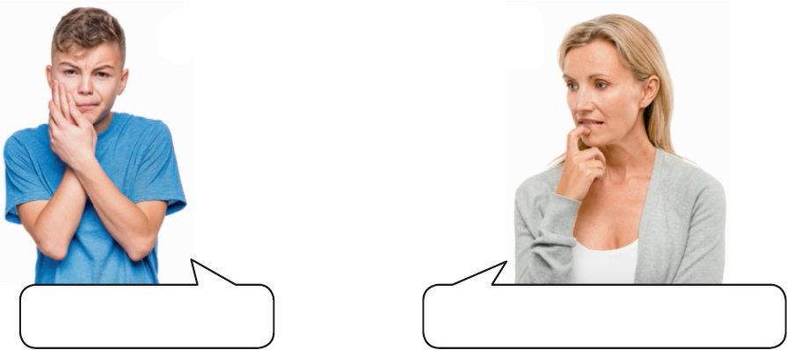

should + verbo no infinitivo

You should go to the dentist.
I have a toothache!

Look at what these people are saying. Match the advice to the picture.
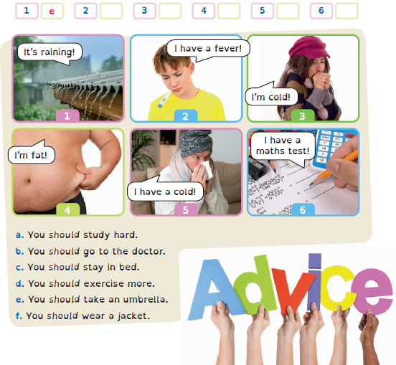
(Observa o que estas pessoas estão a dizer. Liga os conselhos às imagens.)

