What time is it?
Daily routine / Time
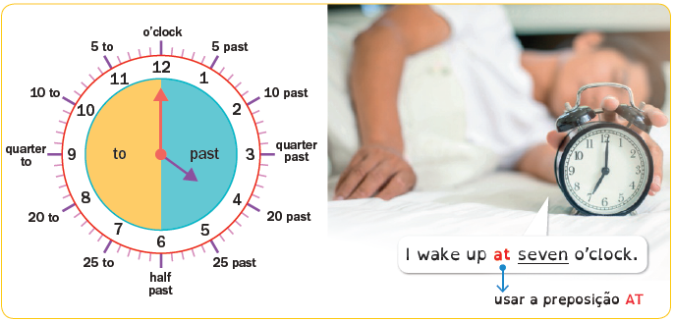
Look at the pictures and match them to the sentences.
Then write the time.
(Observa as imagens e liga-as às frases. Depois escreve as horas.)
1. I have a shower at half past seven.
2. I have breakfast at a quarter past …………………..…..…………..…..…..….. .
3. I go to school at …………………..…..…………..…..…..….. o’clock.
4. I have lunch at …………………..…..…………..…..…..….. past twelve.
5. I do my homework at …………………..…..…………..…..…..….. o’clock.
6. I watch TV at seven …………………..…..…………..…..…..….. .
7. I have dinner at eight …………………..…..…………..…..…..….. .
8. I go to bed at half past …………………..…..…………..…..…..….. .

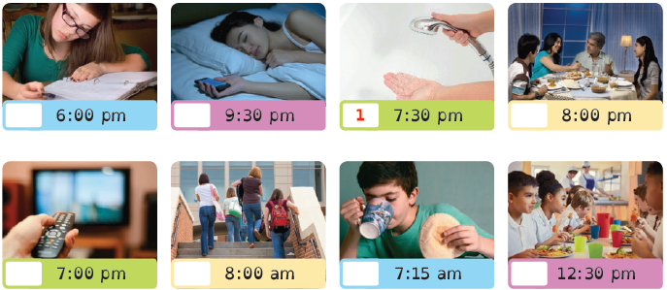

Helping at home
A Look at the pictures and write the household chores. Use the words below.
(Observa as imagens e escreve as tarefas domésticas. Usa as palavras em baixo.)
 |  | 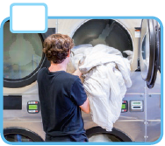 |  |  |  |  |  | 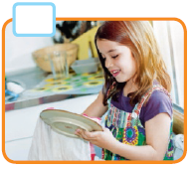
- ………….…………..…..…………..…...…..  ………….…………..…..…………..…...….. |  |  | - …………………..…..…………..…..…..…..  ………….…………..…..…………..…...….. |  |  | - ………………..…..…………..…..……..…..  ………….…………..…..…………..…...…..
 |  |  |  |  |  |  |  | 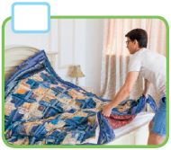
 | - ………….…………..…..…………..…...…..  ………….…………..…..…………..…...….. |  |  | - …………………..…..…………..…..…..…..  ………….…………..…..…………..…...….. |  |  | - ………………..…..…………..…..……..…..  ………….…………..…..…………..…...…..
 |  | 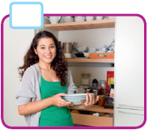 |  |  |  |  |  | 
- ………….…………..…..…………..…...…..  ………….…………..…..…………..…...….. |  |  | - …………………..…..…………..…..…..…..  ………….…………..…..…………..…...…..

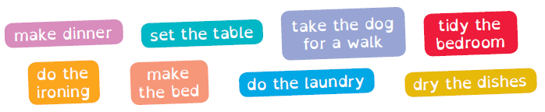

B What do you do at home? Tick (✓) the chores.
(Que tarefas fazes em casa? Assinala as tarefas com um ✓.)

Present Simple

Usamos o Present Simple para falarmos de hábitos e rotinas.

I usually go to school at half past eight.
(Eu normalmente vou para a escola às oito e meia.)

 |  | Affirmative | Negative |  | Interrogative
Singular | I  You | play | don’t play |  | Do | I  you | play…?
Singular | He  She  It | plays | doesn’t play |  | Does | he  she  it | play…?
Plural | We  You  They | play | don’t play |  | Do | we  you  they | play…?

A Circle the correct option.
(Faz um círculo na opção correta.)
1. My brother and I go / goes to school at half past seven.
2. I never make / makes my bed in the morning.
3. Peter play / plays computer games before dinner.
4. Susan and Kim do / does their homework after swimming.
5. They often listen / listens to music on their way to school.

B Write don’t or doesn’t.
(Escreve don’t ou doesn’t.)
1. My mother …………………..…..…………..…..…..….. make lunch on Sundays.
2. I …………………..…..…………..…..…..….. do the ironing. My sister does that.
3. My sister …………………..…..…………..…..…..….. tidy her bedroom.
4. We …………………..…..…………..…..…..….. go to school by bus.

C Write do or does.
(Escreve do ou does.)
1. …………………..…..…………..…..…..….. you take your dog for a walk every day?
2. …………………..…..…………..…..…..….. Gabriel do his homework before dinner?
3. …………………..…..…………..…..…..….. Jack go to school with you?

Verbs: make / do
A Look at the pictures and write the numbers next to the corresponding
expression.
(Observa as imagens e escreve os números ao lado da expressão correta.)
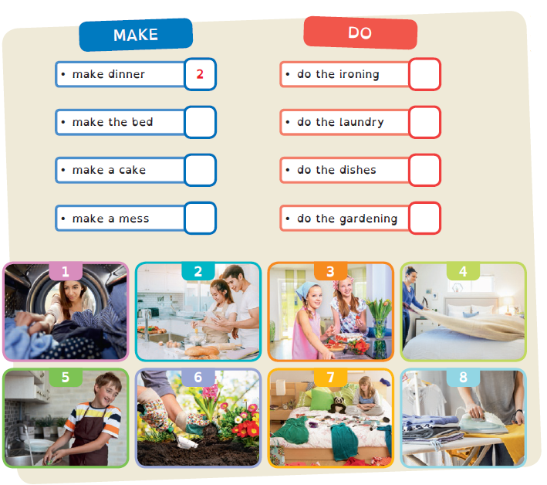

B Circle the correct verb.
(Faz um círculo no verbo correto.)
1. Mum always does / makes a delicious cake for my birthday.
2. I can do / make the dishes tonight.
3. Robert, you have to do / make your bed every day!
4. Don’t do / make a mess in your bedroom, please!
5. My mother and sister do / make the laundry every weekend.
6. My father usually does / makes dinner.
7. My grandma and I do / make the gardening every Sunday.
8. Do you do / make the ironing yourself, or do you pay someone to do it for you?



Writing: my daily routine
A Read about Sandra’s daily routine.
Complete the text with one word
in each space.
(Lê sobre a rotina diária da Sandra. Completa
o texto com uma palavra em cada espaço.)
Name Sandra Boyce
Age 12

Hi! My name is (1) Sandra Boyce and I’m (2) ..…..…………..…..…..…. years old.
I usually wake up at (3) ..…..…………..…..…..….  o’clock and I have a
delicious breakfast with my family.
After that I always make my (4) ..…..…………..…...….  and I go to school.
I have lunch in the school canteen every day.
Later, at four o’clock, I go (5) ..…..…………..…..…..….  with my
mother and I have a (6) ..…..…………..…..…..…. .
I always do my (7) ..…..…………..…..…..….  or I study.
Before dinner, I listen to (8) ..…..…………..…..…..….  or play
computer games.
We have dinner at (9) ..…..…………..…..…..….  o’clock and then I watch TV.
I usually go to bed at half past nine.

B Write sentences about your daily routine. Follow the example.
(Escreve frases sobre a tua rotina diária. Segue o exemplo.)

Nota | Repara como no texto se utilizaram palavras para ligar as ideias:  after that = depois disso * later = mais tarde * before = antes * then = depois

