
Places in school
A Find the words in the word search and label the pictures.
(Encontra as palavras na sopa de letras e legenda as imagens.)
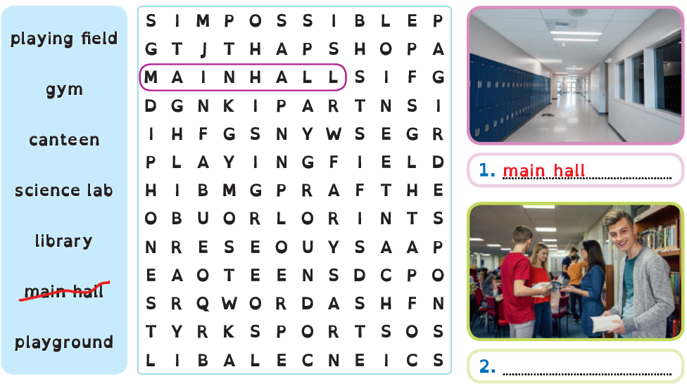
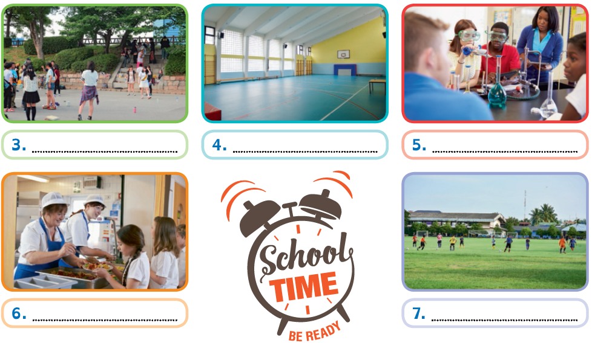
B Match the words to their Portuguese meaning.
(Liga as palavras ao significado em português.)

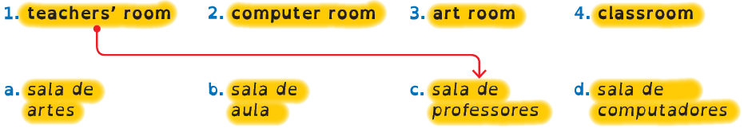

School subjects/timetable

A Look at the pictures and write the school subjects.
(Observa as imagens e escreve as disciplinas escolares.)
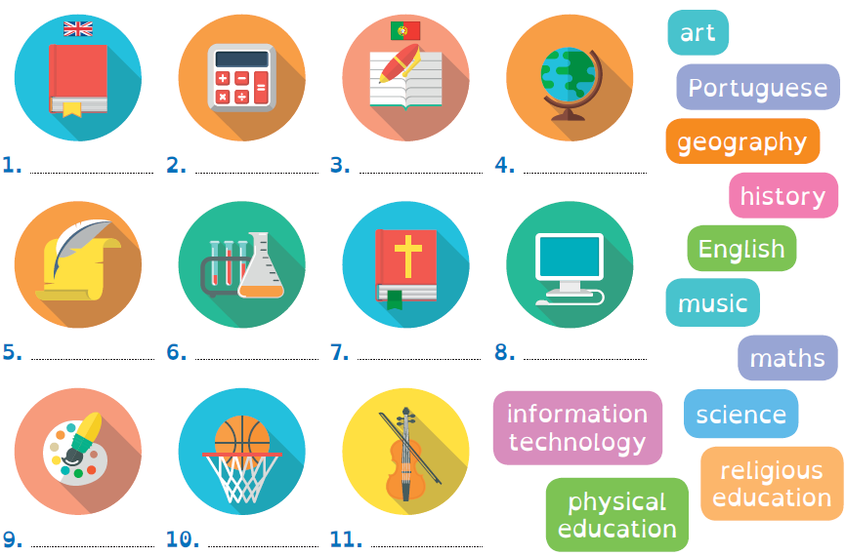

B What are your favourite subjects?
(Quais são as tuas disciplinas preferidas?)
My favourite subjects are ……………………………………………………………………… .

C Complete your timetable with the subjects.
(Completa o teu horário com as disciplinas.)
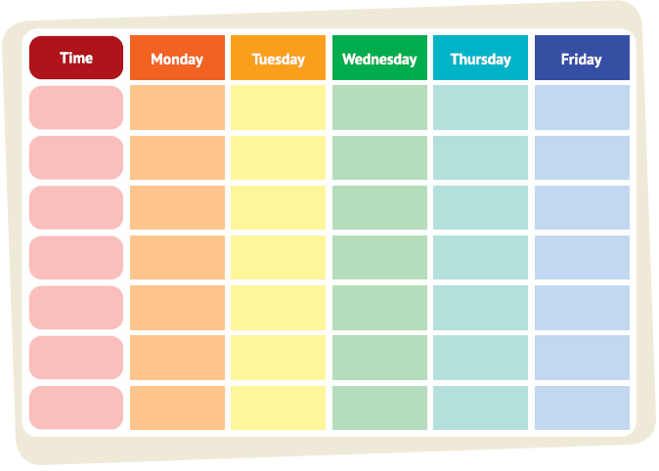

Describing my school
A Read the text about Katie’s new school and complete it.
(Lê o texto sobre a nova escola da Katie e completa-o.)

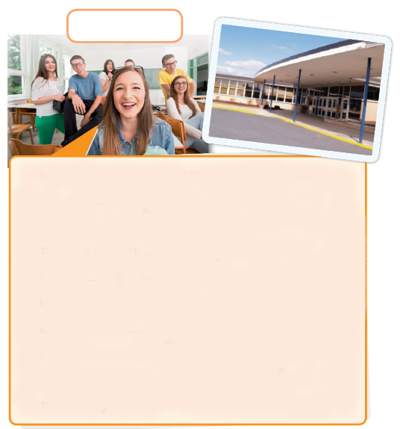
Hi! My name is (1) Katie and I’m a student at St. Helen’s
(2) ……………………………… .
I love my new school! It is modern and big.
There is a large (3) ……………………………… , a cool
(4) ………………………………  and a big (5) ………………………………  outside.
Inside there are many (6) ……………………………… , a big science lab
and a (7) ……………………………… . The (8) ………………………………
room is in front of the teachers’ room. I always have
lunch in the school (9) ……………………………… .
The food is great!
Name Katie
School St. Helen’s

B Describe your school. Follow the example in exercise A.
Use some adjectives from the list to describe your school.
(Descreve a tua escola. Segue o exemplo do exercício A. Usa alguns adjetivos da lista para descreveres a
tua escola.)

Adjectives | old (velho/a) new (novo/a) modern (moderno/a) big (grande)  small (pequeno/a) great (fantástico/a) old-fashioned (antigo/a)

Comparative
A Write the opposite of the adjectives below. Then translate into Portuguese.
(Escreve os opostos dos adjetivos em baixo. Depois traduz para português.)

Adjectives |  |  | Adjetivos
old | young |  | velho/a | jovem
tall |  |  | alto/a
big |  |  | grande
sad |  |  | triste
boring |  |  | aborrecido/a
easy |  |  | fácil

B Look at the comparative of the adjectives. Then look at the picture and
complete the sentences below.
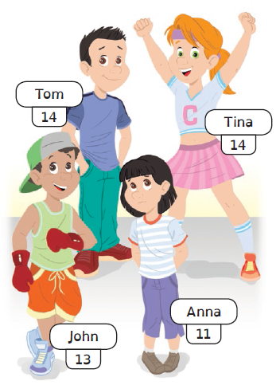
(Observa o comparativo dos adjetivos. Depois olha para a imagem e completa as frases.)

 | Comparativo
 | Superioridade | Igualdade
short | shorter than | as short as
big | bigger than | as big as
happy | happier than | as happy as

1. Tina is happier than (happy) Anna.
2. Tom is ……………………………… (old) Anna.
3. Tom is ……………………………… (tall) John.
4. Tina is ……………………………… (happy) John.
5. Anna is ……………………………… (sad) John.
6. Tom is ……………………………… (old) Tina.
7. Anna is ……………………………… (young) Tina.
8. John is ……………………………… (short) Tom.

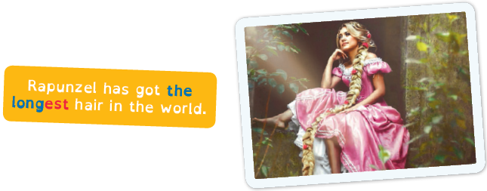
Superlative

A Circle the correct option.
(Faz um círculo na opção correta.)
1. Whales are the heavier / the heaviest animals of all.
2. Tom is the smarter / the smartest boy at school.
3. Surfing is the more difficult / the most difficult sport for me.
4. The most dangerous / The more dangerous animals live
in Africa.
5. Peter is the worse / the worst student in class.
6. I think New York is the best / the better city in the world.

B Complete the sentences and match them to the pictures.
(Completa as frases e liga-as às imagens.)
1. The Amazon river is long, but the Nile River is ……………………………… ……………………………… 
river in the world.
2. The Himalayas are big, but the Andes are ……………………………… ………………………………
mountains in the world.
3. Selena Gomez is pretty, but Vanessa Hudgens is ……………………………… ………………………………
actress for me.
4. Lionel Messi is good, but Cristiano Ronaldo is ……………………………… ………………………………
football player in the world.

