Free-time activities
A Write the expressions below under the correct picture.
(Escreve as expressões por baixo da imagem correta.)
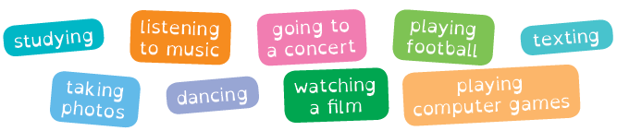

B Write sentences about your preferences.
(Escreve frases sobre as tuas preferências.)
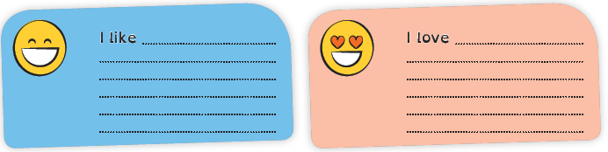

Present Continuous
A Look at the pictures and circle the correct option.
(Observa as imagens e faz um círculo na opção correta.)
 |  | 
1. My friends is / are  playing football. | 2. Diego is / are  studying English. | 3. I am / are taking a  selfie.

B Read the sentences and write the number next to the correct picture.
(Lê as frases e escreve o número junto da imagem correta.)

What are they doing at the park?
1. Dora is taking the dog for a walk. 5. They are having a picnic.
2. Paul and Sue are riding their bikes. 6. Oscar is reading a book.
3. You are taking photos. 7. Samuel is running.
4. Chris is playing the guitar. 8. Paul is skateboarding.
