
Past Simple: to be
 | Affirmative | Negative |  | Interrogative
I  He  She  It | was | was not / wasn’t |  | Was | I  he  she  it | …?
You  We  They | were | were not / weren’t |  | Were | you  we  they | …?


A Circle the correct option.
(Faz um círculo na opção correta.)
1. I was / were with my friends at
the party last night.
2. My father was / were in London
in 2000.
3. Were / Was you sick yesterday?
4. Anne wasn’t / weren’t in my
class last year.
5. They was / were happy with

their test results.

B Look at the pictures and write was or were,
wasn’t or weren’t.
(Observa as imagens e escreve was ou were, wasn’t ou
weren’t.)
1. Mark wasn’t happy with his maths test.
2. It ….…………..……………………. a sunny day.
3. Kim and Harry ….…………..……………………. sick last Sunday.
4. ….…………..……………………. your father in the hospital last week?
5. The children ….…………..……………………. nervous about the play.
They ….…………..……………………. very excited.




Text: social media
Read the text and match to form sentences.
(Lê o texto e liga para formar frases.)


I’m crazy about social media and yesterday was a special day at my
school: there was an exhibition about different types of social media!
Kevin Systrom was there!
He was the co-founder of the popular
application called Instagram.
He was born on 30th December 1983,
in Massachusetts, USA. He was an
excellent student and very interested
in computer programming.
In 2010 Instagram was launched and it
was a success.

1. The exhibition was |  | a. the co-founder of Instagram.
2. Kevin Systrom was |  | b. on 30th December 1983.
3. He was at |  | c. excellent student.
4. He was born |  | d. my school.
5. He was an |  | e. launched in 2010.
6. Instagram was |  | f. about different types of social media.



Past Simple: there to be
 | Affirmative | Negative | Interrogative
 | Havia | Não havia | Havia…?
Singular | There was… | There wasn’t… | Was there…?
Plural | There were… | There weren’t… | Were there…?

A Complete the sentences with was or were.
(Completa as frases com was ou were.)
1. There were a lot of people at the cinema on Friday.
2. There ….…………..……………………. a good programme on TV last night.
3. There ….…………..……………………. a restaurant on this street ten years ago.
4. There ….…………..……………………. three phones on the sofa.


B Write the sentences in the negative. Use wasn’t or weren’t.
(Escreve as frases na negativa. Usa wasn’t ou weren’t.)
1. There weren’t any tables in
the apartment.
2. There ….…………..……………………. any pictures
on the wall.
3. There ….…………..……………………. any chairs in
my bedroom.
4. There ….…………..……………………. a computer
on my desk.


C Write the sentences in the interrogative.
(Escreve as frases na interrogativa.)


1. There were a lot of people at the party.
Were there a lot of people at the party?
2. There was a baby crying at the park.
….…….…………..…………………….………..……………………. ?
3. There were three dogs in the garden.
….…….…………..…………………….………..……………………. ?
4. There was a cat near the school.
….…….…………..…………………….………..……………………. ?

Writing an interview
Read the information about Jennifer Lopez and complete the interview.
(Lê as informações sobre a Jennifer Lopez e completa a entrevista.)Whe
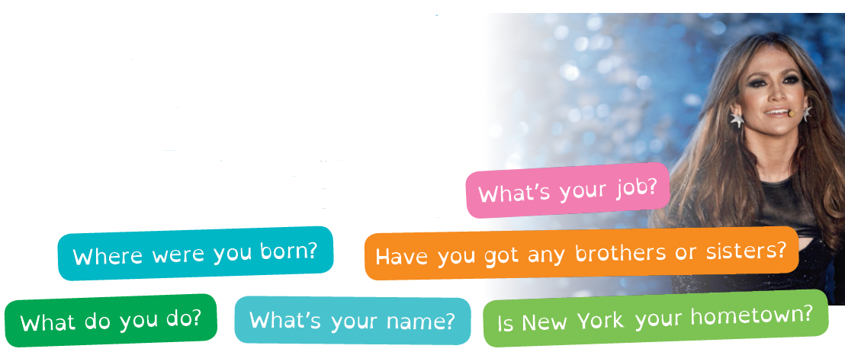

Name | Jennifer Lopez
Born | Bronx
Hometown | New York
Jobs | singer, dancer, actress
Siblings | two sisters

What’s



Good morning!
Jennifer: Good morning!
1. ….…….…………..…………………….………..……………………. ?
Jennifer: My name is Jennifer Lynn Lopez.
2. ….…….…………..…………………….………..……………………. ?
Jennifer: I was born in Bronx, New York.
3. ….…….…………..…………………….………..……………………. ?
Jennifer: Yes, New York is my hometown. I grew up and studied there.
4. ….…….…………..…………………….………..……………………. ?
Jennifer: Well… I’m a singer, a dancer and an actress.
Really…? Fantastic! 5. ….….………..……………………. ?
Jennifer: Yes, I have got two sisters, Leslie and Lynda.
Thank you so much for this interview, Jennifer.
Jennifer: You’re welcome. It was a pleasure!

