Past Simple: regular verbs (affirmative / negative)
 | Affirmative | Negative
Regular verbs  +  -ed / -d | walk walked  live lived | didn’t walk  didn’t live
Regular verbs  +  -ed / -d | I walked the dog last night.  I lived in London last year. | I didn’t walk the dog last night.  I didn’t live in London last year.

A Find the verbs in the word search and write them in the Past Simple.
(Encontra os verbos na sopa de letras e escreve-os no Past Simple.)
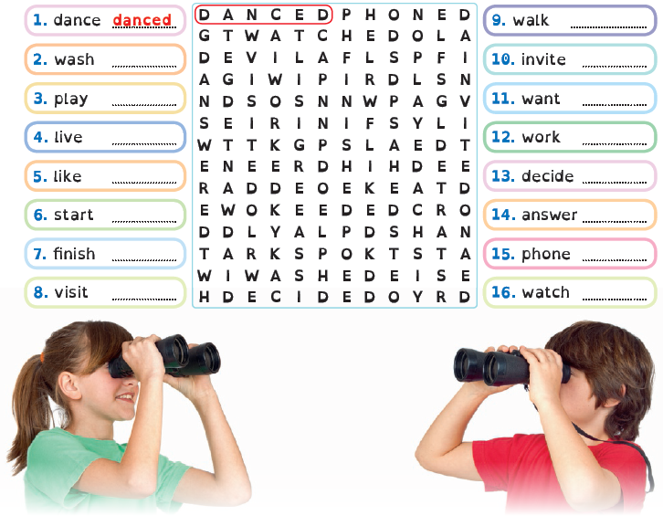
B Write the sentences in the negative.
(Escreve as frases na negativa.)
1. Jerry and Mike played basketball. Jerry and Mike didn’t play basketball.
2. The concert started at 10 o’clock. ….……………….…………..…………………….………..…………………….
3. I visited my cousins in Cardiff. ….…….…………..……………………………….………..…………………….
4. My father worked at my school. ….…….…………..………………………….…….………..…………………….
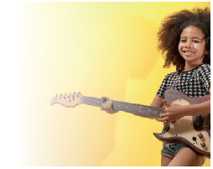
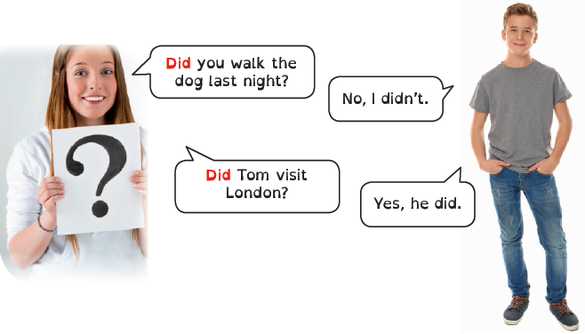
Past Simple: regular verbs (interrogative)
A Read the sentences and write them in
the interrogative. Look at the example.
(Lê as frases e escreve-as na interrogativa. Observa
o exemplo.)

Patti played the guitar.
Did Patti play the guitar?

Simon listened
to music last night. 1. Did Simon listen to music last night ?
Dad washed the car
last Sunday. 2. ….…….…………..………………………….…….………..……………………. ?
Vicky did ballet
at school last year. 3. ….…….…………..………………………….…….………..……………………. ?
Mr Brown worked
at the library. 4. ….…….…………..………………………….…….………..……………………. ?
Sam invited Larry to
his party yesterday. 5. ….…….…………..………………………….…….………..……………………. ?

B Answer these questions about you.
Write Yes, I did or No, I didn’t.
(Responde sobre ti. Escreve Yes, I did ou No, I didn’t.)
1. Did you watch TV last night? ….…….…………..………………………….…….………..…………………….
2. Did you dance hip hop yesterday? ….…….…………..………………………….…….………..…………………….
3. Did you phone your mother today? ….…….…………..………………………….…….………..…………………….
4. Did you study English this week? ….…….…………..………………………….…….………..…………………….


Text: my first phone
A Read and complete the text about Samuel’s first phone.
(Lê e completa o texto sobre o primeiro telemóvel do Samuel.)
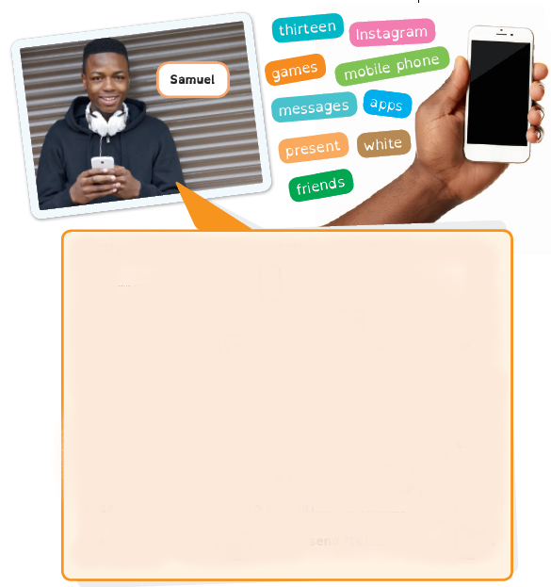
Hi! My name is (1) Samuel and this was my first
(2) ………….…….………..……… .
It was a birthday (3) ………….…….………..………  from my parents.
I was (4) ………….…….………..………  years old and this was one of the
best presents I received that day.
The mobile phone was black and (5) ………….…….………..……… .
It was very modern and it had some (6) ………….…….………..……… , but
then I installed more apps, like (7) ………….…….………..……… .
I used that mobile phone to play (8) ………….…….………..……… , to call
my (9) ………….…….………..………  and to send (10) ………….…….………..……… 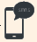.

B Describe your first mobile phone. Follow the example above.
(Descreve o teu primeiro telemóvel. Segue o exemplo acima.)

Adjectives | old (velho/a) new (novo/a) modern (moderno/a)  big (grande) small (pequeno/a) great (fantástico/a)

