
Find the words in the word search and write them under the pictures.
Places in a city
(Encontra as palavras na sopa de letras e escreve-as por baixo das imagens.)
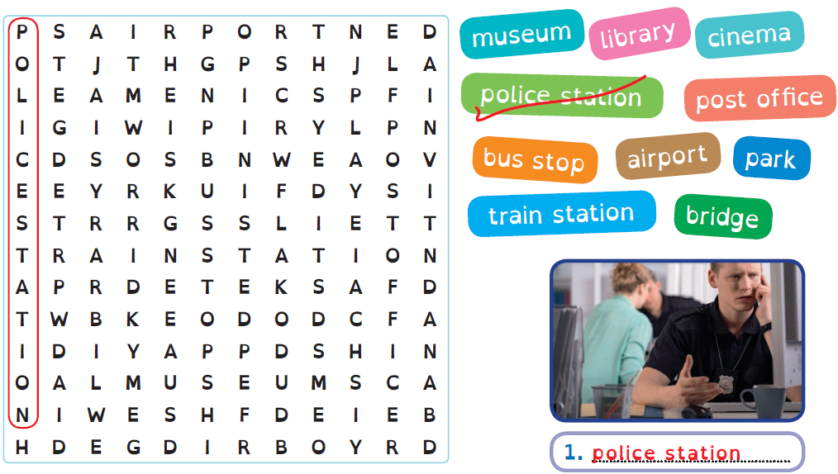
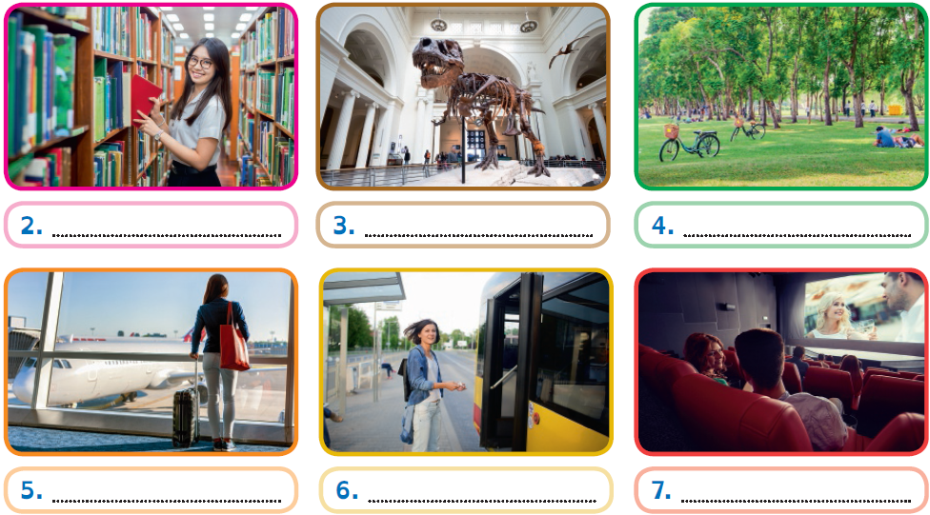
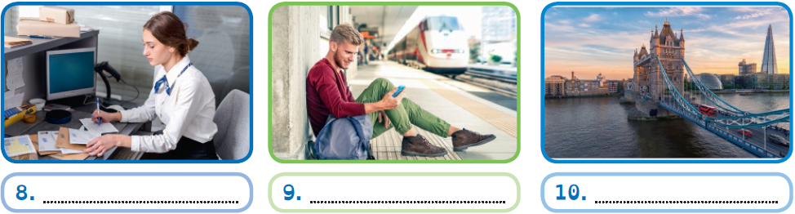

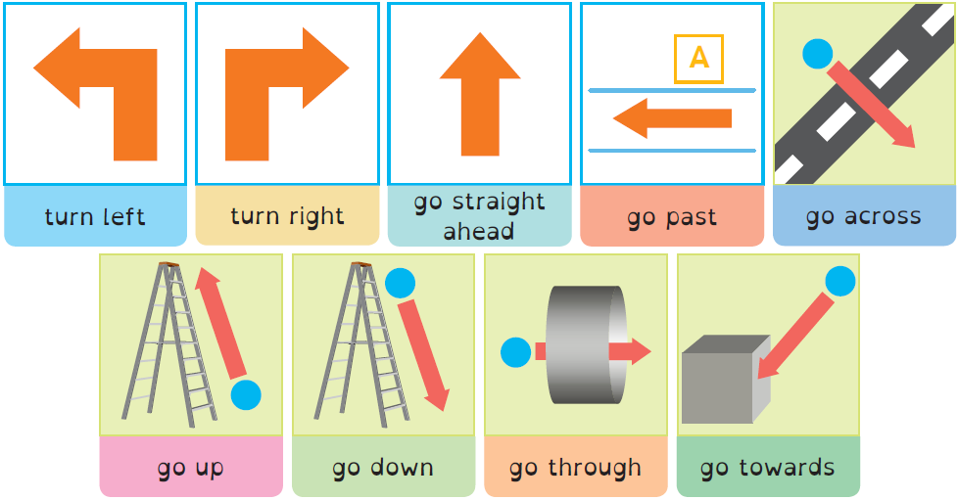
Asking for directions

Look at the map and match.
(Observa o mapa e liga.)
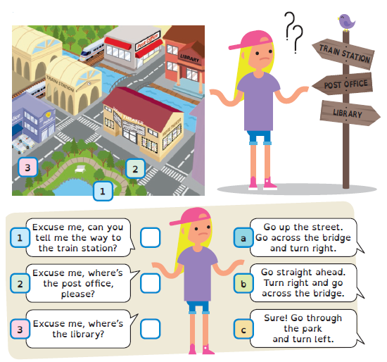

A Write the Past Simple of these verbs.
Past Simple: irregular verbs (affirmative)
(Escreve o Past Simple dos verbos.)


Verb | Past Simple |  | Verb | Past Simple
1. see | saw . |  | 7. write | ……………………………………
2. make | …………………………………… |  | 8. eat | ……………………………………
3. go | …………………………………… |  | 9. drink | ……………………………………
4. send | …………………………………… |  | 10. buy | ……………………………………
5. have | …………………………………… |  | 11. run | ……………………………………
6. fly | …………………………………… |  | 12. get | ……………………………………


B Circle the correct option.
(Faz um círculo na opção correta.)
1. We went / go to Paris in
September.
2. Thomas see / saw the new
film yesterday.
3. John run / ran after the
bus last Monday.
4. Anne bought / buy a postcard for her sister.
5. He send / sent a message to his friends.
6. They have / had a birthday party yesterday.

C Complete the sentences with the verbs in the Past Simple.

(Completa as frases com os verbos no Past Simple.)
1. I finally got (get) a new phone.
2. Sophie ……………………… (drink) another glass
of water.
3. We ……………………… (eat) a box of chocolates.
4. George ……………………… (fly) to London last
week.
5. Mary ……………………… (send) me a postcard.
6. Mum ……………………… (make) a list before
going to the supermarket.

Past Simple: irregular verbs (negative)

 | Affirmative | Negative
Irregular  verbs | make made  see saw | didn’t / did not make  didn’t / did not see
Irregular  verbs | I made a shopping list.  She saw Bob at the museum. | I didn’t make a shopping list.  She did not see Bob at the museum.

A Circle the correct option. Then look at the pictures and choose TRUE or
FALSE.
(Faz um círculo na opção correta. Observa as imagens e escolhe VERDADEIRO ou FALSO.)



1. James didn’t have / had time to buy apples. | 
2. Mrs Smith didn’t catch / caught the train. | 
3. Brian didn’t go / went to the park yesterday.
4. Amy didn’t make / made her bed this morning.
5. My friend didn’t got / get a new tablet for Christmas.
6. I didn’t drank / drink a glass of milk this morning.
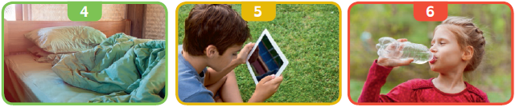

B Write the sentences in the negative.
(Escreve as frases na negativa.)
1. I ate spaghetti for dinner. I didn’t eat spaghetti for dinner .
2. We went to the library. ……………………………………………………………………………………………………………… .
3. I flew to Italy last summer. ……………………………………………………………………………………………………………… .
4. Sally bought a new T-shirt. ……………………………………………………………………………………………………………… .
5. Tom ran a marathon. ……………………………………………………………………………………………………………… .

