Shops
A Write the number next to the correct shop.
(Escreve o número na loja correta.)
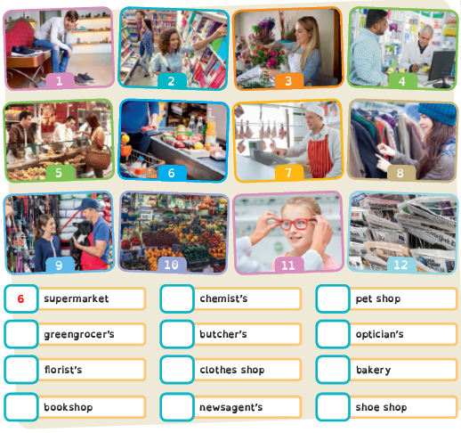
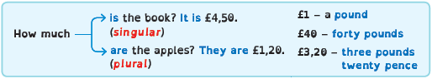

B Circle the correct option.
(Faz um círculo na opção correta.)

4. They is / are
£45,50.
2. It is / are
£60.
1. How much is / are
the white skirt?
3. How much is / are
the red shoes?

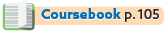
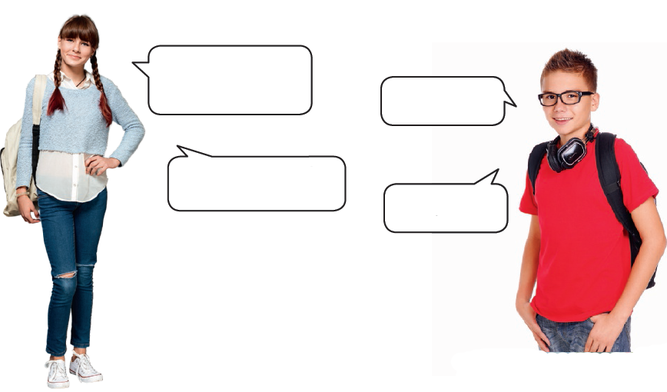
Past Simple: irregular verbs (interrogative)
Yes, I did.
Did you go to the
cinema yesterday?
No, I didn’t.
Did you buy
your glasses at
the chemist’s?
A Write the answers to these questions.
(Escreve as respostas para as perguntas seguintes.)
1. Did you buy that book in the fair?
Yes, I did. (✓).
2. Did you go to the bookshop yesterday?
No, I didn’t. (✗).
3. Did you buy your T-shirt at the supermarket? ………………………………………………….……………………………… (✓).
4. Did you buy the magazine at school? …………………………………………………………………………….…………………… (✗).
5. Did you like the film? ………………………………………………………………………………………………………………………………..…… (✓).
6. Did you visit your grandparents last week? ……………………………………………………………………………………… (✗).

B Write the questions.
(Escreve as perguntas.)
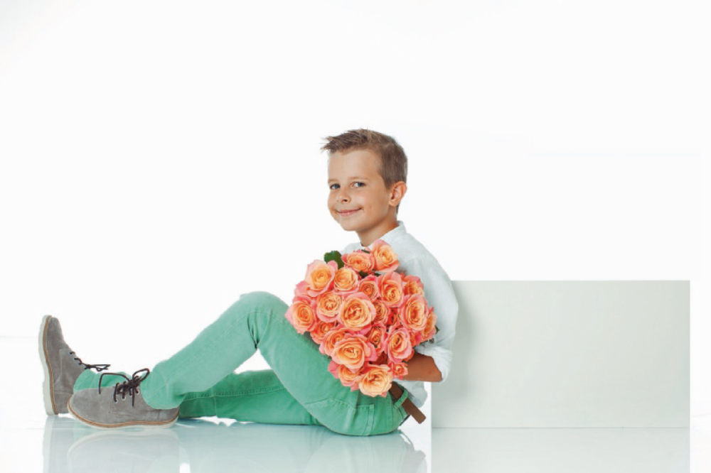
1. Danny bought a bouquet of orange roses.
Did Danny buy a bouquet of orange roses? .
2. John and Tom ate a hamburger yesterday.
……………………………………………………………………………………………………………………………………………………..…… ?
3. She wrote the letter last week.
…………………………………………………………………………………………………………………….………………………………..…… ?
4. Fred went to the pet shop.
…………………………………………………………………………………………………………….………………………………………..…… ?
5. Jim drank a coke at the restaurant.
…………………………………………………………………………………………………..…… ?

A menu: ordering food (interrogative)
A Write the word under the correct picture.
(Escreve a palavra por baixo da imagem correta.)
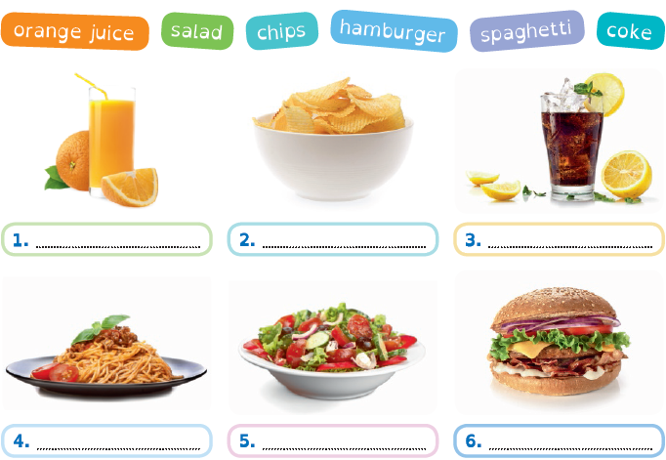

B Write the words below in the correct balloons.
(Escreve as palavras abaixo nos balões de fala corretos.)
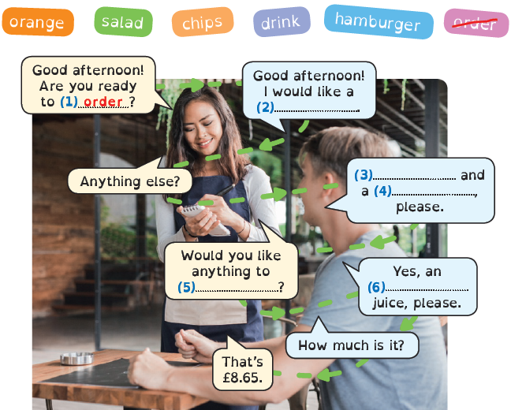

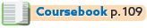
Writing a story (interrogative)
A Put the pictures in order. Match the sentences to the correct pictures to tell
the story.
(Ordena as imagens. Liga as frases às imagens corretas para contares a história.)
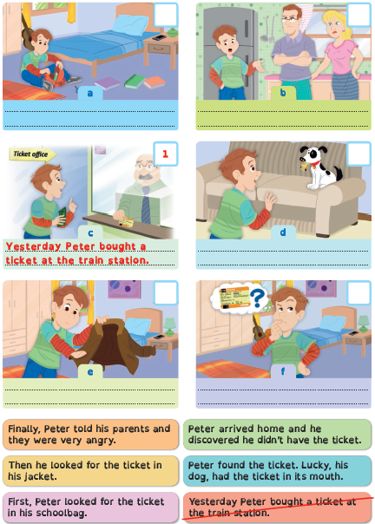
B Write the story in order.
(Escreve a história por ordem.)

