
A Label the pictures.
Summer activities and places
(Legenda as imagens.)
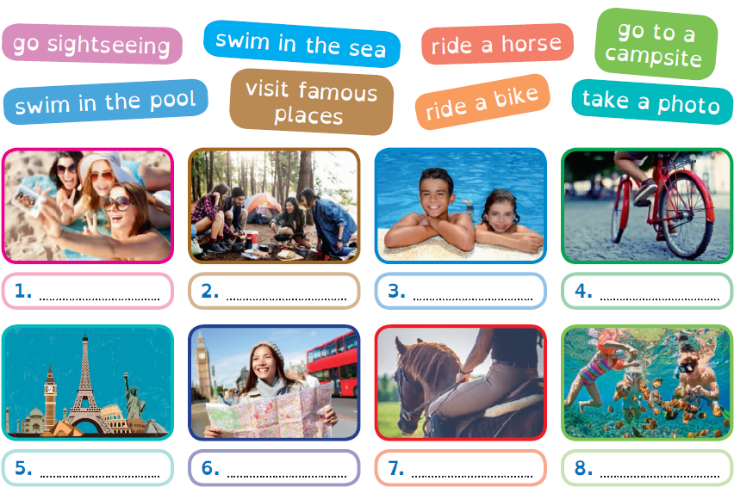

B Look for the words in the word search and write them under the pictures.
(Procura as palavras na sopa de letras e escreve-as por baixo das imagens.)

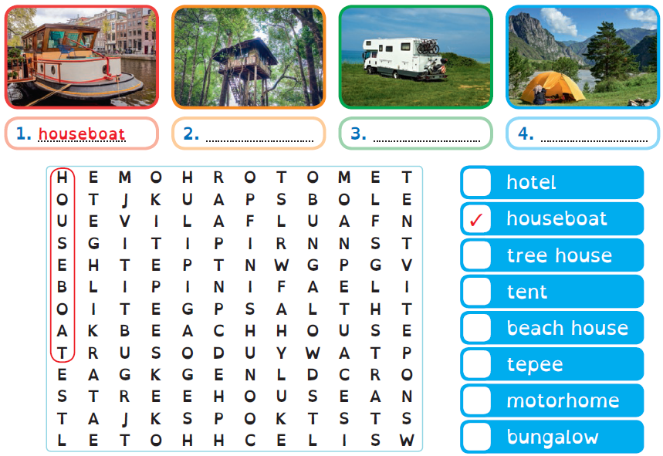

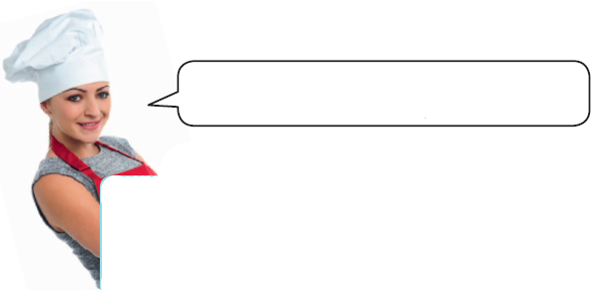
Future: be going to
Usamos to be + going to + verb
para falar de planos para o futuro.

Affirmative | Negative |  | Interrogative
I am  going to eat | I am not  going to eat |  | Am I  going to eat?
He / She / It is  going to eat | He / She / It isn’t  going to eat |  | Is he / she / it  going to eat?
We / You / They are  going to eat | We / You / They aren’t  going to eat |  | Are we / you / they  going to eat?

A Circle the correct option.
(Faz um círculo na opção correta.)
1. I am / are going to buy you a birthday present.
2. Is / Are you going to climb the mountain?
3. Sally is / are going to send me a postcard.
4. She is / are going to visit Buckingham Palace.
5. We isn’t / aren’t going to stay in a hotel next summer.
6. My parents is / are going to visit the museum next weekend.
B Write sentences.
(Escreve as frases.)
1. I / travel… I’m going to travel to Paris. .
2. She / see… She is going to see her uncle. .
3. Paul / climb… ………………………………………………………………………………………………………………
4. They / send… ………………………………………………………………………………………………………………
5. We / swim… ………………………………………………………………………………………………………………
6. You / visit… ………………………………………………………………………………………………………………
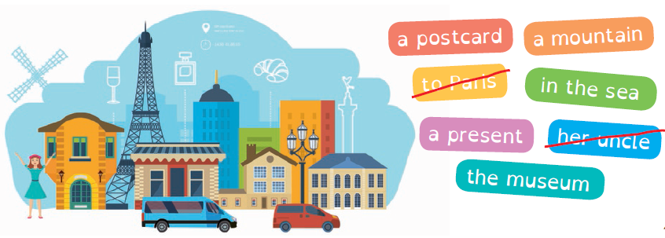
7. He / buy… ………………………………………………………………………………………………………………

Read and complete the text about Vicky’s next summer holidays. Use the words below.
Writing: next summer
(Lê e completa o texto sobre as próximas férias de verão da Vicky. Usa as palavras em baixo.)

