Transport
A Write the correct number.
(Escreve o número correto.)
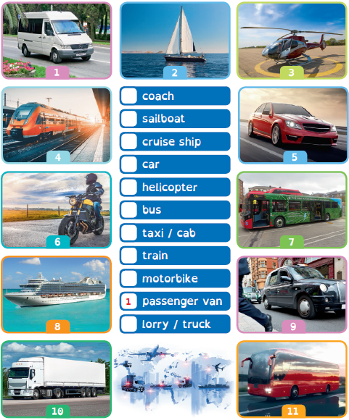

B Answer the question.
(Responde à pergunta.)
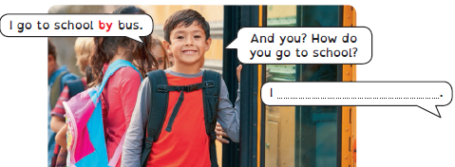

At the train station: asking for information
A Read the dialogue at the train station and complete the table.
(Lê o diálogo na estação de comboios e completa a tabela.)
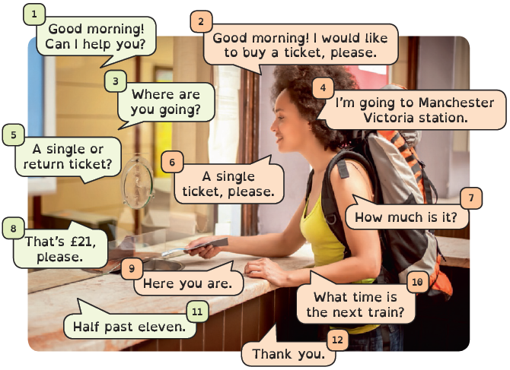
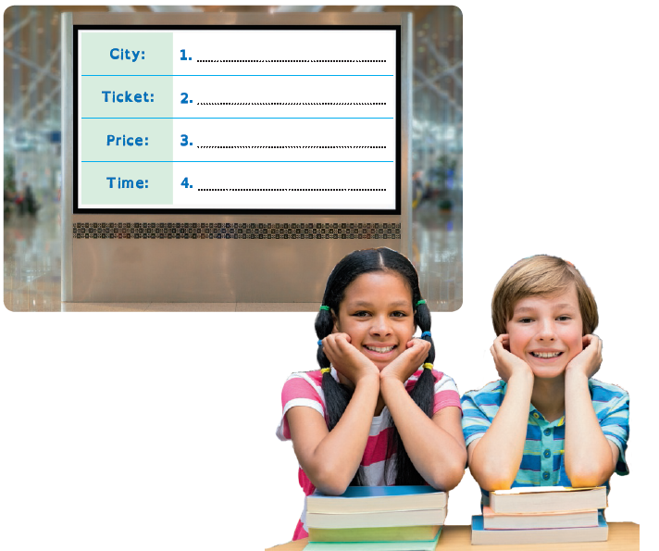

B In pairs, role-play the dialogue.
(Em pares, representa o diálogo.)

