End of first term 6.º ano Listening Test

Name: ______________________________________________________ Class: ____ No.: _______
Date: _______________________________________________________ Score: _______________
Enc. Educação: ________________________________Teacher: ________________________

- Emily is talking about her best friend. Listen and choose the correct option.
Example: What’s his name?

A ☑ Jack | B John |  | C David
1. What does he look like?

A  | B  | C 
2. How old is he?

A 11 | B 12 | C 13
3. What colour are his eyes?

A blue | B black | C brown
4. What is he like?

A confident | B shy | C nervous
5. What is he doing?

A 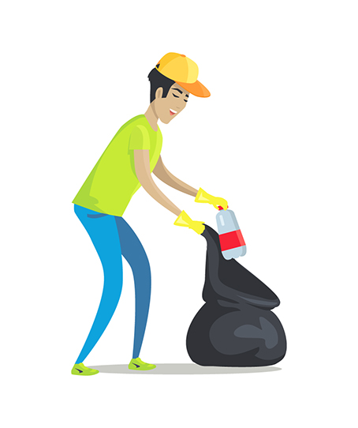 | B  | C 

- Read the questions. Listen and write the answers.

Example:
What’s the boy’s name? His name is Robert .
- Where are they? They are in the _____________.
- What time is it? It’s ______________________.
- What subject does she have at 9:30? It’s ______________________.
- What’s Emily favourite subject? It’s ______________________.
- Which subject is more difficult for her? It’s ______________________.



End of first term 6.º ano Written Test

Name: ______________________________________________________ Class: ____ No.: _______
Date: _______________________________________________________ Score: _______________
Enc. Educação: ________________________________Teacher: ________________________

Vocabulary
A. Look at Robert’s daily routine. Complete the sentences with one word in each space.

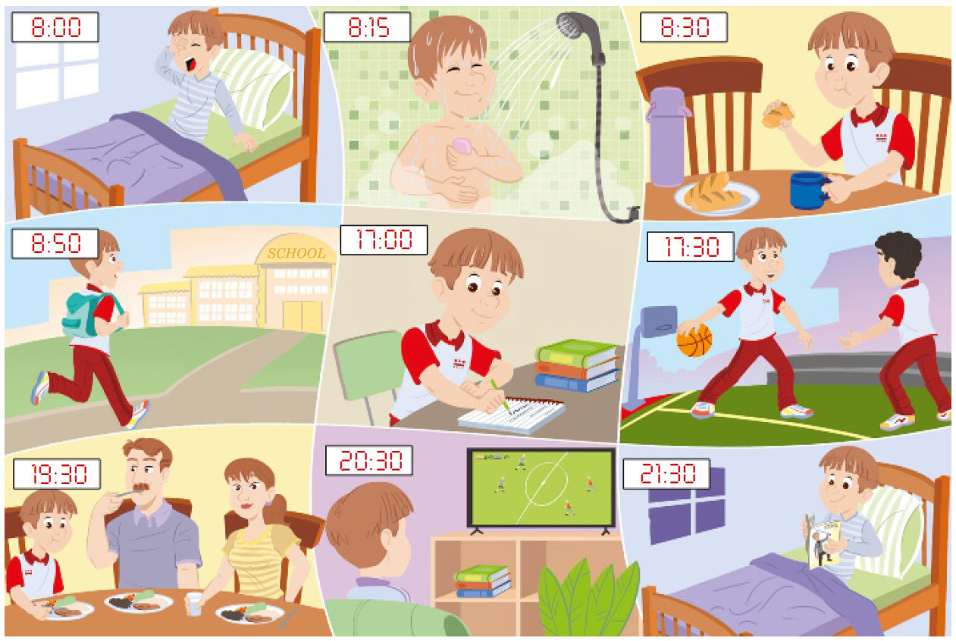

Robert always __gets__ up at (1)________ o’clock. Before having breakfast he has a (2)________. Then he makes his bed and goes to (3)________ on foot at ten (4)________ nine.
At school his favourite (5)________ is maths. He comes back home and at five o’clock he does his (6)________. After that, Robert plays (7)________ with his friends at (8)________ past five.
In the evening, at 19:30, he has (9)________ with his parents. Before watching TV, he helps his mother dry the dishes and goes to (10)________ at 21:30.

B. Look at Robert’s timetable. Read the sentences and write YES or NO.

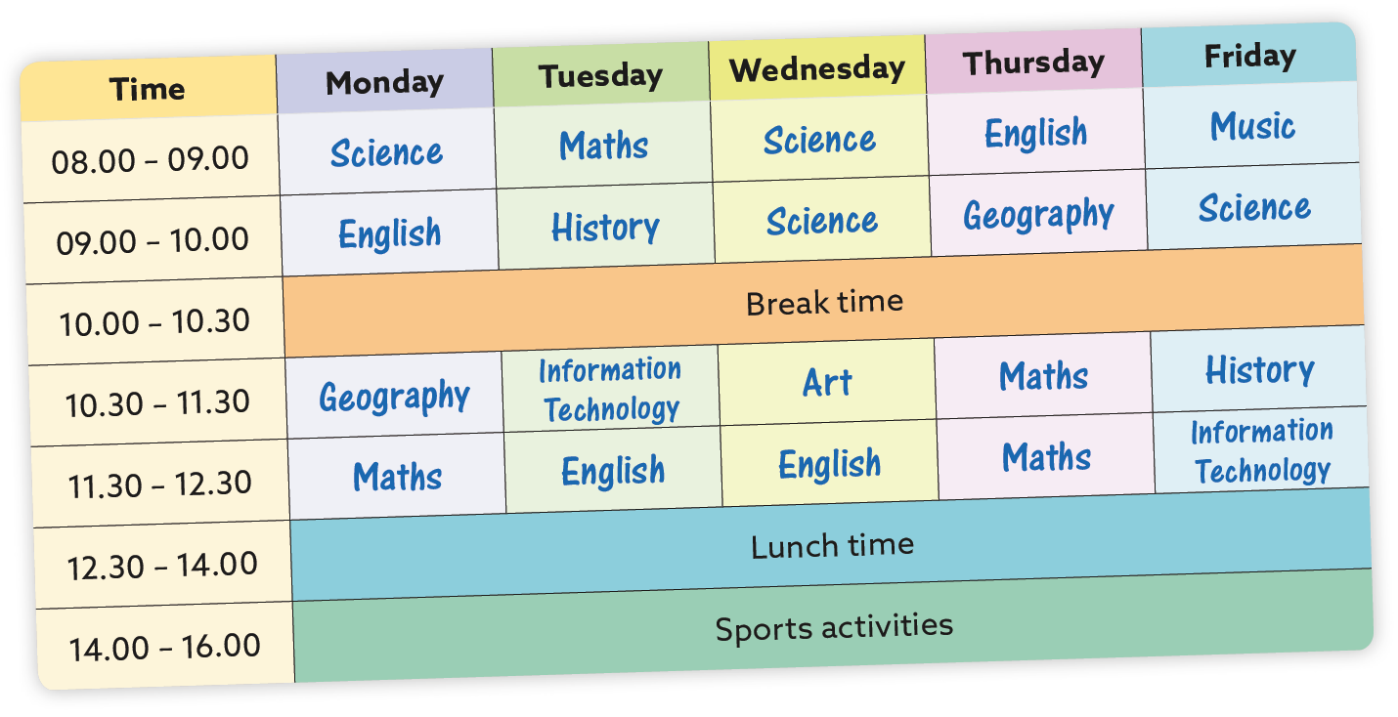

Example:
Robert has maths on Wednesday. ___NO__
- Art is at ten o’clock. ________
- Robert has geography twice a week. ________
- On Wednesday he has art after English. ________
- All his subjects are in the morning. ________
- He has history on Tuesdays and Fridays. ________
- Robert has maths once a week. ________
- His classes start at a quarter past eight. ________
- His first lesson on Friday is music. ________
- He has history before maths on Tuesday. ________
- He has English four times a week. ________

Reading
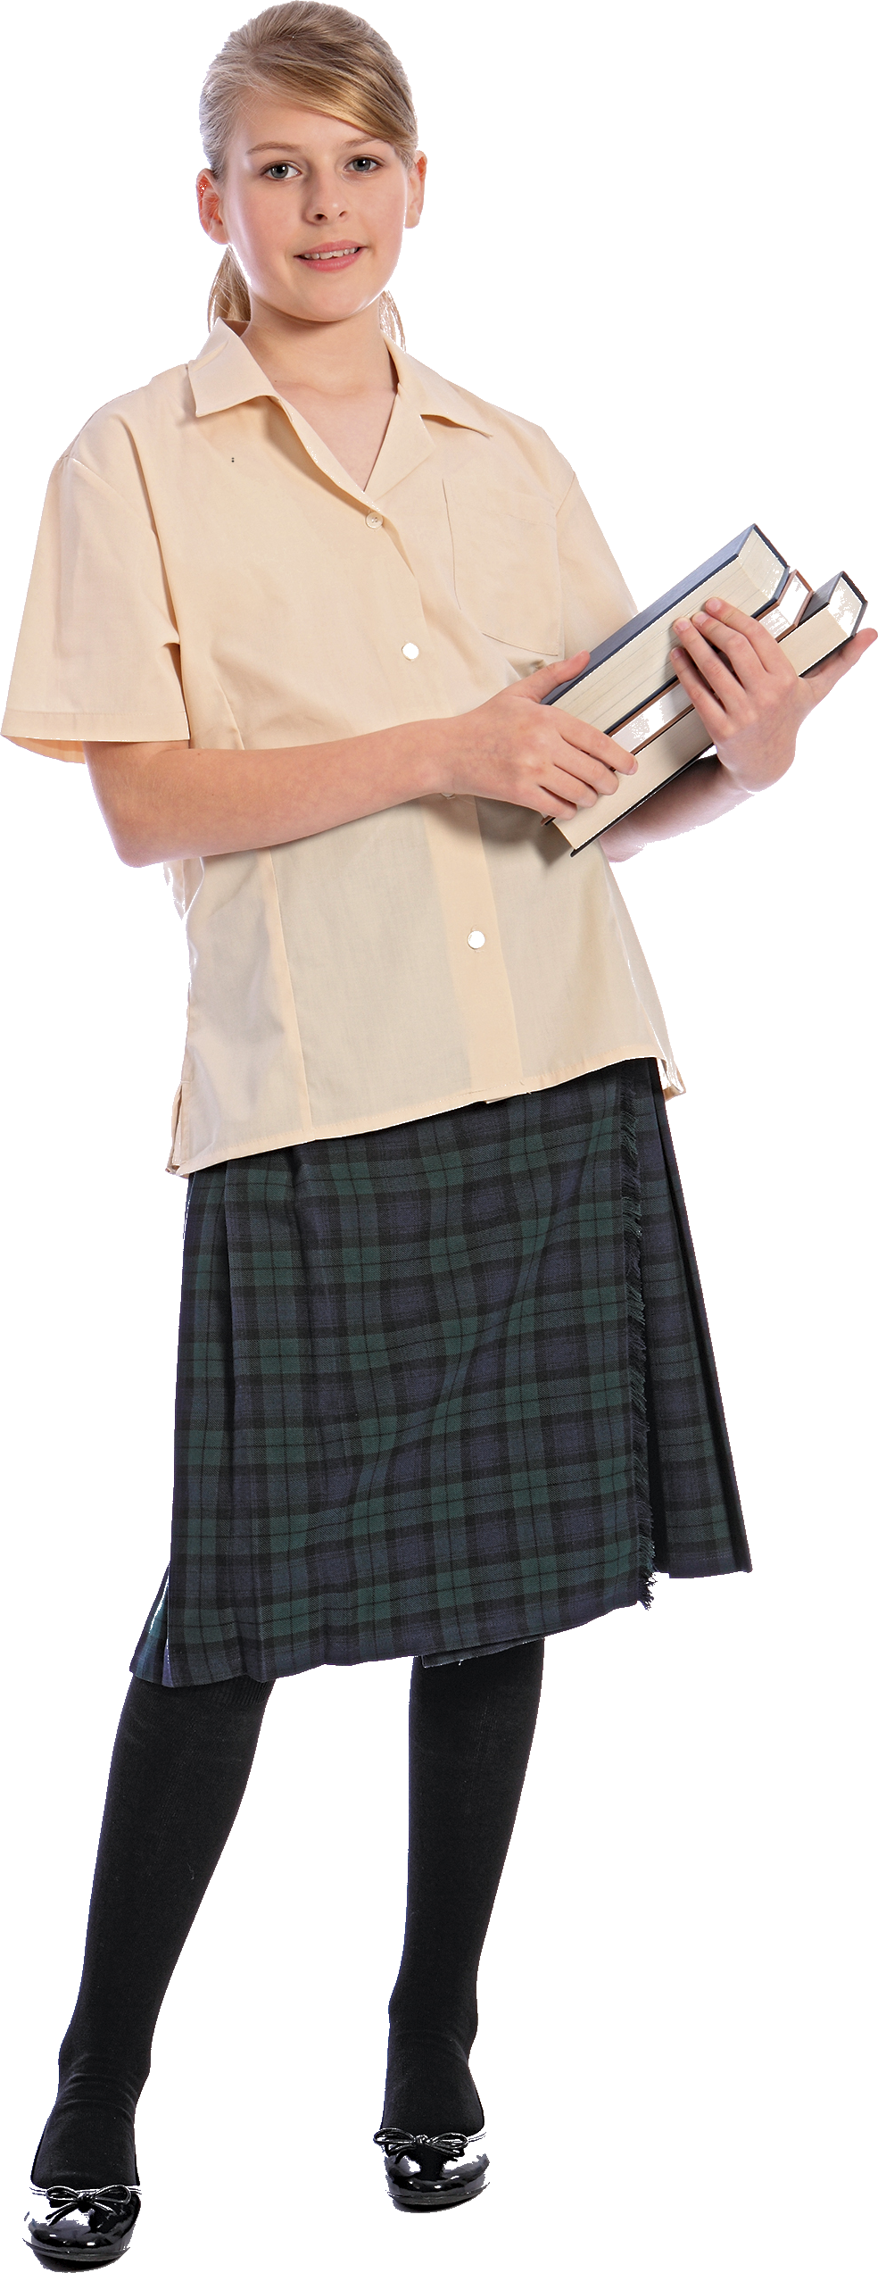
Read about Emily.
My name is Emily and I’m thirteen years old. I’m Irish and Jack is my best friend. He is from Scotland, but now he lives in Ireland, in Dublin. Jack and I go to the same school: “Davis Middle School”.
Jack is my neighbour, so we go to school together. We don’t go to school on foot because my mother takes us there by car.
Before going to school I have breakfast at 7:40 and then I make my bed. At 8:00 Jack comes by and we go to school.
We always start classes at 8:28. I like my school. It is very big, and it has very good facilities, such as a music room, a big gym and an amazing library with a lot of computers.
I’m really keen on doing sports, so I enjoy my PE lessons a lot. I find these lessons very interesting and not difficult at all. I also like science and English because I have very good teachers.
I love school because I have many friends there and we do a lot of things together. After school, we play video games and study together. We always do our homework in the school library, so I never do my homework at home. In my bedroom I usually study, and after that I have dinner with my parents.

- True or false (X)? Correct the false ones.
 | True | False
1. Jack is Irish.
_________________________________________________
2. Emily and Jack go to school on foot.
__________________________________________________
3. Emily has breakfast at twenty to eight.
___________________________________________________
4. Emily likes sports.
___________________________________________________
5. Emily studies after having dinner.
___________________________________________________

- Answer the questions about the text.

1. How old is Emily? ______________________________________________________
2. Who is Jack? __________________________________________________________
3. What time do they go to school? ___________________________________________
4. What does Emily do after school? __________________________________________
5. Where does she do her homework? ________________________________________

Grammar

- Read the sentences and choose the correct option.

Example: That’s my pen. Give it back to __________.
A I B me C myself
- Is __________ your brother?
A his B himself C he

- Look at __________ in the mirror. You look great!
A yourself B your C they
- Who’s that girl? What’s __________ name?
A she B her C herself
- Don’t worry! I can do that by __________.
A I B my C myself
- Emily’s tests are not OK. She __________ ask the teacher for help.
A makes B does C should
- My father usually __________ dinner and I __________ the dishes.
A makes/do B does/make C should/can
- They usually __________ basketball in the afternoon.
A plays B play C is playing
- Look, Jack is studying __________ he is listening to music.
A after B later C while
- I play football __________ a week.
A twice B usually C sometimes
- Now I __________ this book for my Science project.
A read B reads C am reading

- Complete the sentences with the prepositions in the box.

Example: I’m not afraid of dogs.
at
of
about
on
in
- Jack is interested ________ history. He likes studying past events.
- Emily is good ________ science.
- I’m tired ________ studying. Let’s play basketball.
- I’m not keen ________ basketball. I prefer handball.
- Robert is worried ________ the science test.
C. Complete the sentences with the comparative or superlative.
Example: Emily is _________shorter________ (short) than Robert.
- Who is the _____________________ (tall) student in your class?
- Emily thinks that science is _______________________ (easy) than history.
- Maths is the ___________________________ (difficult) subject for me.
- Jack is _________________________ (bad) at science than Emily.
- Making dinner is _____________________ (interesting) than drying the dishes.
Writing

- Imagine you are texting with Emily. Complete the conversation.
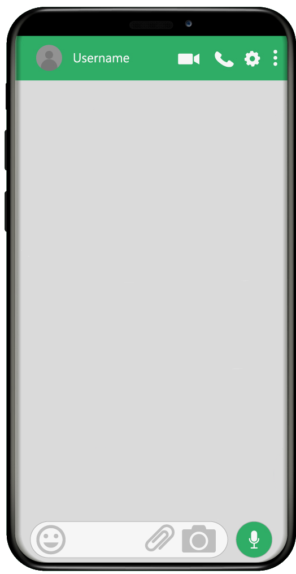
(5)____________________?

No, I don’t. I hate maths.

(4)____________________?

(3)________________ my maths homework?

I’m studying for my science test. And you?

I’m great.

(2)____________________?

Hi 😊(1)________________?

YOU

EMILY

B. Choose one of the topics and write 25-35 words.

OPTION 1
This is Jack’s daily routine. Look at the pictures and write a text about it.
  6:30 |   6:45 | 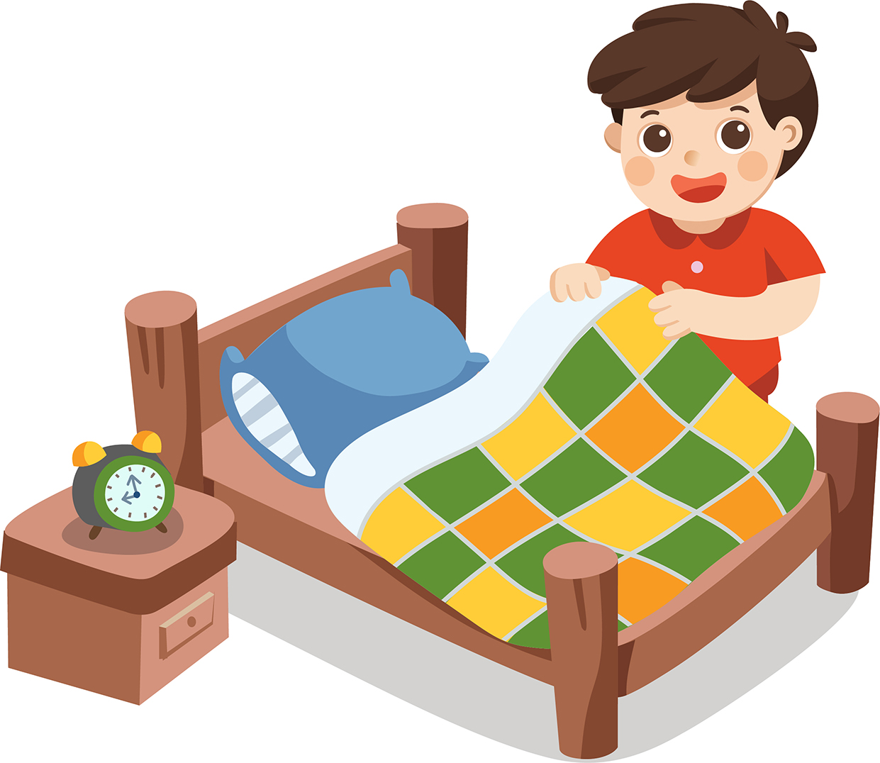
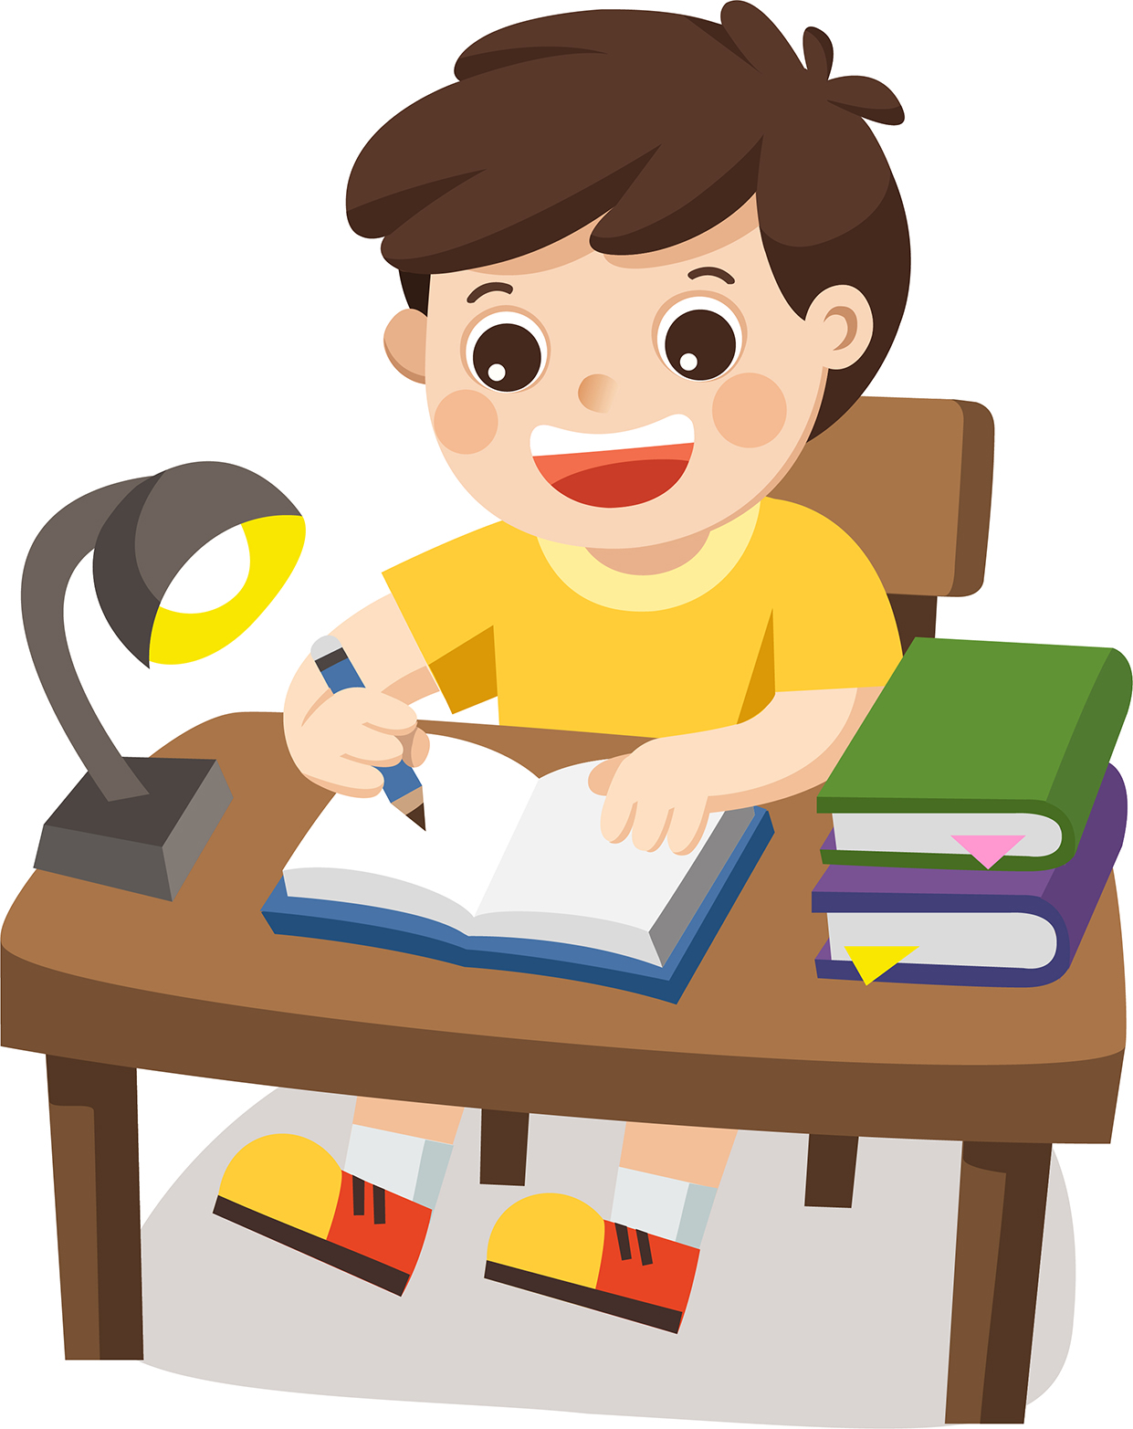  15:00  8:00 | 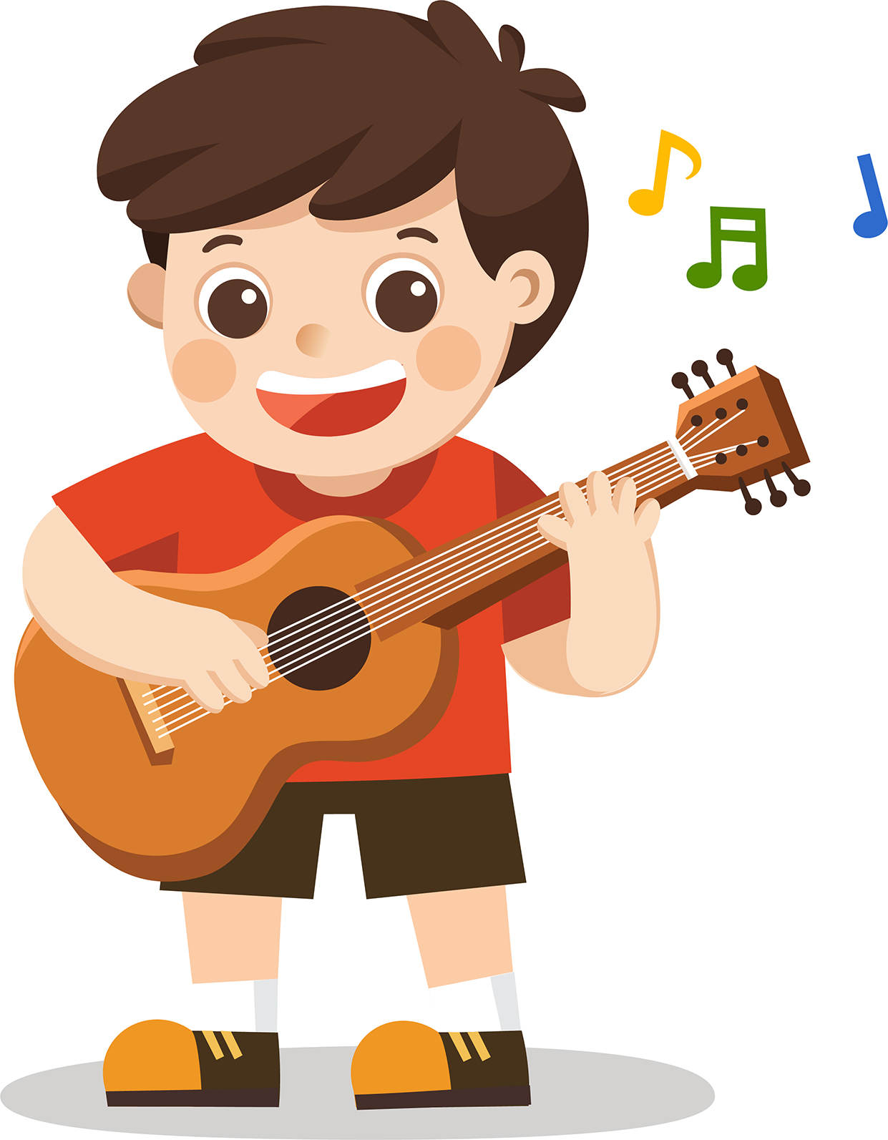  19:30 | 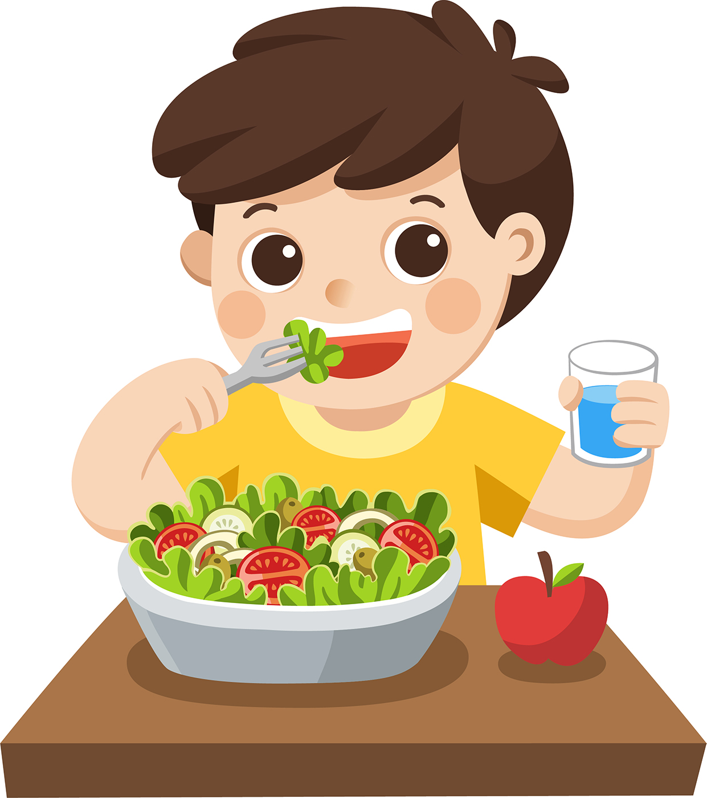
  20:15 | 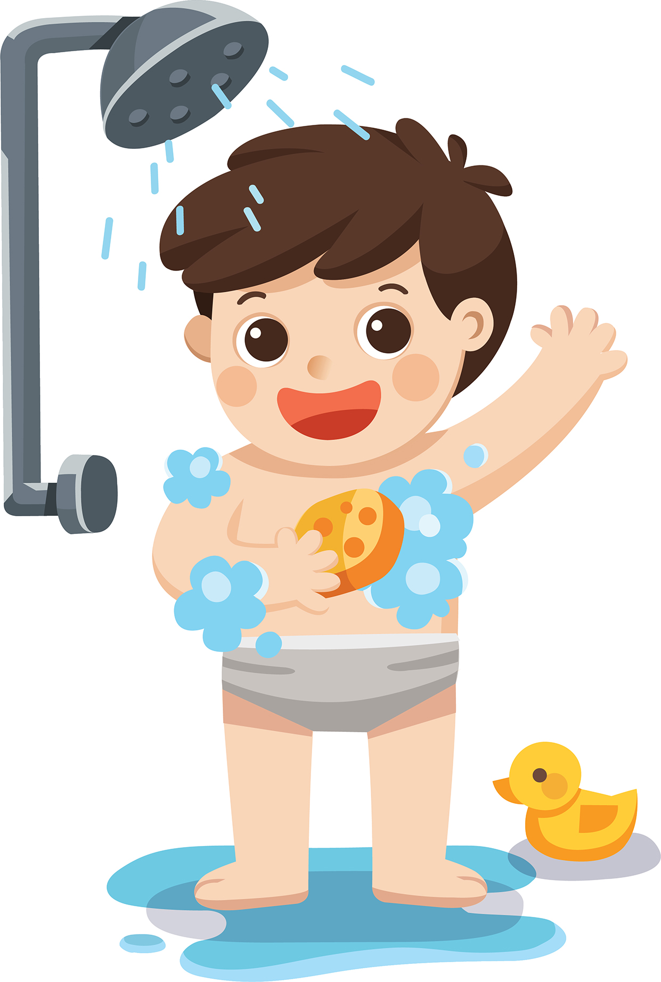  21:00 | 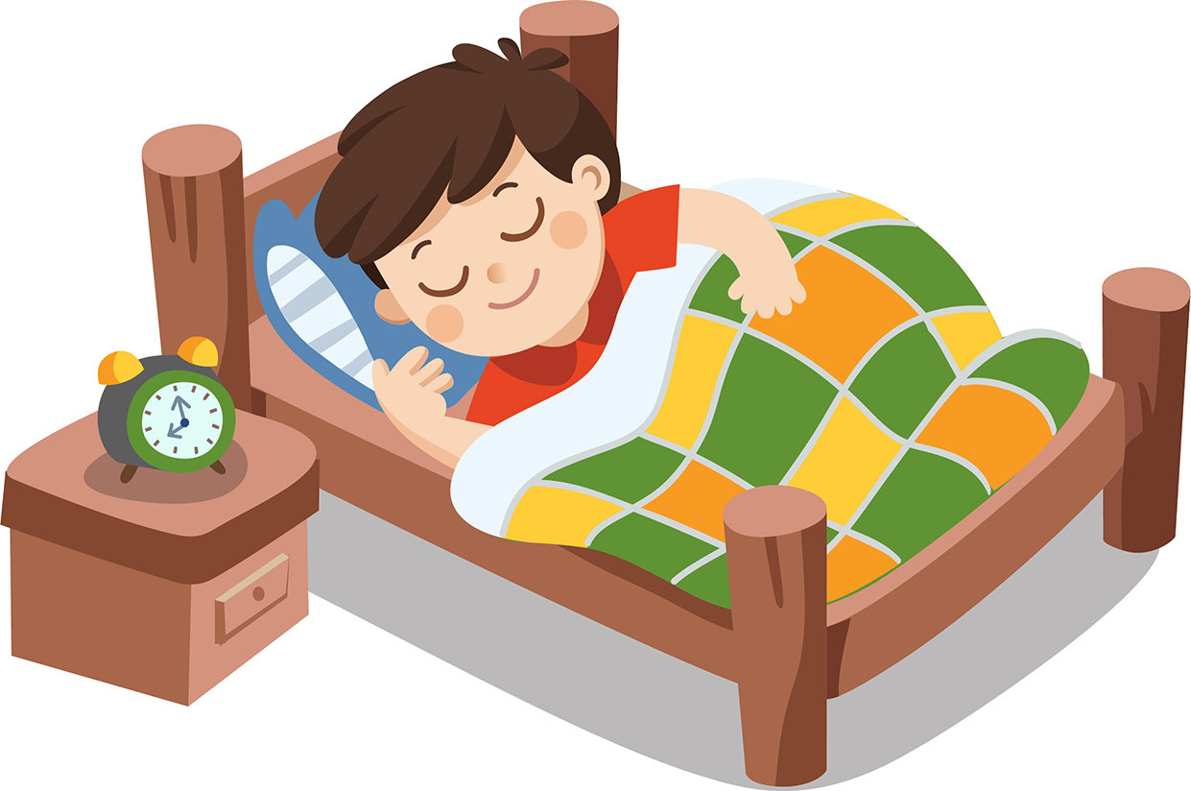
OPTION 2
Imagine this is your school. Write a short text about it.
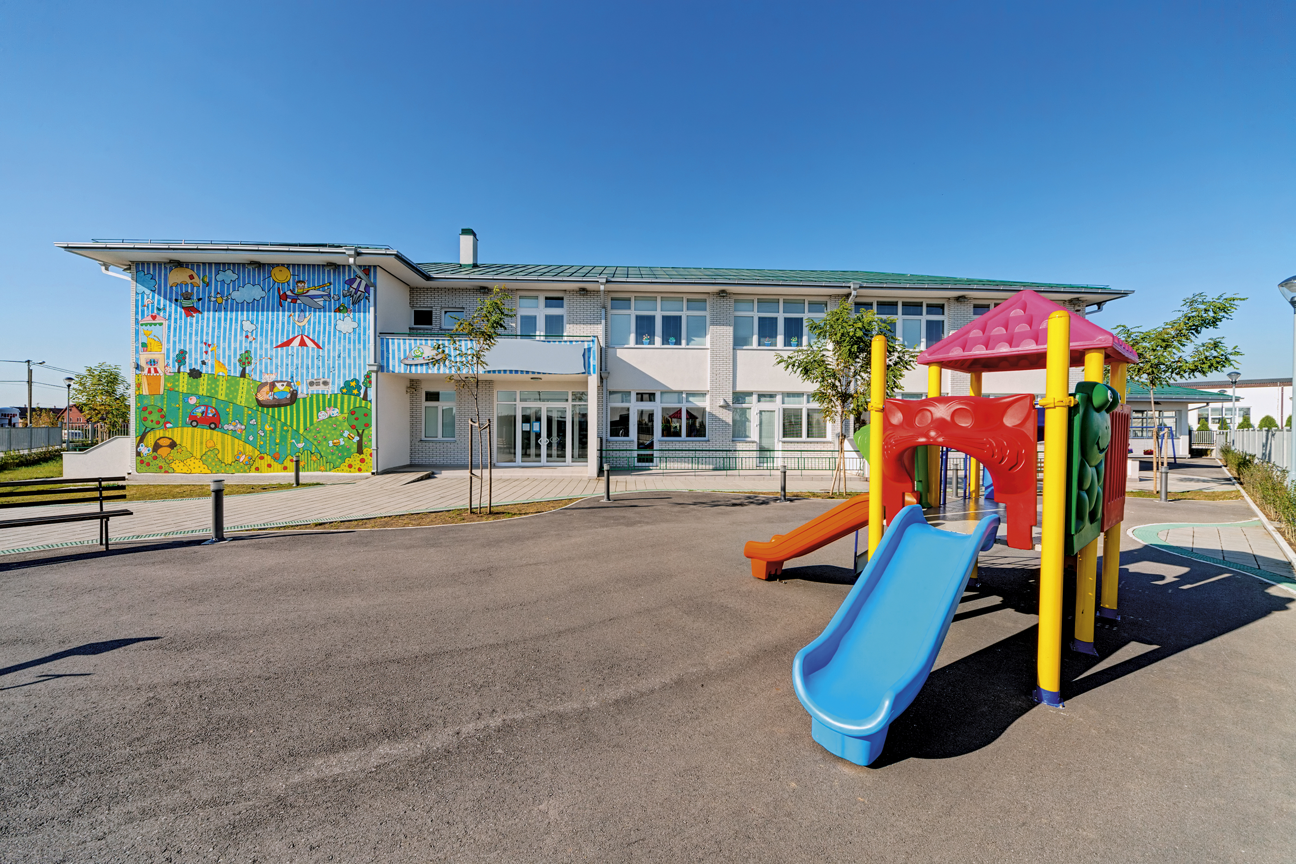

Colour | yellow
Classrooms | 30
Music room | 1
Science labs | 3
Computer rooms | 10

OPTION ______
__________________________________________________________________________
__________________________________________________________________________
__________________________________________________________________________
__________________________________________________________________________
__________________________________________________________________________

