
Unit 2 · 6th grade
Version A
CASA da Aula – Centro de Explicações – www.casadaaula.com
Name: ………………………………..………………………………..………………… Class: …………….. Number: ……………..
Date: ……………..……………..………………………………………………….……. Evaluation: ………………….………………………………………….……..
Teacher: ……………..……………..……………..……………..……………………. E.E.: ……………………………………………………………….……………..
Listening
- Dan is talking to Susan about his school. Listen and choose the correct option.
a. What’s the name of Dan’s school? |  |  |  |  | d. What time is it?
1. Kings Cross Academy |  |  |  |  | 1. 9:30 | 
2. Primrose Hill School |  |  |  |  | 2. 8:40
3. St Aloysius Junior School |  |  |  |  | 3. 9:40
b. What does he like about his school? |  |  |  |  | e. What is he doing?
1. It’s got many computer rooms. |  |  |  |  | 1. He’s studying.
2. It’s in the city centre. |  |  |  |  | 2. He’s texting.
3. It’s got many clubs. |  |  |  |  | 3. He’s taking a photo.
c. His school is …………..….. school in  London. |  |  |  |  | f. Tomorrow he is …………..…...
1. the biggest |  |  |  |  | 1. playing football
2. the oldest |  |  |  |  | 2. going to a concert
3. the best |  |  |  |  | 3. studying

- Complete the information about Dan’s friend.
Name | Susan
Where are they?
What time is it?
Favourite subject
Good at
Bad at

Reading comprehension
Read about Susan’s sister.

My name is Melissa and I go to the same school as my sister
Susan. I like my school. It is not very big, but it has very good
facilities, such as computer rooms, a games room and a big
library.
I’m really keen on working with computers, so I enjoy the
computer coding lessons very much because I learn a lot. I
find these lessons very interesting and not difficult at all. I
also like maths and English because I have very good
teachers, but I think my favourite subject is physical
education.
One of the subjects that I think is boring is history! I really
don’t enjoy these lessons and it is very difficult to remember
all those dates and information.
I like school because I have a lot of good friends there. We do
a lot of things out of school too, like playing video games and
studying together. We are always texting each other and we are never sad.
- Read the text and choose the correct answer.

a. Melissa is talking about …………..…...
 | 1. a famous school | 2. your school | 3. her school
b. Melissa’s school is …………..….. school in New York.
 | 1. not a very big | 2. the biggest | 3. a very small
c. Melissa doesn’t like …………..…...
 | 1. maths | 2. computer lessons | 3. history
d. …………..….. is her favourite subject.
 | 1. Science | 2. Physical education | 3. Maths
e. After school Melissa and her friends …………..…...
 | 1. have computer lessons | 2. play video games | 3. play tennis
f. Melissa and her friends text each other …………..…...
 | 1. once a day | 2. sometimes | 3. all the time

- Find the opposite of the following words in the text.

a. small | b. hate | c. boring | d. easy | e. bad | f. happy
big a | …………..….. | …………..….. | …………..….. | …………..….. | …………..…..

Vocabulary
- Look and read. Then write the correct word.
Examples | In this school subject we study facts from the past. h i s t o r y
 | This is where we have classes. c l a s s r o o m

a. This is where we do indoor sports at school. …… …… ……
b. This is where you have lunch at school. …… …… …… …… …… …… ……
c. This is where you can find books to read. …… …… …… …… …… …… ……
d. In this school subject we study animals and plants. …… …… …… …… …… …… ……
e. This is where you play outside in the school breaks. …… …… …… …… …… …… …… …… …… ……

- What are they doing? Complete the sentences.

 |  |  |  | 
a. He’s listening to music.  ………………………………………………… |  | b. They are …………………  ………………………………………… |  | c. She is ……………………..  ………………………………………
 |  |  |  | 
d. They are ……………………………  ………………………………………………… |  | e. He is …………………………..  ………………………………………… |  | f. I am …………………………….  …………………………………………

Grammar
- Read the text and circle the correct word in the table below.

I love my school and I (1) mmmmmm going to classes every day. I think being at
school is (2) mmmmmm than being on holidays. Holidays are boring!
I am (3) mmmmmm at school and I’m not afraid (4) mmmmmm tests, because
I am keen (5) mmmmmm learning new things. I am (6) mmmmmm interested
(7) mmmmmm science projects (8) mmmmmm the other projects at school. These are
the (9) mmmmmm difficult, but great to learn. I also like science and this is the
(10) mmmmmm subject for me because I think the teacher is (11) mmmmmm than all
the others.
1. | a) hate | b) enjoy | c) enjoys
2. | a) better | b) best | c) worst
3. | a) unhappy | b) saddest | c) happier
4. | a) of | b) if | c) at
5. | a) at | b) in | c) on
6. | a) most | b) more | c) least
7. | a) in | b) of | c) at
8. | a) than | b) the | c) that
9. | a) more | b) most | c) some
10. | a) easy | b) easier | c) easiest
11. | a) better | b) best | c) good



- Complete the sentences with the Present Simple or the Present Continuous.

a. Our school is big, so they are building (build) a swimming pool.
b. The library mmmmmmmmmmm (be) a very quiet place, but when you
mmmmmmmmmmm (talk) you have to leave.
c. Emma mmmmmmmmmmm (have) lunch at home now because she
mmmmmmmmmmm (not / have) lessons in the afternoon.
d. Look! They mmmmmmmmmm (study) while their mother mmmmmmmmmmm (cook) dinner.
e. I usually mmmmmmmmmmm (study) in the library, but today I
mmmmmmmmmmm (work) at home.
f. Ollie mmmmmmmmmmm (like) maths, but now he mmmmmmmmmmm (learn) history
because he has a test tomorrow.
Writing
- Complete the dialogue between John and his mother.

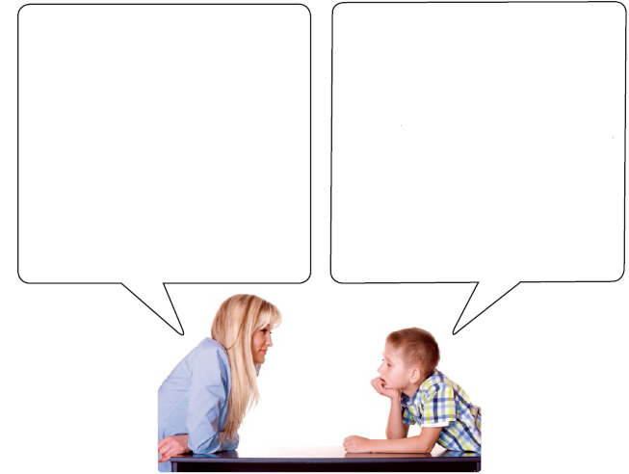
Yes, I do. I love my new school.

a. Classes start at 8:30.
b. My favourite subject is English.
c. No, I don’t like maths.
d. Yes, there is a music room.
e. My best friend is Jack.
Do you like your new school?

a. mmmmmmmmmmmmmmmmmmmmm?
b. mmmmmmmmmmmmmmmmmmmmm?
c. mmmmmmmmmmmmmmmmmmmmm?
d. mmmmmmmmmmmmmmmmmmmmm?
e. mmmmmmmmmmmmmmmmmmmmm?

- Write a short description of your school. Use these topics to help you.
(Write between 25 to 35 words.)
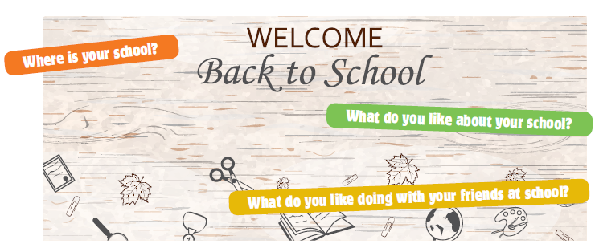

………………………………………………………. Alexandermmmmmmdermmmmmmmddermmm

Unit 2 · 6th grade
Version B
CASA da Aula – Centro de Explicações – www.casadaaula.com
Name: ………………………………..………………………………..………………… Class: …………….. Number: ……………..
Date: ……………..……………..………………………………………………….……. Evaluation: ………………….………………………………………….……..
Teacher: ……………..……………..……………..……………..……………………. E.E.: ……………………………………………………………….……………..
Listening
- Listen and write. There is one example.
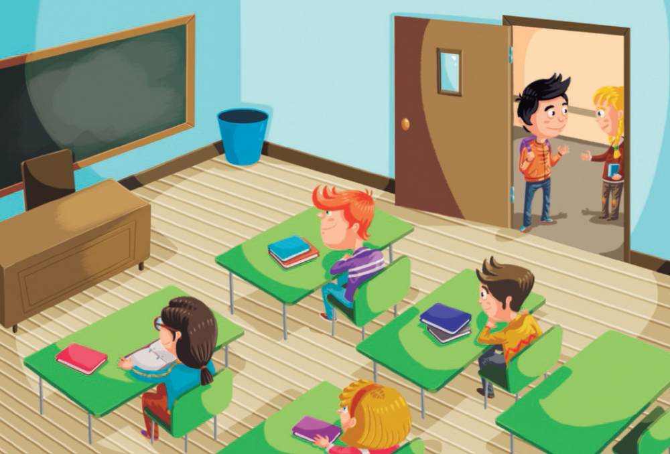

Example | Where is Michael? In the classroom .

Questions
a. What time is it? ………………….………………………………………….……...
b. What’s Michael’s favourite subject? ………………….………………………………………….……...
c. When has Michael got history? ………………….………………………………………….……...
d. What subject does Michael find difficult? ………………….………………………………………….……...
e. Where does Michael have lunch on Fridays? ………………….………………………………………….……...

- Listen and write a number in the box.

Mrs Castle is telling her daughter about some of the students in her class.
Listen and write a number in each box. There is one example.
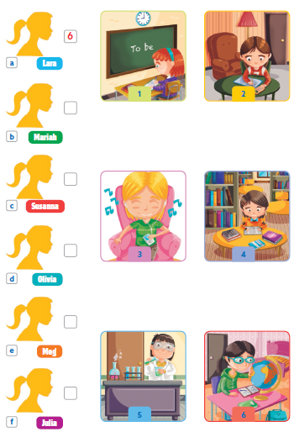

Reading
Look at the pictures and words. Write the correct word. Some words are not necessary.

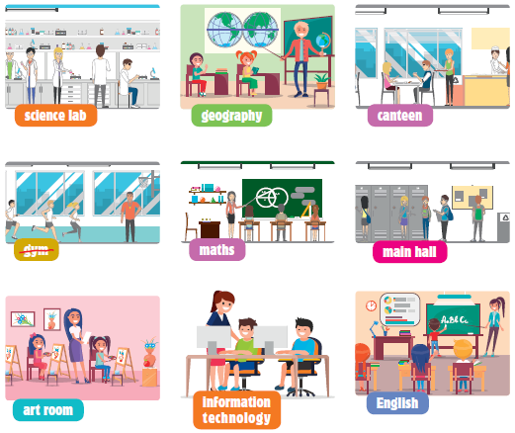
Example | The students have physical education  lessons here. gym a

Questions
a. This is where students draw pictures and paint. ………………….………………………………………….
b. In this lesson students learn a language. ………………….………………………………………….
c. In this room students can try out experiments. ………………….………………………………………….
d. In this subject you study cities and countries, etc. ………………….………………………………………….
e. This is where students usually have their lunch. ………………….………………………………………….
f. This is a subject that teaches students about coding. ………………….………………………………………….

Reading and writing
- Read the story. Choose a word from the boxes. Write the correct word in each space 1-5. Some words are not necessary.
Priscilla’s new school
Priscilla loves her new school. The new school has got a very big
(1) mmmmmm that is full of wonderful books for her to read. Priscilla
goes there every day because that is what the (2) mmmmmm tells all the
students to do.
Priscilla and her class have their own (3) mmmmmm where they grow
vegetables and then they give them to the old age home* opposite their school.
Another place that Priscilla and all the other (4) mmmmmm like is the
(5) mmmmmm because they love their IT teacher and they have lots of fun
in class.
She is very happy at her new school.
*old age home – lar de idosos
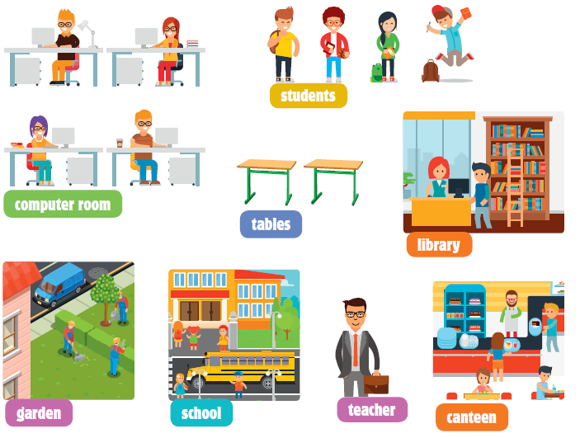

- Read the text, circle the correct words and write them on the lines.
There is one example.
Our computer classes

I am very interested in computers because I want to be a YouTuber.
Computers are one of the greatest inventions of all times! We have lessons
every Monday and I am very keen (1) mmmmmm learning new things.
Mr Cole is always worried (2) mmmmmm our tests because we are
having fun and not doing our work!
Sam is the (3) mmmmmm in our class and he can do everything. He is
making a video game and he is very proud (4) mmmmmm that.
Next week we are learning how to create our own websites and we are all
very (5) mmmmmm about it.
Example | • in | • at | • on

1 | • of | • at | • on
2 | • about | • of | • on
3 | • good | • best | • better
4 | • of | • on | • in
5 | • excited | • keen | • interested

- Look at the pictures and read the story. Write some words to complete the sentences about the story.


A rainy day at school
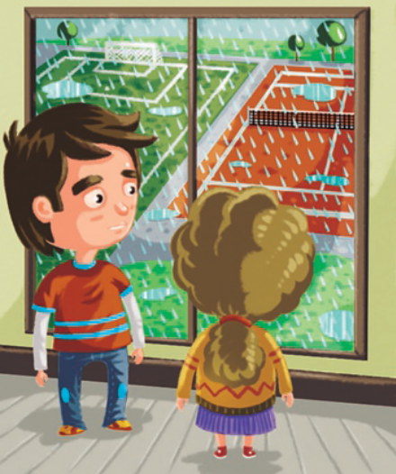
We always have physical education twice a week and I am good at sports, so
I like PE. One lesson is always in the gym and the other is outside. This is the
lesson I like most because I love playing tennis.
“Oh no, Miss Cindy, it’s raining!” says Daisy.
“I know you are upset about not playing outside today, but I have a fun idea!”
says Miss Cindy.
“Really? What are we going to do?” ask the students.

Examples | Daisy loves playing tennis. A
 | The students have PE twice a week. a

Questions
a. One of the lessons is outside and the other is in mmmm mmmmmmmmmmmmmmmmmmm.m.
b. Miss Cindy says the students are upset because they can’t mmmmmmmmmm mmmm.

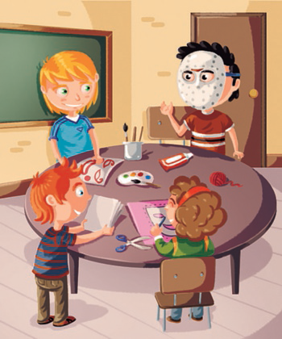

“OK class, we are going to make masks for the parade next week,” says Miss
Cindy.
“Great! I love creating things,” says Jonas.
The students are having so much fun in the art room that Miss Cindy knows
that this is a good idea. The masks are fantastic and the students are really
interested in what they are doing.
The best mask is Janice’s because it’s more colourful and prettier than the
others.
“Ready for the parade?” asks Miss Cindy.
“Yes!” shout the students.

c. The students are making mmmmmmmmmmm mmmm next week.
d. Miss Cindy knows that this mmmmmmmmmmm mmmm because the
students are having so much fun.
e. Janice has mmmmmmmmmmm mmmm in the class.

Writing
Look at the picture, read and write.

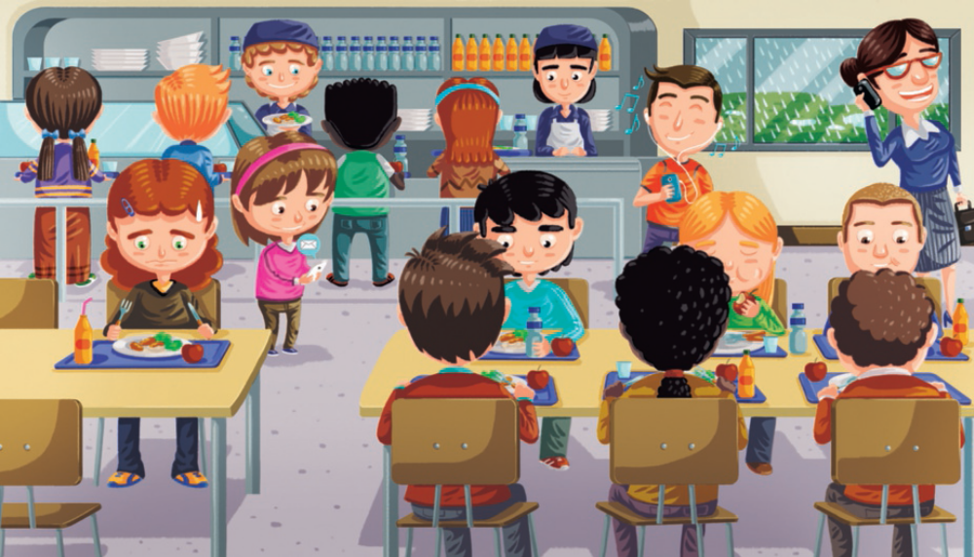

Examples | The children are drinking water and juice .
 | What’s the weather like? It’s raining .

Questions
a. Complete the sentences.
1. The children are in the school mmmmmmmmm mmmmmmmmmm mmmmmmmmmmm mmmmmm m mm.
2. They are having their mmmmmmmmmm mmmmmmmmmmm mmmmmmmmmm mmmmmmmmmmm …m m.
b. Answer the questions.
3. What fruit do they have for lunch today?
mmmmmmmmmm mmmm mmmmmmmmmm mmmmmmmmmmmmmm mmmmmmmmmm mmmmmmmmmmm …m m.
4. How many children are eating at the tables?
mmmmmmmmmm mmmm mmmmmmmmmm mmmmmmmmmmmmmm mmmmmmmmmm mmmmmmmmmmm …m m.
5. What is the teacher doing?
mmmmmmmmmm mmmm mmmmmmmmmm mmmmmmmmmmmmmm mmmmmmmmmm mmmmmmmmmmm …m m.
c. Now write three sentences about the picture (25 to 35 words).
mmmmmmmmmm mmmm mmmmmmmmmm mmmmmmmmmmmmmm mmmmmmmmmm mmmmmmmmmmm …m m
mmmmmmmmmm mmmm mmmmmmmmmm mmmmmmmmmmmmmm mmmmmmmmmm mmmmmmmmmmm …m m
mmmmmmmmmm mmmm mmmmmmmmmm mmmmmmmmmmmmmm mmmmmmmmmm mmmmmmmmmmm …m m

Unit 2 · 6th grade
Version C
CASA da Aula – Centro de Explicações – www.casadaaula.com
Name: ………………………………..………………………………..………………… Class: …………….. Number: ……………..
Date: ……………..……………..………………………………………………….……. Evaluation: ………………….………………………………………….……..
Teacher: ……………..……………..……………..……………..……………………. E.E.: ……………………………………………………………….……………..
Listening
- Dan is talking to Susan about his school. Listen and choose the correct option.
a. What’s the name of Dan’s school? |  |  |  | c. What time is it?
1. Kings Cross Academy |  |  |  | 1. 9:30
2. Primrose Hill School |  |  |  | 2. 8:40
b. His school is …………..….. school in  London. |  |  |  | d. Tomorrow he is …………..…...
1. the biggest |  |  |  | 1. playing football
2. the oldest |  |  |  | 2. studying

- Listen and circle the correct information about Dan’s friend.

a. | Name | Sarah * Susan
b. | Where are they? | canteen * library
c. | What time is it? | 12:30 * 14:30
d. | Favourite subject | maths * geography
e. | Good at | PE * science
f. | Bad at | history * art

Reading comprehension

Read about Susan’s sister.
My name is Melissa.
I like my school. It is not very big, but it has
very good facilities.
I’m really keen on working with computers, so I
enjoy the lessons very much. I also like maths
and English because I have very good teachers,
but I think my favourite subject is physical
education.
One of the subjects that I think is boring is
history! It is very difficult.
After school, my friends and I do a lot of things,
like playing video games and studying together.
We text each other all the time.

Read the text and choose the correct answer.
a. Melissa is talking about …………..…...
 | 1. a famous school | 2. her school
b. Melissa’s school is …………..….. school.
 | 1. not a very big | 2. a very small
c. Melissa doesn’t like …………..…...
 | 1. maths | 2. history
d. …………..….. is her favourite subject.
 | 1. Science | 2. Physical education
e. After school Melissa and her friends …………..…...
 | 1. play video games | 2. play tennis
f. Melissa and her friends text each other …………..…...
 | 1. once a day | 2. all the time

Vocabulary
- Look and write the correct word from the boxes.

 |  | 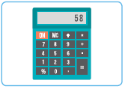 |  | 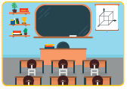
a. English |  | b. …………………………………… |  | c. ……………………………………
 |  |  |  | 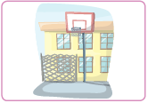
d. …………………………………………… |  | e. ……………………………………… |  | f. ……………………………………

- What are they doing? Complete the sentences with the expressions in the boxes.
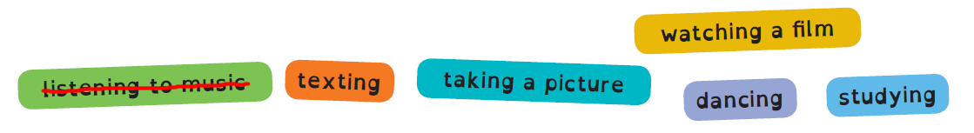
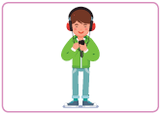 |  |  |  | 
a. He’s listening to music. |  | b. They are ………………… |  | c. She is ……………………..
 |  |  |  | 
d. They are …………………………… |  | e. He is ………………………….. |  | f. I am …………………………….

Grammar
- Look at the picture and complete with the comparative.

a. Anna is sadder than (sad) Tina.
b. John is ………………… (old) Anna.
c. Tina is ………………… (tall) Anna.
d. Tina is ………………… (happy) Anna.
e. Anna is ………………… (young) Tom.
f. Anna is ………………… (short) John.
1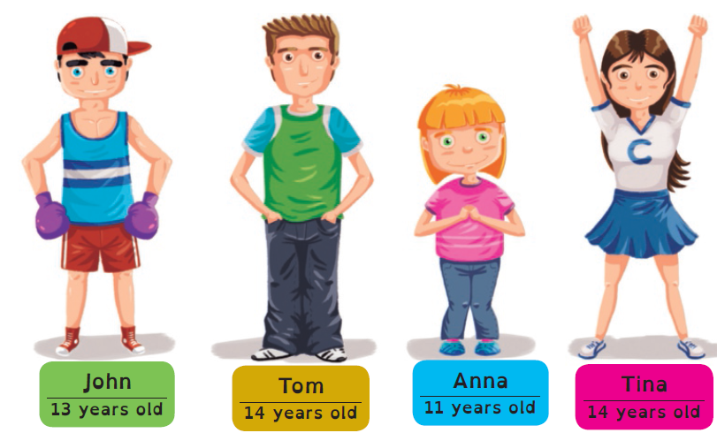

- Complete the sentences with the Present Continuous.


a. John is playing (play) football.
b. Sarah ………………… ………………… (listen) to music.
c. I ………………… ………………… (take) a picture.
d. They ………………… ………………… (dance).
e. Anna ………………… ………………… (watch) television.
f. Ted ………………… ………………… (study) for the test.

Writing
- Complete the dialogue between John and his mother. Match the questions in the box to the answers.

Do you like your new school?  What time do your classes start?  What is your favourite subject? | Is there a music room?  Do you like maths?  Who is your best friend?

Yes, I do. I love my new school.

a. My classes start at 8:30.
b. My favourite subject is English.
c. No, I don’t.
d. Yes, there is.
e. My best friend is Jack.
Do you like your new school?

a. mmmmmmmmmmmmmmmmmmmmm?
b. mmmmmmmmmmmmmmmmmmmmm?
c. mmmmmmmmmmmmmmmmmmmmm?
d. mmmmmmmmmmmmmmmmmmmmm?
e. mmmmmmmmmmmmmmmmmmmmm?

- Answer about you.
a. What’s your favourite subject?
b. Do you like history?
c. What time do your classes start?

