Test specifications | Unit 3 | Now and then!
Version A (Traditional)
Metas Curriculares
Vocabulário  Technology  Famous people  Inventions | Gramática  Connectors  9.3 Usar when.  Verbs  Past Simple – to be, there + to be  Past Simple – regular verbs
Metas / Skills | Questions | Marks |  | Answer key
Listening (10 minutos) |  | 20%
L6. Compreender, com ajuda,  discursos articulados de forma  clara e pausada.  6.1 Entender expressões  relacionadas com os seus  interesses.  6.3 Seguir conversas sobre  assuntos que lhe são familiares  (escola). | 1. Listen and choose the correct option. | 5 x 2 = 10 |  | b. 3; c. 2; d. 3; e. 2; f. 1
 | 2. Complete the information. | 5 x 2 = 10 |  | a. tablet  b. phone  c. computer  d. every day  e. (wireless) headphones
Reading comprehension (10 minutos) |  | 20%
6.4 Identificar a ideia principal e a  informação essencial em textos  diversificados (folhetos, anúncios,  ementas, páginas da internet). | 1. Read the text and choose the correct answer. |  | 5 x 2 = 10 | b. 1; c. 3; d. 2; e. 1; f. 1
 | 2. Complete the sentences according to the text with three words. |  | 5 x 2 = 10 | b. chatting with his  c. was a birthday  d. was old and  e. coming to Alan’s/his school  f. uses the phone
Vocabulary (10 minutos) |  | 20%
10.1 Comparar diferentes rotinas  diárias.  10.2 Identificar disciplinas,  horários e espaços de trabalho e  de lazer na escola. | 1. Label the pictures. |  | 5 x 2 = 10 | a. computer  b. mouse  c. laptop  d. webcam  e. headphones
 | 2. Complete the sentences with the words in the boxes. Some are not  necessary. |  | 5 x 2 = 10 | a. pen drive  b. printer  c. video camera  d. tablet  e. DVD player
Grammar (10 minutos) |  | 20%
Adjectives  9.1 Usar o comparative (regular  and irregular forms).  9.2 Usar o superlative (regular and irregular forms).  Connectors  9.3 Usar when.  Verbs  9.10 Usar os verbos to be, there + to be, to have (got), no Past  Simple, nas formas afirmativa,  negativa e interrogativa. | 1. Complete the sentences with was/were or wasn’t/weren’t. | 10 x 1 = 10 |  | a. Were, wasn’t  b. Was, was  c. Were, weren’t  d. Was, wasn’t  e. were, was
 | 2. Complete the text with the Past Simple. | 10 x 1 = 10 |  | 1. was  2. there was  3. visited  4. There were  5. didn’t have  6. helped  7. arrived  8. was  9. listened  10. danced

Test specifications | Unit 3 | Now and then!
Writing (10 minutos) |  | 20%
7.1 Formular perguntas ou redigir respostas sobre temas estudados.  8.3 Descrever um acontecimento com a ajuda de tópicos ou imagens.  (Talk about a technological object.) | 1. Imagine you are at Alan’s party and you meet Justin Timberlake.  Complete the dialogue. |  | 5 x 2 = 10 | 1. When were you born?  2. Yes, I was.  3. What was the name of your first band?  4. What’s the name of your first album?  5. What’s your favourite song?
 | 2. Write a short description of your  favourite gadget.  Use these topics to help you. |  | 10–8: Escreve entre 25 e 35 palavras, escreve sem erros ortográficos, usa o vocabulário adequado e não dá muitos  erros de gramática.  7–4: Escreve entre 15 e 20 palavras, escreve com alguns erros ortográficos, por vezes usa o vocabulário adequado e dá alguns  erros de gramática.  3–0: Não respeita o número de palavras, escreve com muitos erros ortográficos, não usa o vocabulário adequado e dá  muitos erros de gramática.
TOTAL | 100%

Speaking
Interação oral  SI7. Interagir, com alguma ajuda, com um interlocutor em situações familiares e previamente preparadas.  7.1 Formular perguntas e dar respostas.  7.2 Exprimir sentimentos de agrado e desagrado.  Para avaliar: “Speaking in class – assessment grid”  (Teacher’s File – Tests, p. 125) | Produção oral  SP7. Expressar-se, com vocabulário simples, sobre assuntos familiares do dia a dia  7.5 Descrever acontecimentos e atividades.  7.6 (Re)contar uma pequena história.  Project work: My first (Coursebook, p. 89)  Para avaliar: “Oral presentation – assessment grid”  (Teacher’s File – Tests, pp. 126–128)
Listening scripts
Exercise 1  ALAN: Hi Josie, we’re doing this project on technology together.  JOSIE: Yes, great! I’m really happy about that.  ALAN: Well, let’s look at the first question. I love my smartphone and can’t live without it, but my favourite gadget is my drone!  JOSIE: Oh wow! You’ve got a drone!  ALAN: Yes, it’s great and I have so much fun using it.  JOSIE: Well, you’re lucky, I have a computer and a printer in my room and that’s it!  ALAN: I have that too, but I also have my tablet! I use it to chat and play games.  JOSIE: And which do you find most difficult to use?  ALAN: Well, actually it’s my dad’s video camera because it’s quite old.  JOSIE: Really?? Hahaha!  ALAN: My dad uses his tablet to film when I play football, but I use my smartwatch to control how much I run and things like that. And now for the last question – what are you excited about in the future?  JOSIE: Well, I am interested in robots that clean the house because I hate helping my mother with housework.  ALAN: Me too, but what I’m really excited about is the  self-driving car! | Exercise 2  JOSIE: Alan, you spelt my name wrong, it’s J-O-S-I-E.  ALAN: Sorry, Josie, let’s go to the computer room to find more information.  JOSIE: Well, we can use my tablet to find the information.  ALAN: Good idea. This tablet looks expensive.  JOSIE: It was, but the most expensive gadget I have is my phone.  ALAN: Is your phone your favourite gadget?  JOSIE: No, I like my computer because I can do so many things with it. I can chat with my friends and create graphic art work.  ALAN: How often do you use your phone?  JOSIE: Well, every day, but I only use it to phone people.  ALAN: Really? I do everything on my phone – call, text, play games… I don’t need anything else.  JOSIE: I do… I want to buy the new wireless headphones that come out tomorrow!

Test specifications | Unit 3 | Now and then!
Version B (Cambridge)
Metas Curriculares
Vocabulário  Technology  Famous people  Inventions | Gramática  Connectors  9.3 Usar when.  Verbs  Past Simple – to be, there + to be  Past Simple – regular verbs
Metas / Skills | Questions | Marks |  | Answer key
Listening (10 minutos) |  | 20%
L6. Compreender, com ajuda,  discursos articulados de forma  clara e pausada.  6.1 Entender expressões  relacionadas com os seus  interesses.  6.3 Seguir conversas sobre  assuntos que lhe são familiares  (escola). | 1. Listen and tick. | 5 x 2 = 10 |  | a. 1  b. 2  c. 2  d. 3  e. 1
 | 2. Listen and write a number in each box. | 5 x 2 = 10 |  | b. 4  c. 2  d. 5  e. 3  f. 6
Reading (10 minutos) |  | 12%
6.2 Interpretar instruções e informação específica em  documentos (anúncios, horários). | Look at the pictures and words. Write the correct word. |  | 6 x 2 = 12 | a. laptop  b. mobile phone  c. webcam  d. pen drive  e. printer  f. headphones
Reading and writing (10 minutos) |  | 35%
6.4 Identificar a ideia principal e a  informação essencial em textos  diversificados (folhetos, anúncios,  ementas, páginas da internet).  10.1 Comparar diferentes rotinas  diárias.  10.2 Identificar disciplinas, horários e espaços de trabalho e  de lazer na escola.  Connectors  9.3 Usar when.  Verbs  9.10 Usar os verbos to be, there + to be, to have (got), no Past  Simple, nas formas afirmativa,  negativa e interrogativa. | 1. Read the story. Choose a word from the box. Write the correct word in each space 1–6. |  | 5 x 2 = 10 | 2. films  3. remote control  4. tablet  5. social media  6. mobile phone
 | 2. Read the text and choose the right words and write them on the  lines. |  | 5 x 2 = 10 | 1. were  2. When  3. was  4. weren’t  5. but
 | 3. Look at the pictures and read the story. Write some words to complete the sentences about the story. |  | 5 x 3 = 15 | a. They make videos.  b. David.  c. Listening to music or chatting with her friends.  d. It was raining.  e. They played football in the garden.

Test specifications | Unit 3 | Now and then!
Writing (20 minutos) |  | 33%
Connectors  9.3 Usar when.  Verbs  9.10 Usar os verbos to be, there + to be, to have (got), no Past  Simple, nas formas afirmativa,  negativa e interrogativa. | 1. Look at the picture, read and write.  1.1 Complete the sentences.  1.2 Answer the questions. |  | 5 x 3 = 15 | a. the computer box.  b. the car.  c. The boy and his father.  d. It falls on the ground.  e. No, they don’t
 | 1.3 Now write three sentences about the picture (25 to 35 words). |  | 3 x 6 = 18 | (Any sentence is correct as long as it’s about the picture.)  The father puts the computer on the boy’s desk.  The headphones are next to the computer.  There is a tablet on the bed.
TOTAL | 100%

Speaking
Interação oral  SI7. Interagir, com alguma ajuda, com um interlocutor em situações familiares e previamente preparadas.  7.1 Formular perguntas e dar respostas.  7.2 Exprimir sentimentos de agrado e desagrado.  Para avaliar: “Speaking in class – assessment grid”  (Teacher’s File – Tests, p. 125) | Produção oral  SP7. Expressar-se, com vocabulário simples, sobre assuntos familiares do dia a dia.  7.5 Descrever acontecimentos e atividades.  7.6 (Re)contar uma pequena história.  Project work: My first (Coursebook, p. 89)  Para avaliar: “Oral presentation – assessment grid”  (Teacher’s File – Tests, pp. 126–128)
Listening scripts
Exercise 1  JENNY: Did you have a nice weekend, Mark?  MARK: Yeah, it was great! I was in Amsterdam with my parents and my sister.  JENNY: Wow! Was it cool?  MARK: Really cool. You know I’m a geek, so we visited the famous Amsterdam Computer Museum.  JENNY: That doesn’t sound exciting! What did you see?  MARK: Well, first we watched a short film about the  history of the keyboard and I discovered who invented it!  JENNY: Really? Who was it?  MARK: Christopher Sholes. He was American.  JENNY: Interesting!  MARK: There was also a tour of the museum. The guide talked about the first headphones and even showed us some very old ones from 1910.  JENNY: But didn’t you do anything… fun?  MARK: Of course! We played a game on one of the oldest laptops.  JENNY: Now that sounds like fun! | Exercise 2  MAN: Right, before we finish our lesson today let’s talk about the project. I’d like you to find out some facts about a gadget – when it was invented, who invented it and so on. I’d like you to do a project about CDs. Wait, no, John, you do your project on the webcam, okay?  BOY 1: OK, Mr Oscar, my project is about the webcam.  MAN: Now, who wants to do the project on the tablet?  Yes, I know you all want to do it, but I think Charlie should do it. Charlie, do you agree?  BOY 2: Yes, Mr Oscar. The tablet. That sounds great.  MAN: Ryan, I think you can do one about laptops, but I know that you love your phone, so you can do the project about smartphones.  BOY 3: Smartphones. Cool!  MAN: Matt, the tablet is for Charlie, so you can do the… laptop. Is that OK, Matt?  BOY 4: The laptop? That should be interesting.  MAN: Angelina, you like watching TV, so I think you should do a project about the television.  GIRL: The TV? Great!  MAN: Right Alex, so that leaves the… webcam for you. Oh, no, that is John. You can do the project on the compact disc. Is that okay, Alex?  BOY 5: Sure. I can do the compact disc.

Test specifications | Unit 3 | Now and then!
Version C (NEE)
Metas Curriculares
Vocabulário  Technology  Famous people  Inventions | Gramática  Connectors  9.3 Usar when.  Verbs  Past Simple – to be, there + to be  Past Simple – regular verbs
Metas / Skills | Questions | Marks |  | Answer key
Listening (10 minutos) |  | 20%
L6. Compreender, com ajuda,  discursos articulados de forma  clara e pausada.  6.1 Entender expressões  relacionadas com os seus  interesses.  6.3 Seguir conversas sobre  assuntos que lhe são familiares  (escola). | 1. Listen and choose the correct option. | 5 x 2 = 10 |  | b. 2  c. 1  d. 2  e. 2  f. 1
 | 2. Circle the correct information. | 5 x 2 = 10 |  | a. tablet  b. phone  c. computer  d. every day  e. headphones
Reading comprehension (10 minutos) |  | 20%
6.4 Identificar a ideia principal e a  informação essencial em textos  diversificados (folhetos, anúncios,  ementas, páginas da internet). | 1. Read the text and choose the correct answer. |  | 5 x 2 = 10 | b. 1  c. 2  d. 2  e. 1  f. 1
 | 2. Complete the sentences according to the text with the  expressions in the boxes. |  | 5 x 2 = 10 | b. chatting with his friends  c. a birthday present  d. was old and black  e. coming to his school  f. uses the phone too much
Vocabulary (10 minutos) |  | 20%
10.1 Comparar diferentes rotinas  diárias.  10.2 Identificar disciplinas,  horários e espaços de trabalho e  de lazer na escola. | 1. Label the pictures. Use the words in the boxes. |  | 5 x 2 = 10 | a. computer  b. mouse  c. laptop  d. webcam  e. headphones
 | 2. Complete the  sentences with the words  in the boxes. |  | 5 x 2 = 10 | a. pen drive  b. printer  c. video camera  d. tablet  e. DVD player

Test specifications | Unit 3 | Now and then!
Grammar (10 minutos) |  | 20%
Adjectives  9.1 Usar o comparative (regular  and irregular forms).  9.2 Usar o superlative (regular and irregular forms).  Connectors  9.3 Usar when.  Verbs  9.10 Usar os verbos to be, there + to be, to have (got), no Past  Simple, nas formas afirmativa,  negativa e interrogativa. | 1. Circle the correct option. | 5 x 2 = 10 |  | a. Were, wasn’t  b. Was, was  c. Were, weren’t  d. Was, wasn’t  e. were, was
 | 2. Rewrite the sentences using  the Past Simple. | 5 x 2 = 10 |  | a. Justin Timberlake was in our school.  b. There was a concert in our school.  c. Justin arrived in the morning.  d. We all helped in our school.  e. We danced a lot.
Writing (10 minutos) |  | 20%
7.1 Formular perguntas ou redigir respostas sobre temas estudados. | Imagine you meet  Justin Timberlake.  Complete the  dialogue. |  | 5 x 4 = 20 | a. When were you born?  b. Yes, I was.  c. What was the name of your first band?  d. What’s the name of your first album?  e. What’s your favourite song?
TOTAL | 100%

Speaking
Interação oral  SI7. Interagir, com alguma ajuda, com um interlocutor em situações familiares e previamente preparadas.  7.1 Formular perguntas e dar respostas.  7.2 Exprimir sentimentos de agrado e desagrado.  Para avaliar: “Speaking in class – assessment grid”  (Teacher’s File – Tests, p. 125) | Produção oral  SP7. Expressar-se, com vocabulário simples, sobre assuntos familiares do dia a dia.  7.5 Descrever acontecimentos e atividades.  7.6 (Re)contar uma pequena história.  Project work: My first (Coursebook, p. 89)  Para avaliar: “Oral presentation – assessment grid”  (Teacher’s File – Tests, pp. 126–128)
Listening scripts
Exercise 1  ALAN: Hi Josie, we’re doing this project on technology together.  JOSIE: Yes, great! I’m really happy about that.  ALAN: Well, let’s look at the first question. I love my smartphone and can’t live without it, but my favourite gadget is my drone!  JOSIE: Oh wow! You’ve got a drone!  ALAN: Yes, it’s great and I have so much fun using it.  JOSIE: Well, you’re lucky, I have a computer and a printer in my room and that’s it!  ALAN: I have that too, but I also have my tablet! I use it to chat and play games.  JOSIE: And which do you find most difficult to use?  ALAN: Well, actually it’s my dad’s video camera because it’s quite old.  JOSIE: Really?? Hahaha!  ALAN: My dad uses his tablet to film when I play football, but I use my smartwatch to control how much I run and things like that. And now for the last question – what are you excited about in the future?  JOSIE: Well, I am interested in robots that clean the house because I hate helping my mother with housework.  ALAN: Me too, but what I’m really excited about is the self-driving car! | Exercise 2  JOSIE: Alan, you spelt my name wrong, it’s J-O-S-I-E.  ALAN: Sorry, Josie, let’s go to the computer room to find more information.  JOSIE: Well, we can use my tablet to find the information.  ALAN: Good idea. This tablet looks expensive.  JOSIE: It was, but the most expensive gadget I have is my phone.  ALAN: Is your phone your favourite gadget?  JOSIE: No, I like my computer because I can do so many things with it. I can chat with my friends and create graphic art work.  ALAN: How often do you use your phone?  JOSIE: Well, every day, but I only use it to phone people.  ALAN: Really? I do everything on my phone – call, text, play games… I don’t need anything else.  JOSIE: I do… I want to buy the new wireless headphones that come out tomorrow!


Unit 3 · 6th grade
Version A
Agrupamento …………………………………………………………………………………………………………………………………………………………………..
Name: ………………………………..………………………………..………………… Class: …………….. Number: ……………..
Date: ……………..……………..………………………………………………….……. Evaluation: ………………….………………………………………….……..
Teacher: ……………..……………..……………..……………..……………………. E.E.: ……………………………………………………………….……………..
Listening
- Alan is talking to Josie about the technology he uses. Listen and choose the correct option.
a. What’s Alan’s favourite gadget? |  |  |  |  | d. What gadget does Alan find  the most difficult to use?
1. A smartphone. |  |  |  |  | 1. A smartphone.
2. A tablet. |  |  |  |  | 2. A smart watch.
3. A drone. |  |  |  |  | 3. A video camera.
b. What does he like about this  gadget? |  |  |  |  | e. What equipment does he use when he goes to football  training?
1. It can do a lot of things. |  |  |  |  | 1. His smartphone.
2. It can go where he wants. |  |  |  |  | 2. His smart watch.
3. It’s fun to use. |  |  |  |  | 3. His tablet.
c. What equipment does Alan  have in his room? |  |  |  |  | f. What technology is Alan  excited about in the future?
1. A computer, a laptop and  a tablet. |  |  |  |  | 1. A self-driving car.
2. A computer, a printer and  a tablet. |  |  |  |  | 2. Robots.
3. A computer and a tablet. |  |  |  |  | 3. A flying car.


- Complete the information about Alan’s friend.
Name | Josie
What does she use?
Most expensive gadget
Favourite gadget
How often does she use her phone?
What does she want to buy?

Reading comprehension
Read the text.

My mobile phone
I really like my mobile phone. I’m always texting or chatting with my
friends. It’s great to be connected with all my friends. I use Instagram,
Snapchat and Messenger. I think I send 50 text messages a day, so I use a lot
of emojis to write faster.
This mobile phone was a present for my birthday and it was my first phone.
At first, I didn’t like it because it was black and old, but
then I started to use it and now I can’t live without it.
Yesterday, for example, I used my phone to take
photos for a school project, so I used my phone to
study, and today I’m using my phone to take photos
of Justin Timberlake. He is visiting my school.
My parents tell me not to use the phone too much.
They say that I spend more time looking at my
phone than talking to my friends face to face. Well, I
agree, but I really enjoy using my phone. Don’t you?
- Read the text and choose the correct answer.
a. Alan loves his mobile phone because he likes to…………..…...
 | 1. see his family | 2. communicate with  his friends | 3. use social media
b. He sends a lot of …………..….. every day.
 | 1. text messages | 2. emails | 3. texts
c. He uses emojis because …………..…...
 | 1. he likes the  pictures | 2. his friends use it | 3. he wants to write  more quickly
d. He …………..….. a black mobile phone.
 | 1. always wanted | 2. didn’t want | 3. didn’t get
e. Yesterday he used his phone to …………..…...
 | 1. study | 2. play | 3. call a friend
f. His parents think that it’s better to …………..….. than to use the phone all the time.
 | 1. spend time with  friends | 2. look at the phone | 3. study

- Complete the sentences about the text with three words.
a. Alan loves his mobile phone .
b. Alan is always texting or …………..….. …………..….. …………..….. friends.
c. Alan’s mobile …………..….. …………..….. …………..….. present.
d. Alan’s first mobile phone …………..….. …………..….. …………..….. black.
e. Justin Timberlake is …………..….. …………..….. …………..….. school.
f. Alan’s parents don’t like it when he …………..….. …………..….. …………..….. too much.

Vocabulary

- Label the pictures.

 | 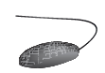 |  |  | 
a. …………..….. | b. …………..….. | c. …………..….. | d. …………..….. | e. …………..…..

- Complete the sentences with the words in the boxes. Some are not necessary.

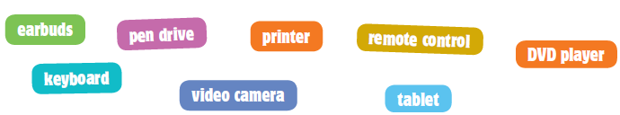

a. Give me my …………..….…………..….... I want to save this document.
b. I can’t print the document because there is no paper in the …………..….…………..…....
c. Let’s take the …………………..…..…..….. and film the school play and then watch it.
d. I’ve got many apps on my …………..….…………..…....
e. Have you got a …………………..…..…..…. .at home? I’d like to watch a film.

Grammar
- Complete the sentences with was/were or wasn’t/weren’t.
a. …………………..…..…..…. you at the concert yesterday? No, I …………………..…..…..…..
b. …………………..…..…..…. Jane online last night? Yes, she …………………..…..…..…..
c. …………………..…..…..…. they in the school library yesterday? No, they …………………..…..…..…..
d. …………………..…..…..…. Alan in New York last summer? No, he …………………..…..…..…..
e. When …………………..…..…..…. you born? I …………………..…..…..…. born on 5th October 2007.

- Complete the text with the Past Simple.


Yesterday, Justin Timberlake (1) …………………..…..…..…. (be) at our school because
(2) …………………..…..…..…. (there to be) a singing competition. Then he
(3) …………………..…..…..…. (visit) our town. (4) …………………..…..…..…. (there to be)
thousands of people there.
We (5) …………………..…..…..…. (not/have) classes because we had to prepare the
stage and the decorations. We all (6) …………………..…..…..…. (help). Then Justin
(7) …………………..…..…..…. (arrive). It (8) …………………..…..…..…. (be) a wonderful day:
we (9) …………………..…..…..…. (listen) to music and (10) …………………..…..…..…. (dance)
all day long.

Writing

- Imagine you are at Alan’s party and you meet Justin Timberlake. Complete the dialogue.
You: What’s your full name?
Justin: My name is Justin Randall Timberlake.
You: (1) …………………..……………………..…..…..……..…..….
………………………..…..……….………………..…..…..…. ?
Justin: I was born on 31st January 1981.
You: Were you born in the USA?
Name | Justin Randall Timberlake
Born | 31st January 1981
Hometown | Tennessee, USA
Name of first band | ’N SYNC
First album | Justified
Favourite song | Can’t stop the feeling
Justin: Yes, (2) ………………..……………………..………..
You: (3) …………………..……………………..…..…..……..…..….
………………………..…..……….………………..…..…..…. ?
Justin: It was ’N SYNC.
You: (4) …………………..……………………..…..…..……..…..….
………………………..…..……….………………..…..…..…. ?
Justin: It’s “Justified.”
You: (5) …………………..……………………..…..…..….....…..….
………………………..…..……….………………..…..…..…. ?
Justin: My favourite song is “Can’t stop the feeling”.
You: Thanks for the interview. I love your music!
Justin: Thanks! Here’s an autograph!
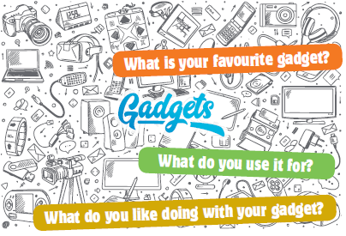

- Write a short description
of your favourite gadget.
Use these topics to help
you. (Write between
25 to 35 words.)

………………………………………………………. Alexandermmmmmmdermmmmmmmddermmm

Unit 3 · 6th grade
Version B
Agrupamento …………………………………………………………………………………………………………………………………………………………………..
Name: ………………………………..………………………………..………………… Class: …………….. Number: ……………..
Date: ……………..……………..………………………………………………….……. Evaluation: ………………….………………………………………….……..
Teacher: ……………..……………..……………..……………..……………………. E.E.: ……………………………………………………………….……………..
Listening
- Mark is talking about last weekend. Listen and tick.
a. Where did he go last weekend?
 |  |  | 
b. What did he visit last weekend?
 |  |  | 
c. He watched a film about…
 |  | 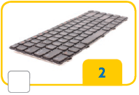 | 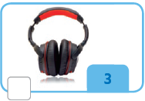
d. The guide talked about…
 | 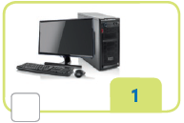 |  | 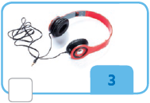
e. While he was there, he played…
 |  |  | 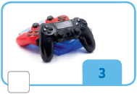

- Mr Oscar is talking to the students about their next class project. Listen and write a number in each box. There is one example.

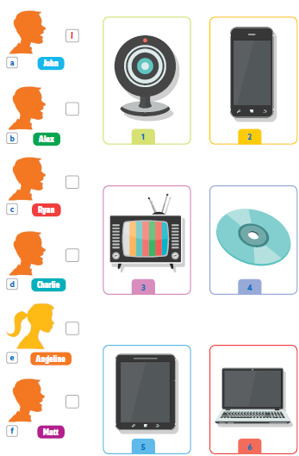

Reading
Look at the pictures and words. Write the correct word. Some words are not necessary.

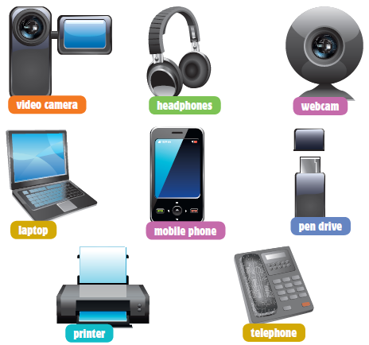

Example | You have this in the house to make  phone calls. telephone_

Questions
a. It’s a small and portable computer. …………………..……………………..…..…..…..…..….
b. This is a device to make phone calls and to text. …………………..……………………..…..…..…..…..….
c. You use this to see the person when you talk
to them on the internet. …………………..……………………..…..…..…..…..….
d. You can save a lot of documents, videos and
pictures in this small device. …………………..……………………..…..…..…..…..….
e. This is used if you want a document or a picture
on paper. …………………..……………………..…..…..…..…..….
f. You use these on your ears to listen to music. …………………..……………………..…..…..…..…..….

Reading and writing
- Read the story. Choose a word below. Write the correct word in each space 1 to 6. Some words are not necessary.


Karl’s new tablet
Karl’s parents know that he loves technology and gadgets, so what
should they buy him for his birthday? Karl’s dad wants to buy a new
(1) television because the one he has in his room is small and old and he
loves watching his favourite (2) …………………..…………, but he also needs a new
(3) …………………..………… to change the channels. His mother thinks that he would
prefer a (4) …………………..…………to play video games and use (5) …………………..………… to
chat with his friends.
But his brother thinks that Karl really wants a new (6) …………………..………… to call
and text his friends. What do you think?

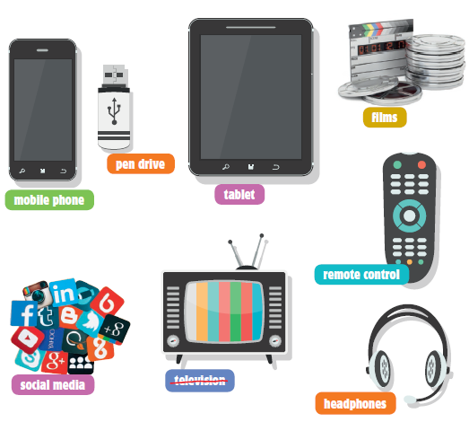

- Read the text and choose the correct words and write them on the lines.
There is one example.

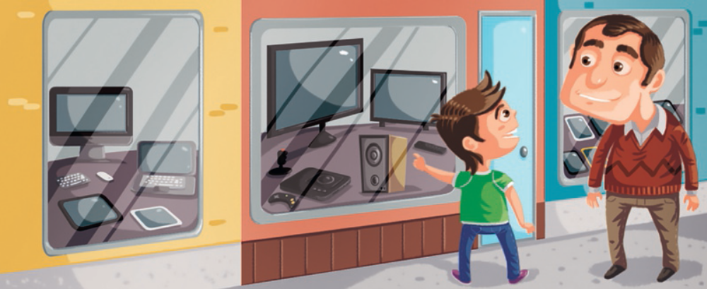

The best technology shops in the world
I’m a geek! Last year I was in Japan with my dad and there were so many
shops with fantastic gadgets. It was amazing!
There (1) …………………..………… about 100 electronics shops on one street!
(2) …………………..………… we arrived at shop number 20, dad (3) …………………..…………
already tired, but my brother and I (4) …………………..………….
We wanted to visit all the shops, (5) …………………..………… we were very hungry, so
we decided to go to McDonald’s. Then we visited 70 shops!

Example | • were | • was | • wasn’t

1 | • was | • were | • wasn’t
2 | • When | • While | • Where
3 | • weren’t | • were | • was
4 | • was | • weren’t | • were
5 | • and | • then | • but

- Look at the pictures and read the story. Write some words to complete the sentences about the story.

A rainy weekend
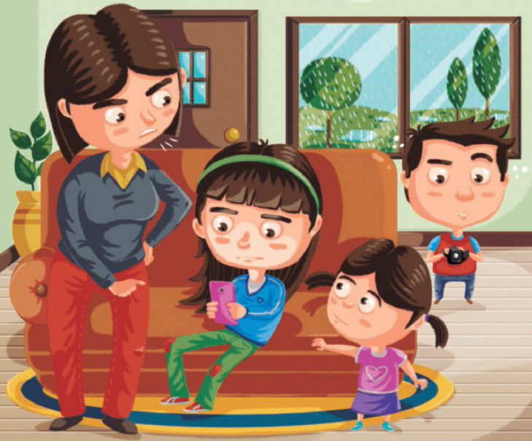
It’s raining, so the children can’t play outside. Helen is twelve years old and
she has a brother and a sister. They like making videos at the weekend.
“Come and help us make a video!” they said to Helen.
Helen doesn’t like filming and prefers listening to music or chatting with her
friends on her smartphone. Her mother is always saying “Get off the phone,
Helen, and go have fun with Grace and David.”

Example | How old is Helen? twelve__

Questions
- What do her brother and sister do at the weekend? …………………..…………………………..…………...…
…………………..…………………………..……………………………..……………………………..……………………………..……………………………..……………
- What is Helen’s brother’s name? …………………..…………………..…………………………………………………..…………...…
…………………..…………………………..……………………………..……………………………..……………………………..……………………………..……………
- What does Helen like doing on her smartphone? ………………………..…………………………..…………...…
…………………..…………………………..……………………………..……………………………..……………………………..……………………………..……………

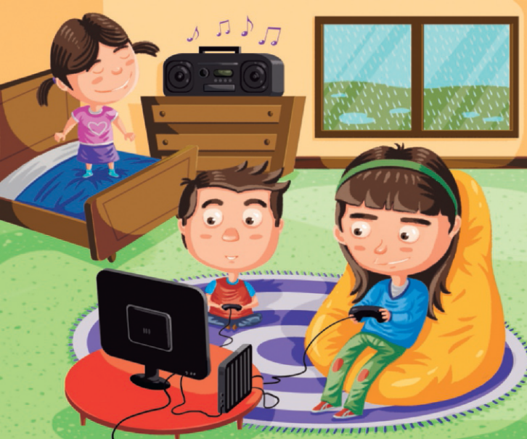

On Sunday morning, it was still raining and the weather was terrible to go
out with her friends. Helen decided that her mother was right, so she called
Grace and David to her room. “I don’t want to make a video, but we can listen
to music and play games. What do you think?” “Yes!” said Grace.
They sat in Helen’s room and listened to music and played video games.
At 3 pm it was sunny again, so they played football in the garden.

- What was the weather like on Sunday morning? ………….……………..…………………………..…………...…
…………………..…………………………..……………………………..……………………………..……………………………..……………………………..……………
- What did they do in the afternoon? ………………………………..………………..……..…………………………..…………...…
…………………..…………………………..……………………………..……………………………..……………………………..……………………………..……………

Writing
- Look at the pictures, read and write.
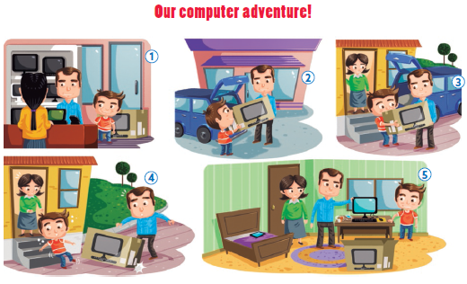
Examples | They are going to buy a computer____
 | Are the boy and his father happy? Yes, they are.___

1.1. Complete the sentences.
a. While dad is paying, the boy is near ….……………..…………………………..…………...…
b. The boy and his father put the computer in ….……………..…………………………..…………...…
1.2. Answer the questions.
c. Who carries the computer to the house? ….……………..…………………………..…………...…
d. What happens to the computer? ….……………..…………………………..…………...…
e. Do they break the computer? ….……………..…………………………..…………...…
1.3. Now write three sentences about picture number 5 (25 to 35 words).
………………………………………………………. Alexandermmmmmmdermmmmmmmddermmm

Unit 3 · 6th grade
Version C
Agrupamento …………………………………………………………………………………………………………………………………………………………………..
Name: ………………………………..………………………………..………………… Class: …………….. Number: ……………..
Date: ……………..……………..………………………………………………….……. Evaluation: ………………….………………………………………….……..
Teacher: ……………..……………..……………..……………..……………………. E.E.: ……………………………………………………………….……………..
Listening
- Alan is talking to Josie about the technology he uses. Listen and choose the correct option.
a. What’s Alan’s favourite gadget? |  |  |  |  | d. What gadget does Alan find  the most difficult to use?
1. A tablet. |  |  |  |  | 1. A smart watch.
2. A drone. |  |  |  |  | 2. A video camera.
b. What does he like about this  gadget? |  |  |  |  | e. What equipment does he use when he goes to football  training?
1. It can go where he wants. |  |  |  |  | 1. His smartphone.
2. It’s fun to use. |  |  |  |  | 2. His smartwatch.
c. What equipment does Alan  have in his room? |  |  |  |  | f. What technology is Alan  excited about in the future?
1. A computer, a printer and  a tablet. |  |  |  |  | 1. A self-driving car.
2. A computer and a tablet. |  |  |  |  | 2. Robots.

- Circle the correct information about Alan’s friend.
Name | Jane * Josie
What does she use? | a. laptop * tablet
Most expensive gadget | b. phone * computer
Favourite gadget | c. tablet * computer
How often does she  use her phone? | d. sometimes * every day
What does she want to  buy? | e. headphones * a new phone

Reading comprehension
Read the text.
My mobile phone
I really like my mobile phone. I’m always texting my friends. I use
Instagram, Snapchat and Messenger. I think I send 50 text messages
a day.
This mobile phone was a present for my
birthday. My first phone! I didn’t like it
because it was black and old, but now I
can’t live without it.
Yesterday, for example, I used my phone to
take photos for a school project, and today
I’m using my phone to take photos of Justin
Timberlake. He is visiting my school!
My parents tell me not to use the phone
too much and spend more time talking to
my friends face to face. Well, I agree, but I
really enjoy using my phone. Don’t you?
- Read the text and choose the correct answer.

a. Alan loves his mobile phone because he likes to…………..…...
 | 1. see his family | 2. communicate with his friends
b. He sends a lot of …………..….. every day.
 | 1. text messages | 2. emails
c. He uses emojis because …………..…...
 | 1. he likes the pictures | 2. he wants to write more quickly
d. He …………..….. a black mobile phone.
 | 1. always wanted | 2. didn’t want
e. Yesterday he used his phone to …………..…...
 | 1. study | 2. play
f. His parents think that it’s better to …………..….. than to use the phone all the time.
 | 1. spend time with friends | 2. study

- Complete the sentences about the text with the expressions in the boxes.
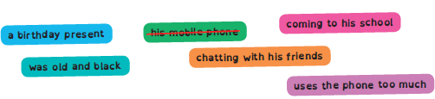
a. Alan loves his mobile phone .
b. Alan is always texting and …………..……………..…...
c. Alan’s mobile was …………..……………..…...
d. Alan’s first mobile phone …………..……………..…...
e. Justin Timberlake is …………..……………..…...
f. Alan’s parents don’t like it when he …………..……………..…...

Vocabulary
- Label the pictures. Use the words in the boxes.

 |  |  |  | 
a. …………..….. | b. …………..….. | c. …………..….. | d. …………..….. | e. …………..…..

- Complete the sentences with the words in the boxes.

a. Give me my …………..….…………..….... I want to save this document.
b. I can’t print the document because there is no paper in the …………..….…………..…....
c. Let’s take the …………………..…..…..….. and film the school play and then watch it.
d. I’ve got many apps on my …………..….…………..…....
e. Have you got a …………………..…..…..…. at home? I’d like to watch a film.

Grammar
- Circle the correct option.

a. Was / Were you at the concert yesterday? No, I wasn’t / weren’t.
b. Was / Were Jane online last night? Yes, she was / were.
c. Was / Were they in the school library yesterday? No, they wasn’t / weren’t.
d. Was / Were Alan in New York last summer? No, he wasn’t / weren’t.
e. When was / were you born? I was / were born on 5th October 2007.

- Rewrite the sentences using the Past Simple. Follow the example.


Example | Justin Timberlake visits our town.  Justin Timberlake visited our town.

a. Justin Timberlake is in our school.
…………………..…………………………..……………………………..……………………………..……………………………..……………………………..…………….
b. There is a concert in our school.
…………………..…………………………..……………………………..……………………………..……………………………..……………………………..…………….
c. Justin arrives in the morning.
…………………..…………………………..……………………………..……………………………..……………………………..……………………yesterday.
d. We all help in our school.
…………………..…………………………..……………………………..……………………………..……………………………..……………………………..…………….
e. We dance a lot.
…………………..…………………………..……………………………..……………………………..……………………………..……………………………..…………….

Writing
Imagine you are at Alan’s party and you meet Justin
Timberlake.
Yes, I was.
What’s your full name?
What’s your favourite song?
When were you born?
What was the name of your first band?
What’s the name of your first album?
Complete the dialogue. Use the questions in the box.

You: What’s your full name?
Name | Justin Randall  Timberlake
Born | 31st January 1981
Hometown | Tennessee, USA
Name of  first band | ’N SYNC
First album | Justified
Favourite  song | Can’t stop the  feeling
Justin: My name is Justin Randall Timberlake.
You: (1) ………………………..…..……….………………..…..…..…. ?
Justin: I was born on 31st January
1981.
You: Were you born in the USA?
Justin: (2) ………………..……………………..………..
You: (3) ………………………..…..……….………………..…..…..…. ?
Justin: It was ’N SYNC.
You: (4) ………………………..…..……….………………..…..…..…. ?
Justin: It’s “Justified.”
You: (5) ………………………..…..……….………………..…..…..…. ?
Justin: My favourite song is “Can’t stop the feeling”.
You: Thanks for the interview. I love your music!
Justin: Thanks! Here’s an autograph!

