Test specifications | Unit 4 | Around town
Version A (Traditional)
Metas Curriculares
Vocabulário  Public places  Asking for directions  Shops  Ordering food at the restaurant | Gramática  Prepositions of movement  Past Simple: irregular verbs (affirmative, negative and interrogative)  Would like / Want
Metas / Skills | Questions | Marks |  | Answer key
Listening (10 minutos) |  | 20%
L6. Compreender, com ajuda,  discursos articulados de forma  clara e pausada.  6.1 Entender expressões  relacionadas com os seus  interesses.  6.2 Entender informações e  perguntas que lhe são dirigidas.  6.3 Seguir conversas sobre  assuntos que lhe são familiares. | 1. Listen and choose the correct option. | 5 x 2 = 10 |  | b. 3; c. 1; d. 1;  e. 3; f. 3
 | 2. Answer the questions. | 5 x 2 = 10 |  | a. magazine  b. Fiona  c. email  d. no  e. old houses
Reading comprehension (10 minutos) |  | 20%
6.4 Identificar a ideia principal e a  informação essencial em textos  diversificados (folhetos, anúncios,  ementas, páginas da internet). | 1. Choose the correct answer. |  | 5 x 2 = 10 | b. 2; c. 1; d. 2;  e. 3; f. 1
 | 2. Answer the questions. |  | 5 x 2 = 10 | a. (She lives in) Sydney.  b. (She’s) Her/Fiona’s cousin.  c. (She usually goes there) Every summer.  d. She jumped and swam in the lake.  e. Yes, it is.
Vocabulary (10 minutos) |  | 20%
9.1 Associar nacionalidades a  países.  10.1 Comparar diferentes rotinas  diárias.  10.6 Comparar formas de socialização familiar e convenções sociais: horários e refeições. | 1. Label the pictures. |  | 5 x 2 = 10 | a. florist’s  b. train station  c. bookshop  d. bakery  e. chemist’s
 | 2. Look and read. Then write the correct word. |  | 5 x 2 = 10 | a. post office  b. police station  c. library  d. greengrocer’s (supermarket)  e. cinema
Grammar (10 minutos) |  | 20%
Prepositions  9.8 Usar across, through, towards (movement).  Verbs  9.10 Usar os verbos to be, there + to be, to have (got), no Past  Simple, nas formas afirmativa,  negativa e interrogativa.  9.11 Usar verbos regulares e  irregulares mais frequentes, no  Past Simple, nas formas  afirmativa, negativa e  interrogativa.  9.12 Usar o verbo to do, como  auxiliar, no Past Simple, nas formas negativa e interrogativa. | 1. Look at the picture below. Read the dialogue and underline the correct option. | 5 x 2 = 10 |  | 1. right  2. opposite  3. up  4. left  5. through
 | 2. Complete the sentences with the Past Simple. | 10 x 1 = 10 |  | a. wrote, didn’t have  b. went, sent  c. bought, loved  d. did, studied  e. didn’t go, was

Test specifications | Unit 4 | Around town
Writing (10 minutos) |  | 20%
7.1 Formular perguntas ou redigir respostas sobre temas estudados.  8.3 Descrever um acontecimento com a ajuda de tópicos ou imagens.  (A description of what you did last weekend.) | 1. Read the dialogue in a restaurant and write the questions. |  | 5 x 2 = 10 | a. How much is the lasagne?  b. Would you like a salad?/Would you like anything else?  c. How much is the pizza?  d. Would you like anything to drink?  e. How much is the total?/ Can I have the bill?
 | 2. Imagine you are writing to a friend to tell him/her what you did last weekend. Write an email. |  | 10–8: Escreve entre 25 e 35 palavras, escreve sem erros ortográficos, usa o vocabulário adequado e não dá muitos  erros de gramática.  7–4: Escreve entre 15 e 20 palavras, escreve com alguns erros ortográficos, por vezes usa o vocabulário adequado e dá alguns  erros de gramática.  3–0: Não respeita o número de palavras, escreve com muitos erros ortográficos, não usa o vocabulário adequado e dá  muitos erros de gramática.
TOTAL | 100%

Speaking
Interação oral  SI7. Interagir, com alguma ajuda, com um interlocutor em situações familiares e previamente preparadas.  7.1 Formular perguntas e dar respostas.  7.2 Exprimir sentimentos de agrado e desagrado.  Para avaliar: “Speaking in class – assessment grid”  (Teacher’s File – Tests, p. 125) | Produção oral  SP7. Expressar-se, com vocabulário simples, sobre assuntos familiares do dia a dia.  7.5 Descrever acontecimentos e atividades.  7.6 (Re)contar uma pequena história.  Project work: Writing a story and finishing it  (Coursebook, p. 113)  Para avaliar: “Oral presentation – assessment grid”  (Teacher’s File – Tests, pp. 126–128)
Listening scripts
Exercise 1  FIONA: Is your school far from your house, Mandy?  MANDY: No, you just go across the bridge and turn right and it is on your left.  FIONA: I need to go to a chemist’s to buy sunscreen. Can we go?  MANDY: No problem. It is not far from my school. It is opposite the bank.  FIONA: Is there a swimming pool here?  MANDY: Yes. It’s a bit far, but if you want to walk you have to go past the post office, turn left at the bus station and it’s about 100 metres on the right.  FIONA: I also need to send some postcards, so which is the quickest way to the post office?  MANDY: Well, I think the quickest way is across the bridge. No, actually, the quickest way is past the greengrocer’s on Station Road.  FIONA: I’d like to get some pens and books for my sister.  MANDY: I know just the place. Nate’s bookshop. It’s close to the new school, but you have to cross the bridge, then go straight up the road and it’s on the right.  FIONA: Now, for the most important, Mandy. I would like to buy new clothes.  MANDY: That’s easy. There are many shops up the road, but my favourite one is past the stadium. | Exercise 2  This art exhibition is the latest by the graffiti artist Bordalo II. Mandy saw his art work in a magazine and I bought tickets. She didn’t come with me, so she doesn’t know we are going. It’s a surprise. I wrote an email to the organiser and reserved the tickets. I saw a lot of his work on buildings and bridges. He creates all his pieces of art with recycled material. For me his best works are always on old houses. It’s amazing!

Test specifications | Unit 4 | Around town
Version B (Cambridge)
Metas Curriculares
Vocabulário  Public places  Asking for directions  Shops  Ordering food at the restaurant | Gramática  Prepositions of movement  Past Simple: irregular verbs (affirmative, negative and interrogative)  Would like / Want
Metas / Skills | Questions | Marks |  | Answer key
Listening (15 minutos) |  | 20%
L6. Compreender, com ajuda,  discursos articulados de forma  clara e pausada.  6.1 Entender expressões  relacionadas com os seus  interesses.  6.2 Entender informações e  perguntas que lhe são dirigidas.  6.3 Seguir conversas sobre  assuntos que lhe são familiares. | 1. Listen and write. | 5 x 2 = 10 |  | 1. hotel  2. newspaper  3. £2.50  4. bookshop  5. train station
 | 2. Listen and write a number in each box. | 5 x 2 = 10 |  | b. Faith – 3  c. Fred – 6  d. Naida – 4  e. Abdul – 2  f. Victor – 5
Reading and writing (20 minutos) |  | 47%
6.2 Interpretar instruções e informação específica em documentos (anúncios, horários).  6.3 Entender mensagens.  6.4 Identificar a ideia principal e a informação essencial em textos  diversificados (folhetos, anúncios,  ementas, páginas da internet).  Prepositions  9.8 Usar across, through, towards (movement).  Verbs  9.10 Usar os verbos to be, there + to be, to have (got), no Past  Simple, nas formas afirmativa,  negativa e interrogativa. | 1. Read the sentences and write the correct word. |  | 5 x 2 = 10 | a. library  b. clothes shop  c. bakery  d. optician’s  e. airport
 | 2. Read the story. Choose a word from the boxes. Write the correct word in each space 1–6. |  | 6 x 2 = 12 | 1. bridge  2. newsagent’s  3. bookshop  4. greengrocer’s  5. butcher’s  6. shoe shop
 | 3. Read the text and choose the right words and write them on the  lines. |  | 5 x 2 = 10 | 1. turn  2. go  3. up  4. on  5. ahead
 | 4. Look at the pictures and read the story. Write some words to complete the sentences about the story. |  | 5 x 3 = 15 | a. Museum (of Science)  b. (too) big  c. lunch  d. players  e. (some) souvenirs, a shirt

Test specifications | Unit 4 | Around town
Writing (15 minutos) |  | 33%
W8. Produzir textos de 25 a 35  palavras.  8.3 Descrever um acontecimento  com a ajuda de tópicos ou  imagens. | 1. Look at the picture, read and write.  1.1 Complete the sentences.  1.2 Answer the questions. |  | 5 x 3 = 15 | a. across  b. school  c. pet shop  d. £30  e. Yummy
 | 1.3 Now write three sentences about the picture (25 to 35 words). |  | 3 x 6 = 18 | (Any sentence is correct as long as it’s about the picture.)  Jack is buying a bus ticket.  The supermarket is next to the school.  There is a bus on the street.
TOTAL | 100%

Speaking
Interação oral  SI7. Interagir, com alguma ajuda, com um interlocutor em situações familiares e previamente preparadas.  7.1 Formular perguntas e dar respostas.  7.2 Exprimir sentimentos de agrado e desagrado.  Para avaliar: “Speaking in class – assessment grid”  (Teacher’s File – Tests, p. 125) |  | Produção oral  SP7. Expressar-se, com vocabulário simples, sobre assuntos familiares do dia a dia.  7.5 Descrever acontecimentos e atividades.  7.6 (Re)contar uma pequena história.  Project work: Writing a story and finishing it  (Coursebook, p. 113)  Para avaliar: “Oral presentation – assessment grid”  (Teacher’s File – Tests, pp. 126–128)
Listening scripts
Exercise 1  Example  WOMAN: Hello, I’d like a ticket to see the new exhibition. How much are the tickets?  MAN: The exhibition is £3.50 and the museum is £5.00.  WOMAN: Can I have one for the exhibition for £3.50? Thank you.  Dialogue 1  WOMAN: Mr Johnson, did you sleep well? Was your room comfortable?  MAN: Yes, thank you. Where’s Bob’s café?  WOMAN: When you walk out, turn right and go past the bank and it is the next shop.  Dialogue 2  MAN: Good morning, Dora.  WOMAN: Good morning, Bob. I’d like the newspaper and a car magazine for Joe.  Dialogue 3  WOMAN: How much is the paper and the magazine?  MAN: The newspaper is £1.50, and the magazine is £2.50. So the total is £4.00.  Dialogue 4  WOMAN: Hello Keith, I see you bought a new book. What did you buy?  MAN: The new book by Vix Mason. The bookshop has a lot of new books.  Dialogue 5  WOMAN: Excuse me, can you tell me the way to the train station?  MAN: Sure. Go straight ahead past the school and the post office, turn left and the train station is just behind the post office. |  | Exercise 2  MUM: Abbey, did you go to the cinema last weekend?  ABBEY: No, I went to the clothes shop to buy some jeans.  MUM: And what did you do last weekend, Faith?  FAITH: I went to buy food for our rabbit at the pet shop.  MUM: And you, Fred, what did you do at the weekend?  FRED: Well, on Saturday I went to the circus and on Sunday I went to the airport to pick up my friend.  MUM: Naida, did you go to the supermarket this weekend to buy things for the party?  NAIDA: No, I didn’t. I went to the library to finish the school project.  MUM: Abdul, did you get the eggs from the supermarket for me?  ABDUL: Yes, Mum, I went to the supermarket on the way home.  MUM: Victor, did you buy a present for Claire’s birthday on Sunday?  VICTOR: Yes, I did. I bought some flowers from the florist’s.
Test specifications | Unit 4 |  | Around town
Version C (NEE)
Metas Curriculares
Vocabulário  Public places  Asking for directions  Shops  Ordering food at the restaurant | Gramática  Prepositions of movement  Past Simple: irregular verbs (affirmative, negative and interrogative)  Would like / Want
Metas / Skills | Questions |  | Marks |  | Answer key
Listening (10 minutos) |  |  | 20%
L6. Compreender, com ajuda,  discursos articulados de forma  clara e pausada.  6.1 Entender expressões  relacionadas com os seus  interesses.  6.2 Entender informações e  perguntas que lhe são dirigidas.  6.3 Seguir conversas sobre  assuntos que lhe são familiares. | 1. Listen and choose the correct option. |  | 5 x 2 = 10 |  | b. 2  c. 1  d. 1  e. 2  f. 2
 | 2. Answer the questions. |  | 5 x 2 = 10 |  | b. artist  c. in a magazine  d. Fiona  e. an email  f. no
Reading comprehension (10 minutos) |  |  | 20%
6.4 Identificar a ideia principal e a  informação essencial em textos  diversificados (folhetos, anúncios,  ementas, páginas da internet). | 1. Read the text and choose the correct answer. |  |  | 5 x 2 = 10 | b. 2; c. 1; d. 2;  e. 1; f. 2
 | 2. Read the text and complete the sentences. |  |  | 5 x 2 = 10 | a. grandparents, bookshop  b. twelve (12)  c. lake; hot
Vocabulary (10 minutos) |  |  | 20%
9.1 Associar nacionalidades a  países.  10.1 Comparar diferentes rotinas  diárias.  10.6 Comparar formas de socialização familiar e convenções sociais: horários e refeições. | 1. Label the pictures with the words in the boxes. |  |  | 5 x 2 = 10 | a. florist’s  b. train station  c. bookshop  d. bakery  e. chemist’s
 | 2. Look and read. Then write the correct word. |  |  | 5 x 2 = 10 | a. post office  b. police station  c. library  d. greengrocer’s (supermarket)  e. cinema
Grammar (10 minutos) |  |  | 20%
Prepositions  9.8 Usar across, through, towards (movement).  Verbs  9.10 Usar os verbos to be, there + to be, to have (got), no Past  Simple, nas formas afirmativa,  negativa e interrogativa.  9.11 Usar verbos regulares e  irregulares mais frequentes, no  Past Simple, nas formas  afirmativa, negativa e  interrogativa.  9.12 Usar o verbo to do, como  auxiliar, no Past Simple, nas formas negativa e interrogativa. | 1. Look at the picture below. Read the dialogue and underline the correct option. |  | 5 x 2 = 10 |  | 1. right  2. next to  3. up  4. left  5. through
 | 2. Circle the correct option. |  | 10 x 1 = 10 |  | a. wrote, didn’t have  b. went, sent  c. bought, loved  d. did, studied  e. didn’t go, was

Test specifications | Unit 4 | Around town
Writing (10 minutos) |  | 20%
7.1 Formular perguntas ou redigir respostas sobre temas estudados.  8.3 Descrever um acontecimento com a ajuda de tópicos ou imagens.  (A description of what you did last weekend) | Read the dialogue  in a restaurant and  write the  questions. |  | 5 x 4 = 20 | a. How much is the lasagne?  b. Would you like a salad?/Would you like anything else?  c. How much is the pizza?  d. Would you like anything to drink?  e. How much is the total?/Can I have the bill?
TOTAL | 100%

Speaking
Interação oral  SI7. Interagir, com alguma ajuda, com um interlocutor em situações familiares e previamente preparadas.  7.1 Formular perguntas e dar respostas.  7.2 Exprimir sentimentos de agrado e desagrado.  Para avaliar: “Speaking in class – assessment grid”  (Teacher’s File – Tests, p. 125) | Produção oral  SP7. Expressar-se, com vocabulário simples, sobre assuntos familiares do dia a dia.  7.5 Descrever acontecimentos e atividades.  7.6 (Re)contar uma pequena história.  Project work: Writing a story and finishing it  (Coursebook, p. 113)  Para avaliar: “Oral presentation – assessment grid”  (Teacher’s File – Tests, pp. 126–128)
Listening scripts
Exercise 1  FIONA: Is your school far from your house, Mandy?  MANDY: No, you just go across the bridge and turn right and it is on your left.  FIONA: I need to go to a chemist’s to buy sunscreen. Can we go?  MANDY: No problem. It is not far from my school. It is opposite the bank.  FIONA: Is there a swimming pool here?  MANDY: Yes. It’s a bit far, but if you want to walk you have to go past the post office, turn left at the bus station and it’s about 100 metres on the right.  FIONA: I also need to send some postcards, so which is the quickest way to the post office?  MANDY: Well, I think the quickest way is across the bridge. No, actually, the quickest way is past the greengrocer’s on Station Road.  FIONA: I’d like to get some pens and books for my sister.  MANDY: I know just the place. Nate’s bookshop. It’s close to the new school, but you have to cross the bridge, then go straight up the road and it’s on the right.  FIONA: Now, for the most important, Mandy. I would like to buy new clothes.  MANDY: That’s easy. There are many shops up the road, but my favourite one is past the stadium. | Exercise 2  This art exhibition is the latest by the graffiti artist Bordalo II. Mandy saw his art work in a magazine and I bought tickets. She didn’t come with me, so she doesn’t know we are going. It’s a surprise. I wrote an email to the organiser and reserved the tickets. I saw a lot of his work on buildings and bridges. He creates all his pieces of art with recycled material. For me his best works are always on old houses. It’s amazing!


Version A
Unit 4 · 6th grade
Agrupamento …………………………………………………………………………………………………………………………………………………………………..
Name: ………………………………..………………………………..………………… Class: …………….. Number: ……………..
Date: ……………..……………..………………………………………………….……. Evaluation: ………………….………………………………………….……..
Teacher: ……………..……………..……………..……………..……………………. E.E.: ……………………………………………………………….……………..
Listening
- Fiona is talking to her cousin Mandy from the USA. She is visiting her town. Listen and choose the correct option.
a. To go to school, Mandy  walks… |  |  |  |  | d. What’s the fastest way to  the post office?
1. across the bridge. |  |  |  |  | 1. Past the greengrocer’s. | 
2. through a tunnel. |  |  |  |  | 2. Across the bridge.
3. straight ahead. |  |  |  |  | 3. Up the road.
b. Where’s the chemist’s? |  |  |  |  | e. Which is the easiest way to  the bookshop?
1. Opposite the school. |  |  |  |  | 1. Turn right.
2. Opposite the post office. |  |  |  |  | 2. Go straight down the road.
3. Opposite the bank. |  |  |  |  | 3. Go straight up the road.
c. To get to the local swimming  pool they have to… |  |  |  |  | f. Where is Mandy’s favourite  shop?
1. walk past the post office. |  |  |  |  | 1. Up the road.
2. turn right at the bus station. |  |  |  |  | 2. Down the road.
3. turn left at the post office. |  |  |  |  | 3. Past the stadium.


- Listen to Fiona talking to her friend about the exhibition and answer the questions.
What do they want to visit? | an art exhibition
Where did Mandy see Bordalo’s work? | - in a
Who bought the tickets?
What did Fiona write? | - an
Does Mandy know that she is going?
Where did Fiona see his best work? | - on

Reading comprehension
Read about Fiona’s favourite city.

My favourite city
I really like my mother’s hometown. She was born in Canberra, the capital of
Australia. It has a lot of gardens because they think natural spaces are
important. We live in Sydney, but we go to Canberra every summer to see
my grandparents.
This year I went there at the end of January. My grandparents took me to
the local bookshop to buy a new book by my favourite author. Then we
visited the National Gallery. The gallery is opposite mum’s old school.
I also went to the swimming pool with my cousins who live in Canberra.
When I was there, my cousin Samantha turned 12, so we had a picnic near
Lake Burley Griffin for her birthday. There were a lot of her school friends
there too. We jumped in the lake and swam a lot because it was very hot.
We had a lot of fun in the park. Then I went to the cinema with my cousins
and my aunt.
My mother showed me her old school and told me great stories.
Canberra is a beautiful city with a big lake and it has bridges to go from one
side of the city to the other. I want to go back again next summer!
- Read the text and choose the correct answer.
a. Fiona’s favourite city is…………..…...
 | 1. Sydney | 2. Melbourne | 3. Canberra
b. After buying a new book, Fiona went to the …………..….. with her grandparents.
 | 1. bookshop | 2. National Gallery | 3. swimming pool
c. Fiona visited Canberra …………..…...
 | 1. in January | 2. in February | 3. on her birthday
d. Where did they have a picnic to celebrate Samantha’s birthday?
 | 1. National Gallery. | 2. Lake Burley Griffin. | 3. The swimming pool.
e. Fiona went to the cinema with …………..…...
 | 1. her cousins | 2. her aunt | 3. her cousins and aunt
f. Fiona had fun with her mother …………..…...
 | 1. at her mother’s  school | 2. at her grandmother’s  school | 3. at the swimming  pool

- Read the text again and answer these questions.
a. Where does Fiona live? …………..….…………..….…………..….…………..….…………..….…………..….…………..….…………..….........
b. Who is Samantha? …………..….…………..….…………..….…………..….…………..….…………..….…………..….…………..….………….........
c. When does she usually travel to Canberra? …………..….…………..….…………..….…………..….…………..….….....
d. What did Fiona do in the park? …………..….…………..….…………..….…………..….…………..….…………..….…………..….........
e. Is Canberra a big city? …………..….…………..….…………..….…………..….…………..….…………..….…………..….…………..….…........

Vocabulary
- Label the pictures.

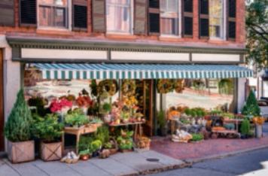 |  | 
a. ………….…………..…..…………..…...….. | b. …………………..…..…………..…..…..….. | c. ……………..…..…………..…..……..…..
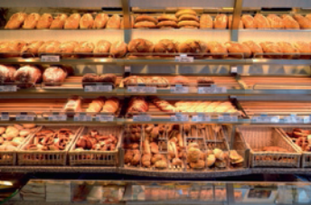 | 
d. …………………..…..…………..…..…..….. | e. ………………..…..…………..…..……..…..

- Look and read. Then write the correct word.

Example | We go to this place for swimming lessons. S W I M M I N G P O O L

a. We go to this place to mail a letter. .… .… .… .… .… .… .… .… .… .…
b. This is where you go if you need help. .… .… .… .… .… .… .… .… .… .… .… .… .…
c. We can borrow books from this place. .… .… .… .… .… .… .…
d. We can buy vegetables here. .… .… .… .… .… .… .… .… .… .… .… .…
e. This is where we go to see a film. .… .… .… .… .… .…

Grammar
- Look at the picture below. Read the dialogue and underline the correct option.

Fiona: Excuse me, can you tell me the way to the bank?
David: Sure. Go past / up the post office.
Then turn (1) left / right. And the bank is (2) next to / opposite the
library.
Fiona: And one more thing… Where’s the chemist’s?
David: That’s easy. Go (3) towards / up the street. Turn (4) left / right.
Go (5) through / down the tunnel in the park. And the chemist’s is
next to the café.
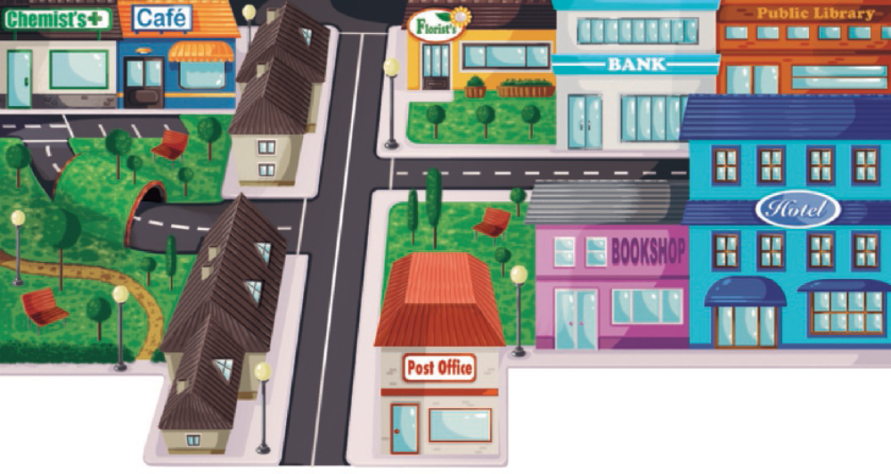
- Complete the sentences with the verb in the Past Simple.

Example | Yesterday I m a d e (make) a cake for my mum.

a. Samantha .….…….….….….….….….….….… (write) me a letter, but I
.….…….….….….….….….….….… (not / have) time to write back.
b. I .….…….….….….….….….….….… (go) to Canberra, so I .….…….….….….….….….….….… (send) my best
friend a postcard.
c. I .….…….….….….….….….….….… (buy) a small present for my best friend and she
.….…….….….….….….….….….… (love) it.
d. Now I’m back in school, so last weekend I .….…….….….….….….….….….… (do) all my
homework and .….…….….….….….….….….….… (study) for the maths test.
e. Yesterday we .….…….….….….….….….….….… (not / go) to school because our teacher
.….…….….….….….….….….….… (be) sick.
Writing
- Read the dialogue in a restaurant and write the questions.
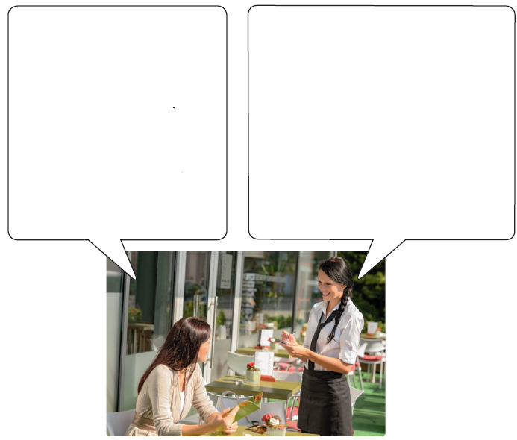
What would you like to order?
- .….…….……………………………..….….….….….….….…
. ….…….….….….….….….….….…………………………...?
- .….…….……………………………..….….….….….….….…
. ….…….….….….….….….….….…………………………...?
- .….…….……………………………..….….….….….….….…
. ….…….….….….….….….….….…………………………...?
- .….…….……………………………..….….….….….….….…
. ….…….….….….….….….….….…………………………...?
- .….…….……………………………..….….….….….….….…
. ….…….….….….….….….….….…………………………...?

I’d like a hamburger and chips, please.
- The lasagne is £9.20.

- Yes, I’d like a salad with my pasta.

- The pizza is £12.50.

- Yes. I’d like a bottle of water, please.

- The total is £55.85.

- Imagine you are writing to a friend to tell him/her what you did last weekend. Write an email. (Write between 25 to 35 words.)

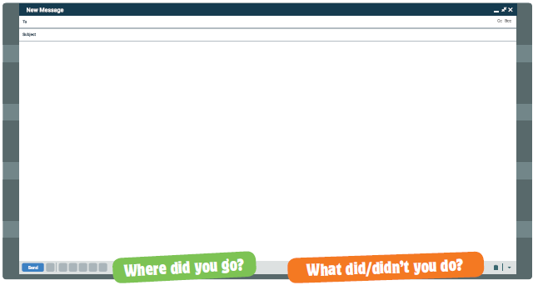
Version B
Unit 4 · 6th grade
Agrupamento …………………………………………………………………………………………………………………………………………………………………..
Name: ………………………………..………………………………..………………… Class: …………….. Number: ……………..
Date: ……………..……………..………………………………………………….……. Evaluation: ………………….………………………………………….……..
Teacher: ……………..……………..……………..……………..……………………. E.E.: ……………………………………………………………….……………..
Listening
- Listen to the different dialogues and complete the sentences. Write one or two words or numbers. There is one example.

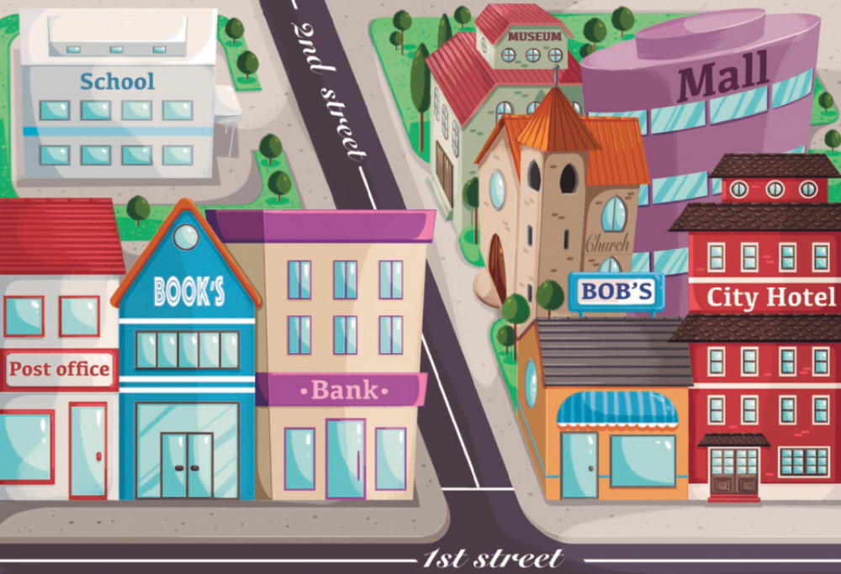
Example | How much is the ticket for the exhibition? £3.50 .

Questions
1. Mr Johnson is at the …………..….…………..….…………..….…………..….…………..….…………..…………..
2. The woman bought the …………..….…………..….…………..….. and a car magazine.
3. The magazine costs …………..….…………..….…………..……………..….…………..….…………..…………....
4. Keith bought a new book at the …………..….…………..….…………..….…………..….……………..
5. Janet wants to go to the …………..….…………..….…………..….…………..….…………..….…………..…..

- The Bradley family are talking about what they did last weekend. Listen and write a number in each box. There is one example.

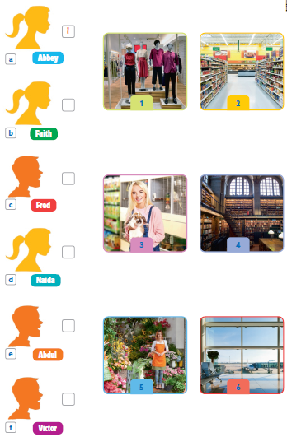

Reading and writing
- Read the sentences and write the correct word.

Example | You can buy books at this place. bookshop .

Questions
a. You can borrow books from this place. …………..….…………..….…………..….
b. This is where you can buy jeans and tops. …………..….…………..….…………..….
c. You can buy bread and croissants here. …………..….…………..….…………..….
d. You can buy glasses here. …………..….…………..….…………..….
e. You can catch a plane here. …………..….…………..….…………..….
- Read the story. Choose a word from the boxes. Write the correct word
in each space 1 to 6. There is an example. There is one extra word.
Sage’s shopping trip
Sage lives across the river from town, so to get to town she has to cross the
(1) ………………..…..…. Her mother sent her shopping yesterday and she had a long
list! First, she stopped to buy the newspaper for her brother at the
(2) ………………..…..… and then she went to the (3) ………………..…..… next door to buy
the new book by her favourite writer. Her mother also asked her to buy
some fresh vegetables for dinner from the (4) ………………..…..… and to get the
meat that she ordered from the (5) ………………..…..… too.
After doing all the things, her mother asked Sage to go to the local
(6) ………………..…..… to look at the new trainers that arrived. Wow, they were great!
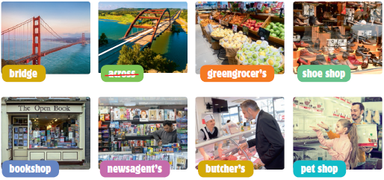

- Read the text and choose the correct words and write them on the lines.
Excuse me…
I visited this city many years ago, but I can’t remember where the shops are.
‘Excuse me, can you tell me if I need to go straight ahead or (1) ………………..…..…
left at the next road to go to the bakery?’
‘Well you need to (2) ………………..…..… past the greengrocer’s and then go
(3) ………………..…..… the street and it’s (4) ………………..…..… the left.’
‘Thank you very much. I’ll go straight (5) ………………..…..… and past the
greengrocer’s then.’
Example | • straight | • up | • in
1 | • past | • turn | • up
2 | • go | • went | • goed
3 | • up | • in | • on
4 | • on | • up | • ahead
5 | • by | • in | • ahead
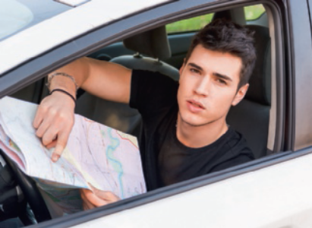

- Look at the picture and read the story. Write some words to complete the sentences about the story.
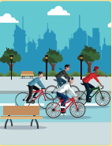
Felix’s weekend in Manchester
We had an incredible weekend in Manchester! We
took our bikes and we rode around the whole city.
We had so much fun and saw so many things. We
went to the famous Museum of Science and we
were there for one hour. Then we went to the Art
Gallery and there were some beautiful paintings,
but we didn’t see it all because we only had an hour
and a half and it was too big to see everything.

Examples | Felix spent the weekend in Manchester .
 | Felix thought the weekend trip to Manchester was incredible .

a. Felix spent one hour in the ………………..…..………………..…..…….
b. They didn’t see the whole museum because it was ………………..…..………………..…..…….
We had lunch at The Red Café, in the Old Trafford Stadium, and then we had
a tour of the stadium where Manchester United play. The tour was great
because we met one of the players. We were so lucky! After the tour, we went
to the megastore to buy some souvenirs and Jack wanted to buy a shirt.
When he left the stadium, Jack’s dad picked us up in his car and took us to
Castlefield where we saw a Roman fort. That was very interesting.
c. Felix and his friends had ……………..…..………………..….. at the Red Café.
d. During the tour they met one of the ……………..…..………………..…...
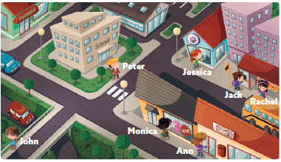
e. Felix bought ……………..…..………………..….. at the shop and Jack bought ……………..…..………………..…...
Writing
- Look at the
picture, read
and write.

Examples | Rachel is in front of the bus stop .
 | How many cars are there? There are two .

1.1. Complete the sentences.
a. John is walking ……………..…..………………..….. the bridge.
b. The boy near the ……………..…..………………..….. is talking on the phone.

1.2. Answer the questions.
c. Where is Jessica? She’s in front of the ………………..…..
d. How much is the dress? It’s ………………..…………………..……………………...
e. What’s the name of the restaurant? It’s ………………..…………………..……………………...

  - Now write three sentences about the picture (25 to 35 words). Use the Past Simple.
………………………………………………………. ……………………………………………………………………..

Version C
Unit 4 · 6th grade
Agrupamento …………………………………………………………………………………………………………………………………………………………………..
Name: ………………………………..………………………………..………………… Class: …………….. Number: ……………..
Date: ……………..……………..………………………………………………….……. Evaluation: ………………….………………………………………….……..
Teacher: ……………..……………..……………..……………..……………………. E.E.: ……………………………………………………………….……………..
Listening
- Fiona is talking to her cousin Mandy from the USA. She is visiting her town. Listen and choose the correct option.

a. To go to school, Mandy  walks… |  |  |  |  | d. What’s the fastest way to  the post office?
1. across the bridge. |  |  |  |  | 1. Past the greengrocer’s.
2. through a tunnel. |  |  |  |  | 2. Up the road.
b. Where’s the chemist’s? |  |  |  |  | e. Which is the easiest way to  the bookshop?
1. Opposite the school. |  |  |  |  | 1. Turn right.
2. Opposite the bank. |  |  |  |  | 2. Go straight up the road.
c. To get to the local swimming  pool they have to… |  |  |  |  | f. Where is Mandy’s favourite  shop?
1. walk past the post office. |  |  |  |  | 1. Down the road.
2. turn right at the bus station. |  |  |  |  | 2. Past the stadium.

- Listen to Fiona talking to her friend about the exhibition and answer the questions.

a. What do they want to visit? | an art exhibition |  | a museum
b. Bordalo is a graffiti… | artist |  | expert
c. Where did Mandy see his work? | on TV |  | in a magazine
d. Who bought the tickets? | Mandy |  | Fiona
e. What did Fiona write? | a letter |  | an email
f. Does Mandy know that she is going? | no |  | yes

Reading comprehension
Read about Fiona’s favourite city.
My favourite city
I really like my mother’s hometown. It’s Canberra, the capital of Australia.
I went there at the end of January. My grandparents took me to the
bookshop to buy a new book. Then we visited the National Gallery.
When I was there, my cousin Samantha turned 12. We had a picnic near
Lake Burley Griffin for her birthday. We jumped in the lake and swam a
lot because it was very hot. We had a lot of fun in the park. Then I
went to the cinema with my cousins.
Canberra is a beautiful city with a big lake and it has bridges to go from
one side of the city to the other.
I want to go back again next summer!
- Read the text and choose the correct answer.

a. Fiona’s favourite city is…………..…...
 | 1. Sydney | 2. Canberra
b. After buying a new book, Fiona went to the …………..….. with her grandparents.
 | 1. swimming pool | 2. National Gallery
c. Fiona visited Canberra …………..…...
 | 1. in January | 2. at Christmas
d. Where did they have a picnic to celebrate Samantha’s birthday?
 | 1. National Gallery. | 2. Lake Burley Griffin.
e. Fiona went to the cinema with …………..…...
 | 1. her cousins | 2. her aunt
f. Canberra has a big lake and it has …………..….. to go from one side of the city to the other.
 | 1. lakes | 2. bridges

- Read the text and complete the sentences.
a. Fiona’s …………..….. took her to the …………..….. to buy a book.
b. Samantha turned …………..….. years old.
c. They swam in the …………..….. because it was …………..…...

Vocabulary
- Label the pictures with the words in the boxes.

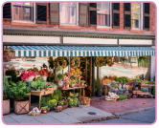 | 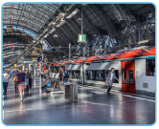 | 
a. ………….…………..…..…………..…...….. | b. …………………..…..…………..…..…..….. | c. ………………..…..…………..…..……..….
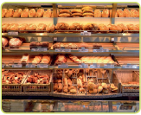 | 
d. …………………..…..…………..…..…..….. | e. ………………..…..…………..…..……..…..

- Look and read. Then write the correct word.

Example | We go to this place for swimming lessons.  S W I M M I N G P O O L

a. We go to this place to mail a letter. P .… .… .… O .… .… .… C .…
b. This is where you go if you need help. P .… .… .… .… .… S .… .… T .… .… .…
c. We can borrow books from this place. L .… .… .… .… .… Y
d. We can buy vegetables here. G .… .… .… .… .… R .… .… .… .… .…
e. This is where we go to see a film. C .… .… .… .… .…

Grammar
- Look at the picture below. Read the dialogue and underline the correct option.

Fiona: Excuse me, can you tell me the way to the bank?
David: Sure. Go past / up the post office. Then turn (1) left / right.
And the bank is (2) next to / opposite the library.
Fiona: And one more thing… Where’s the chemist’s?
David: That’s easy. Go (3) towards / up the street.
Turn (4) left / right. Go (5) through / down the tunnel in the
park. And the chemist’s is next to the café.
- Circle the correct option.

Example | Yesterday I make / made a cake for my mum.

a. Samantha wrote / writed me a letter, but I didn’t have /
didn’t had time to write back.
b. I goed / went to Canberra, so I sent / sended my best friend a
postcard.
c. I bought / buys a small present for my best friend and she
loved / love it.
d. Now I’m back in school, so last weekend I do / did all my
homework and study / studied for the maths test.
e. Yesterday we didn’t go / doesn’t go to school because our
teacher were / was sick.
Writing
What would you like to order? * Would you like anything to drink?
Would you like a salad? * How much is the total?
How much is the lasagne? * How much is the pizza?
- Read the dialogue in a restaurant and write the questions.

I’d like a hamburger and chips, please.
- The lasagne is £9.20.

- Yes, I’d like a salad with my pasta.

- The pizza is £12.50.

- Yes. I’d like a bottle of water, please.

- The total is £55.85.

What would you like to order?
- .….…….……………………………..….….….….….….….…
. ….…….….….….….….….….….…………………………...?
- .….…….……………………………..….….….….….….….…
. ….…….….….….….….….….….…………………………...?
- .….…….……………………………..….….….….….….….…
. ….…….….….….….….….….….…………………………...?
- .….…….……………………………..….….….….….….….…
. ….…….….….….….….….….….…………………………...?
- .….…….……………………………..….….….….….….….…
. ….…….….….….….….….….….…………………………...?

