Test specifications | Unit 5 | Going places
Version A (Traditional)
Metas Curriculares
Vocabulário  Summer activities  Holiday accommodation  Means of transport | Gramática  Future: going to  Adverbs – adjective + -ly
Metas / Skills | Questions | Marks |  | Answer key
Listening (10 minutos) |  | 20%
L6. Compreender, com ajuda,  discursos articulados de forma  clara e pausada.  6.1 Entender expressões  relacionadas com os seus  interesses.  6.3 Seguir conversas sobre  assuntos que lhe são familiares (escola). | 1. Listen and choose the correct option. | 5 x 2 = 10 |  | b. 3  c. 2  d. 3  e. 2  f. 1
 | 2. Complete de information. | 5 x 2 = 10 |  | a. horse riding  b. train  c. sailing  d. (local) campsite  e. swimming in the sea
Reading comprehension (10 minutos) |  | 20%
6.4 Identificar a ideia principal e a  informação essencial em textos  diversificados. | 1. Read the text and choose the correct answer. |  | 5 x 2 = 10 | b. 2  c. 1  d. 3  e. 3  f. 2
 | 2. Find the opposites of the following words in the text. |  | 5 x 2 = 10 | b. best  c. big  d. fun  e. warm  f. never
Vocabulary (10 minutos) |  | 20%
10.3 Comparar diferentes meios  de transporte.  10.4 Comparar diferentes tipos de  habitação. | 1. Label the pictures. |  | 5 x 2 = 10 | a. tent  b. houseboat  c. treehouse  d. castle  e. motorhome
 | 2. Read and write the correct transport. |  | 5 x 2 = 10 | a. cruise ship  b. truck/lorry  c. train  d. bike  e. motorbike
Grammar (10 minutos) |  | 20%
Verbs  9.10 Usar os verbos to be, there + to be, to have (got), no Past  Simple, nas formas afirmativa,  negativa e interrogativa.  9.13 Expressar a ideia de futuro  com going to.  Uso de see/watch/look at.  Word Formation  9.15 Reconhecer processos de  formação do advérbio (adjective + -ly). | 1. Read the text and circle the correct word. | 10 x 1 = 10 |  | 1. b  2. b  3. a  4. c  5. b  6. b  7. a  8. c  9. b  10. b
 | 2. Complete the sentences with be going to. | 5 x 2 = 10 |  | a. is going to see, isn’t going to do  b. are going to watch  c. isn’t going to buy  d. am not going to stay

Test specifications | Unit 5 | Going places
Writing (10 minutos) |  | 20%
7.1 Formular perguntas ou redigir respostas sobre temas estudados.  8.3 Descrever um acontecimento com a ajuda de tópicos ou imagens.  (A concert – what are you going to do?) | 1. Complete the dialogue. Write the questions. |  | 5 x 2 = 10 | a. Is there a bus every hour?/Is there a regular bus service?  b. Where is the bus stop?/ Where is the bus going to stop?  c. What time is the last bus?  d. How much is the ticket?  e. How long does it take to get there?/How long is the trip/journey?
 | 2. Imagine you are going to a concert with your friends.  Write a short description about  what you are going to do. |  | 10–8: Escreve entre 25 e 35 palavras, escreve sem erros ortográficos, usa o vocabulário adequado e não dá muitos  erros de gramática.  7–4: Escreve entre 15 e 20 palavras, escreve com alguns erros ortográficos, por vezes usa o vocabulário adequado e dá alguns  erros de gramática.  3–0: Não respeita o número de palavras, escreve com muitos erros ortográficos, não usa o vocabulário adequado e dá  muitos erros de gramática.
TOTAL | 100%

Speaking
Interação oral  SI7. Interagir, com alguma ajuda, com um interlocutor em situações familiares e previamente preparadas.  7.1 Formular perguntas e dar respostas.  7.2 Exprimir sentimentos de agrado e desagrado.  Para avaliar: “Speaking in class – assessment grid”  (Teacher’s File – Tests, p. 125) | Produção oral  SP7. Expressar-se, com vocabulário simples, sobre assuntos familiares do dia a dia.  7.4 Apresentar projetos futuros (I’m going to buy a dog).  Project work: Planning a holiday trip to California  (Coursebook, p. 137)  Para avaliar: “Oral presentation – assessment grid”  (Teacher’s File – Tests pp. 126–128)
Listening scripts
Exercise 1  MASON: Hi, Sophia. Let me show you the photos from my holiday in the USA.  SOPHIA: Hi, Mason. I’d love to see them. Where did you go in the USA? To Florida?  MASON: No, we went to California.  SOPHIA: Look at you on a bike. Did you ride around everywhere?  MASON: No, this is my cousin’s bike. We travelled by car.  When we arrived we were very tired, but on the second day we had so much fun.  SOPHIA: What did you do?  MASON: We went sightseeing with my uncle and I took hundreds of photos.  SOPHIA: Sounds like you had a good time in California.  MASON: Yes, especially because I love taking photos of new things. I also got to do something for the first time. Don’t laugh!  SOPHIA: Why, what did you do?  MASON: I stayed in a campsite for the first time ever. It was great! We didn’t do very much the last week because my uncle had to go back to work.  SOPHIA: So, what did you do?  MASON: We went to the local swimming pool which was 500 m from the house. | Exercise 2  MASON: Where did you go, Sophia?  SOPHIA: I went to Croatia. It is beautiful there.  MASON: What did you like the most?  SOPHIA: I liked everything, but I loved horse riding.  MASON: And how did you go, by plane or by car?  SOPHIA: Well, we went by train!  MASON: By train, wow! And did you do any other exciting things?  SOPHIA: My brother went sailing, but I didn’t go because I was sick that day.  MASON: Oh, what a pity. And where did you stay?  SOPHIA: We stayed in a local campsite which had so many fun activities!  MASON: Sounds like a fun holiday. Is there anything you didn’t like?  SOPHIA: Swimming in the sea, it was very, very cold!

Test specifications | Unit 5 | Going places
Version B (Cambridge)
Metas Curriculares
Vocabulário  Summer activities  Holiday accommodation  Means of transport | Gramática  Future: going to  Adverbs – adjective + -ly
Metas / Skills | Questions | Marks |  | Answer key
Listening (15 minutos) |  | 20%
L6. Compreender, com ajuda,  discursos articulados de forma  clara e pausada.  6.1 Entender expressões  relacionadas com os seus  interesses.  6.3 Seguir conversas sobre  assuntos que lhe são familiares (escola). | 1. Listen and choose the correct option 1, 2 or 3. | 5 x 2 = 10 |  | b. 1  c. 3  d. 2  e. 2  f. 1
 | 2. Listen and write a number in the box. | 5 x 2 = 10 |  | b. Cullen – 4  c. Maddox – 5  d. Jade – 1  e. Violet – 3  f. Cohen – 6
Reading and writing (20 minutos) |  | 50%
6.4 Identificar a ideia principal e a  informação essencial em textos  diversificados.  Verbs  9.10 Usar os verbos to be, there + to be, to have (got), no Past  Simple, nas formas afirmativa,  negativa e interrogativa.  9.13 Expressar a ideia de futuro  com going to.  Uso de see/watch/look at.  Word Formation  9.15 Reconhecer processos de  formação do advérbio (adjective + -ly). | 1. Look at the pictures and  words. Write the correct  word. |  | 5 x 2 = 10 | a. cruise ship  b. truck  c. taxi  d. bicycle  e. motorbike
 | 2. Read the story. Choose  a word from the box. Write  the correct word in each  space 1-5. There is an  example. |  | 5 x 2 = 10 | 1. ticket  2. lunch time  3. half past two  4. house  5. castle
 | 3. Read the text and  choose the correct option. |  | 5 x 3 = 15 | a. 3  b. 1  c. 2  d. 2  e. 3
 | 4. Look at the pictures and  read the story. Write some  words to complete the  sentences about the story. |  | 5 x 3 = 15 | a. clothes  b. train  c. taxi  d. a bungalow  e. her T-shirt
Writing (15 minutos) |  | 30%
8.3 Descrever um acontecimento  com a ajuda de tópicos ou  imagens. | 1. Look at the picture, read and write.  1.1 Complete the sentences.  1.2 Answer the questions. |  | 5 x 3 = 15 | a. a horse  b. the car  c. 10  d. On Thursday  e. To the swimming pool/campsite
 | 1.3 Now write three sentences about picture number 6 (25 to 35 words). |  | 3 x 5 = 15 | (Any sentence is correct as long as it’s about the picture)  Suggestions:  There is a tent and a tepee.  The mother is taking a photo.  Her brother is riding a bike.
TOTAL | 100%

Speaking
Interação oral  SI7. Interagir, com alguma ajuda, com um interlocutor em situações familiares e previamente preparadas.  7.1 Formular perguntas e dar respostas.  7.2 Exprimir sentimentos de agrado e desagrado.  Para avaliar: “Speaking in class – assessment grid”  (Teacher’s File – Tests, p. 125) | Produção oral  SP7. Expressar-se, com vocabulário simples, sobre assuntos familiares do dia a dia.  7.4 Apresentar projetos futuros (I’m going to buy a dog).  Project work: Planning a holiday trip to California  (Coursebook, p. 137)  Para avaliar: “Oral presentation – assessment grid”  (Teacher’s File – Tests pp. 126–128)
Listening scripts
Exercise 1  BOY 1: So Jude, are you going to Madrid again this year?  BOY 2: No, I’m going much further away.  BOY 1: Where?  BOY 2: Cuba.  BOY 1: And where are you going to stay in Cuba?  BOY 2: My father wanted to stay in a campsite, but my mother said no, so we are going to stay in a hotel.  BOY 1: How are you going to get there?  BOY 2: Well, we can go by plane, but my parents want to go on a cruise ship.  BOY 1: Wow, that is going to be fun, but it must be expensive…  BOY 2: It is! By plane it’s £120, but by cruise ship it’s £550 each!  BOY 1: So, it’s going to take a long time to get there.  BOY 2: Yes, it is.  BOY 1: Are you leaving early in the morning?  BOY 2: No, we’re travelling at night, so we are leaving at 5:30 pm.  BOY 1: Have you got any plans for things to do while you are there?  BOY 2: There is a lot to do, but I don’t have any friends there. So, we are going to do a lot of sightseeing.  BOY 1: You are so lucky! | Exercise 2  Example  BOY: Where are you going on holiday next summer, Rosie? Are you going camping?  GIRL: My family and I are going to Bali and we are going to stay in a bungalow.  1  GIRL: And you, Cullen, where are you going?  BOY: I am so excited. We are going to China and we’re going to stay at my dad’s friend’s house. It’s a houseboat!  GIRL: Wow!  2  BOY: And you, Jade, what are you going to do for your holiday?  GIRL: Well, my parents are going to hire a motorhome and we are going all over Europe.  BOY: That sounds great!  3  GIRL: Maddox, where are you going?  BOY: We’re going on a safari in Africa and I’m a little scared because we’re going to stay in a treehouse!  GIRL: Don’t be scared, it’ll be fun.  4  BOY: Are you going anywhere exciting, Violet?  GIRL: Not really. We are going to visit the same places as usual and we are going to stay at the same hotel… as usual! Boring!  5  GIRL: Are you going to do anything interesting, Cohen?  BOY: We’re going to visit my family in the Algarve and we’re going to stay at their beach house. It’s going to be fun.

Test specifications | Unit 5 | Going places
Version C (NEE)
Metas Curriculares
Vocabulário  Summer activities  Holiday accommodation  Means of transport | Gramática  Future: going to  Adverbs – adjective + -ly
Metas / Skills | Questions | Marks |  | Answer key
Listening (10 minutos) |  | 20%
L6. Compreender, com ajuda,  discursos articulados de forma  clara e pausada.  6.1 Entender expressões  relacionadas com os seus  interesses.  6.3 Seguir conversas sobre  assuntos que lhe são familiares (escola). | 1. Listen and choose the correct option. | 5 x 2 = 10 |  | b. 2  c. 1  d. 2  e. 1  f. 1
 | 2. Choose the correct option. | 5 x 2 = 10 |  | b. horse riding  c. by train  d. went sailing  e. in a campsite  f. swimming
Reading comprehension (10 minutos) |  | 20%
6.4 Identificar a ideia principal e a  informação essencial em textos  diversificados. | 1. Read the text and choose the correct answer. |  | 5 x 2 = 10 | b. 2  c. 1  d. 1  e. 2  f. 2
 | 2. Read the text and complete the sentences. |  | 5 x 2 = 10 | a. family, Thailand  b. camper van, weeks  c. Elephant
Vocabulary (10 minutos) |  | 20%
10.3 Comparar diferentes meios  de transporte.  10.4 Comparar diferentes tipos de  habitação. | 1. Label the pictures. Use the words below. |  | 5 x 2 = 10 | b. tepee  c. houseboat  d. treehouse  e. castle  f. motorhome
 | 2. Read and write the correct transport. |  | 5 x 2 = 10 | a. cruise ship  b. truck  c. train  d. bike  e. motorbike
Grammar (10 minutos) |  | 20%
Verbs  9.10 Usar os verbos to be, there + to be, to have (got), no Past  Simple, nas formas afirmativa,  negativa e interrogativa.  9.13 Expressar a ideia de futuro  com going to.  Uso de see/watch/look at.  Word Formation  9.15 Reconhecer processos de  formação do advérbio (adjective + -ly). | 1. Read the text and circle the correct word. | 5 x 2 = 10 |  | 1. b  2. b  3. a  4. b  5. a
 | 2. Complete the sentences with be going to. | 5 x 2 = 10 |  | a. is going to see, isn’t going to do  b. are going to watch  c. isn’t going to buy  d. am not going to stay

Test specifications | Unit 5 | Around town
Writing (10 minutos) |  | 20%
7.1 Formular perguntas ou redigir respostas sobre temas estudados. | Complete the dialogue with the  questions in the box. |  | 5 x 4 = 20 | a. Is there a bus every hour?  b. Where is the bus stop?  c. What time is the last bus?  d. How much is the ticket?  e. How long is the journey?
TOTAL | 100%

Speaking
Interação oral  SI7. Interagir, com alguma ajuda, com um interlocutor em situações familiares e previamente preparadas.  7.1 Formular perguntas e dar respostas.  7.2 Exprimir sentimentos de agrado e desagrado.  Para avaliar: “Speaking in class – assessment grid”  (Teacher’s File – Tests, p. 125) | Produção oral  SP7. Expressar-se, com vocabulário simples, sobre assuntos familiares do dia a dia.  7.4 Apresentar projetos futuros (I’m going to buy a dog).  Project work: Planning a holiday trip to California  (Coursebook, p. 137)  Para avaliar: “Oral presentation – assessment grid”  (Teacher’s File – Tests pp. 126–128)
Listening scripts
Exercise 1  MASON: Hi, Sophia. Let me show you the photos from my holiday in the USA.  SOPHIA: Hi, Mason. I’d love to see them. Where did you go in the USA? To Florida?  MASON: No, we went to California.  SOPHIA: Look at you on a bike. Did you ride around everywhere?  MASON: No, this is my cousin’s bike. We travelled by car. When we arrived we were very tired, but on the second day we had so much fun.  SOPHIA: What did you do?  MASON: We went sightseeing with my uncle and I took hundreds of photos.  SOPHIA: Sounds like you had a good time in California.  MASON: Yes, especially because I love taking photos of new things. I also got to do something for the first time. Don’t laugh!  SOPHIA: Why, what did you do?  MASON: I stayed in a campsite for the first time ever. It was great! We didn’t do very much the last week because my uncle had to go back to work.  SOPHIA: So, what did you do?  MASON: We just went to the local swimming pool which was 500m from the house. | Exercise 2  MASON: Where did you go, Sophia?  SOPHIA: I went to Croatia. It is beautiful there.  MASON: What did you like the most?  SOPHIA: I liked everything, but I loved horse riding.  MASON: And how did you go, by plane or by car?  SOPHIA: Well, we went by train!  MASON: By train, wow! And did you do any other exciting things?  SOPHIA: My brother went sailing, but I didn’t go because I was sick that day.  MASON: Oh, what a pity. And where did you stay?  SOPHIA: We stayed in a local campsite which had so many fun activities!  MASON: Sounds like a fun holiday. Is there anything you didn’t like?  SOPHIA: Swimming in the sea, it was very, very cold!


Version A
Unit 5 · 6th grade
Agrupamento …………………………………………………………………………………………………………………………………………………………………..
Name: ………………………………..………………………………..………………… Class: …………….. Number: ……………..
Date: ……………..……………..………………………………………………….……. Evaluation: ………………….………………………………………….……..
Teacher: ……………..……………..……………..……………..……………………. E.E.: ……………………………………………………………….……………..
Listening
- Mason is talking to Sophia about his holiday. Listen and choose the correct option.

a. Where did Mason go? |  |  |  |  | d. What does Mason like to do  when he is in a new place?
1. Florida. |  |  |  |  | 1. Visit museums.
2. California. |  |  |  |  | 2. Go swimming.
3. Cuba. |  |  |  |  | 3. Take photos.
b. How did he travel while he was  there? |  |  |  |  | e. What did Mason do for the first time?
1. On a horse. |  |  |  |  | 1. Swam in the sea.
2. By bike. |  |  |  |  | 2. Stayed in a campsite.
3. By car. |  |  |  |  | 3. Rode a horse.
c. What did he find exciting on  the second day? |  |  |  |  | f. Where did Mason go the last  week of his holiday?
1. Going to the swimming pool. |  |  |  |  | 1. To the swimming pool.
2. Going sightseeing. |  |  |  |  | 2. To a campsite.
3. Going sailing. |  |  |  |  | 3. To a language school.

- Complete the information about Sophia’s holiday.
Name of country | Croatia
What did she enjoy most?
How did she get there? | - by
What did her brother do? | - went
Where did she stay? | - in a
What didn’t she like?

Reading comprehension
Read about Mia’s summer holiday.

My summer holiday
Last summer I had the best holiday of my life! I went with my family to
Thailand. We visited the Temple of the Reclining Buddha and it was incredible.
I was amazed because it is so big! We stayed in a bungalow near the beach and we went swimming every morning. We always ate fresh fruit for breakfast, but dad just had bread and butter as usual. The fruit juices in Thailand were delicious.
We travelled around Thailand in a camper van for two weeks. It was one of
the most amazing experiences of my life. We spent a day at the Ramayana
Water Park and we had so much fun… even mum and dad loved it!
We travelled to Koh Rok Island and dad went snorkeling, while we enjoyed
the warm water and swam all day. The best part of the holiday was the day
we spent at the Patara Elephant Farm! We fed, bathed and played with the
elephants. I will never forget my holiday in Thailand!
- Read the text and choose the correct answer.

a. Mia had …………..….. for breakfast.
 | 1. bread and butter | 2. juice | 3. fresh fruit
b. The family stayed in a …………..…...
 | 1. water park | 2. bungalow | 3. campsite near the beach
c. Mia visited the Reclining Buddha and was …………..…...
 | 1. surprised | 2. angry | 3. upset
d. They travelled around Thailand for …………..…...
 | 1. one day | 2. every morning | 3. two weeks
e. In Koh Rok Island dad went …………..…...
 | 1. surfing | 2. fishing | 3. snorkeling
f. At Patara Elephant Farm they …………..….. with the elephants.
 | 1. fed | 2. fed, bathed and played | 3. bathed and fed

- Find the opposites of the following words in the text above.
a. first | b. worst | c. small | d. boring | e. cold | f. always
last a | …………..….. | …………..….. | …………..….. | …………..….. | …………..…..
Vocabulary
- Label the pictures.

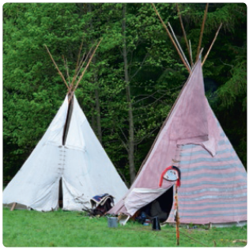 | 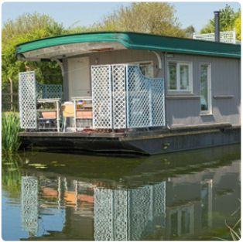 | 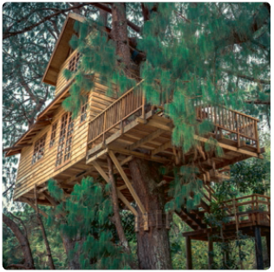
a. ………….…………..…..…………..…...….. | b. …………………..…..…………..…..…..….. | c. ………………..…..…………..…..……..…..

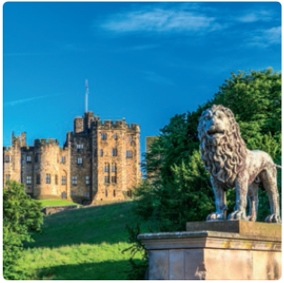 | 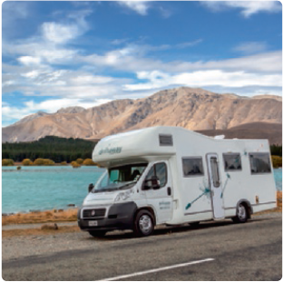
d. …………………..…..…………..…..…..….. | e. ………………..…..…………..…..……..…..

- Read and write the correct transport.

Example | This is a form of public transport in the city. B U S

a. This is used to travel by sea. .… .… .… .… .… .… .… .… .… .…
b. This transport is used to carry things from one place
to another. .… .… .… .… .…
c. You catch this at a station and it has several carriages. .… .… .… .… .…
d. This has two wheels and you ride it. It doesn’t have a motor. .… .… .… .…
e. This has two wheels and it can go very fast. .… .… .… .… .… .… .… .… .…

Grammar
- Read the text and circle the correct word in the table below.


Last week we visited Google. What an experience! We had the chance to
see the office. We were all very (1) ..…..…………..….. to be there.
It is not (2) ..…..………..….. to work at Google because you have to be very (3) ..…..…………..…...
Only intelligent people work there!
(4) ..…..…………..….., we got the chance to visit one of the best companies in the world.
Time went by very (5) .…..……….….. and we had to be (6) ..….…….…. because they don’t
like noise when they are concentrated. We (7) ..….………..….. at some of their best work
and got to (8) ..…..…………..….. old videos of when they started. We didn’t (9) ..…..…………..…..
the massage area! They also have a running track and a gym. I hope I am
(10) ..…..…………..….. in the future and get a job like this!
 | a) look | b) see | c) watch
1. | a) happily | b) happy | c) unhappy
2. | a) easily | b) easy | c) hard
3. | a) good | b) well | c) bad
4. | a) Lucky | b) Unlucky | c) Luckily
5. | a) quick | b) quickly | c) slow
6. | a) noisy | b) quiet | c) quietly
7. | a) looked | b) saw | c) watched
8. | a) have | b) look | c) watch
9. | a) look | b) see | c) watch
10. | a) luck | b) lucky | c) unlucky

- Complete the sentences with be going to.

Example | Tomorrow we are going to visit (visit) the art museum.

a. Sam ..…..…………..….. (see) the doctor, so he ..…..…………..….. (not / do) any tests.
b. On Saturday we ..…..…………..….. (watch) a film at the cinema.
c. James ..…..…………..….. (not / buy) a new tablet.
d. I ..…..…………..….. (not / stay) in a hotel in Thailand.

Writing
- Complete the dialogue. Write the questions.
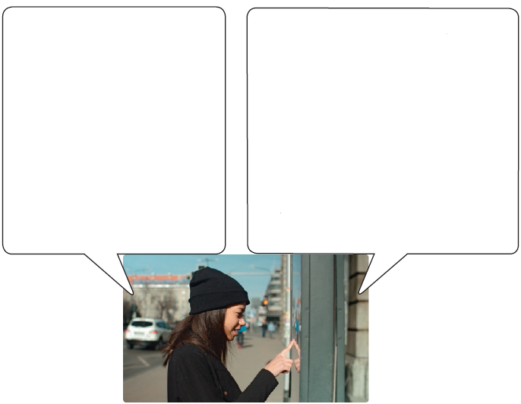
Yes, here it is. Read it carefully.

a. Yes, there is a bus every hour.
b. The bus is going to stop at the train station near the festival.
c. The last bus gets back at 2:00 in the morning.
d. Each ticket is £5.00 one way or £8.00 return.
e. It takes about 1 hour to get there.

Do you have a timetable for the shuttle bus?

- .….…….……………………………..…....….….….….…...?
- .….…….……………………………..….….….….….….….…
….…….….….….….….….….….…………………………...?
- .….…….……………………………..….….….….….….….…
….…….….….….….….….….….…………………………...?
- .….…….……………………………..….….….….….….….…
….…….….….….….….….….….…………………………...?
- .…….……………………………….….….….….….….…....?
- Imagine you are going to a concert with your friends. Write a short description about what you are going to do.
Use these topics to help you. (Write between 25 to 35 words.)

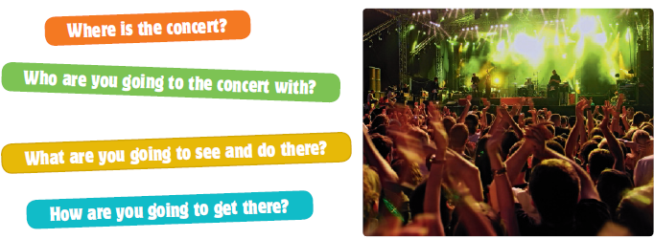

………………………………………………………. ………………………………………………………. ………………….……………………………………………………………..

Version B
Unit 5 · 6th grade
Agrupamento …………………………………………………………………………………………………………………………………………………………………..
Name: ………………………………..………………………………..………………… Class: …………….. Number: ……………..
Date: ……………..……………..………………………………………………….……. Evaluation: ………………….………………………………………….……..
Teacher: ……………..……………..……………..……………..……………………. E.E.: ……………………………………………………………….……………..
Listening
- Listen and choose the correct option 1, 2 or 3. There is one example.

a. Where is Jude going for his holiday?
 | 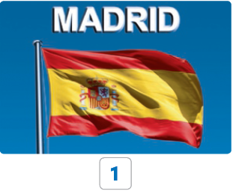 |  | 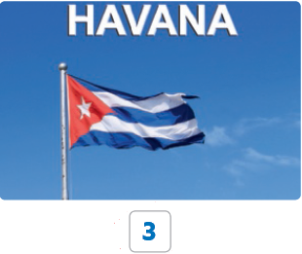
b. Where are Jude and his family going to stay?
 | 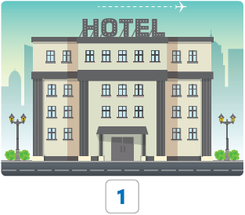 | 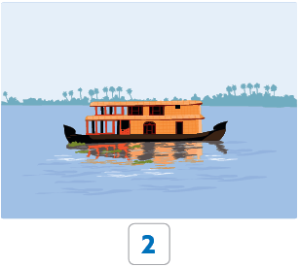 | 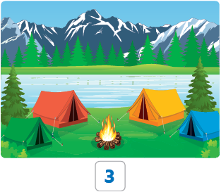
c. How are they going to get there?
 | 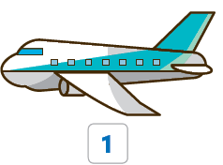 | 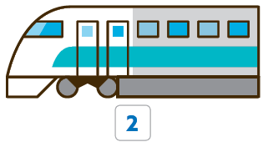 | 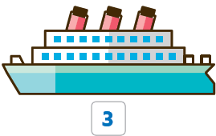
d. How much were the tickets?
 | 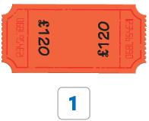 | 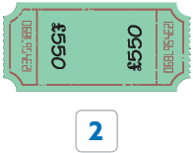 | 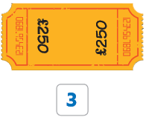
e. What time are they leaving?
 |  |  | 
f. What are they going to do while they are there?
 | 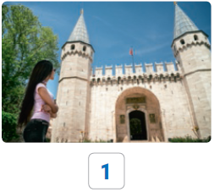 |  | 

- Listen to some friends talking about their next holiday and the accommodation they are going to stay in. Listen and write a number in each box. There is one example.

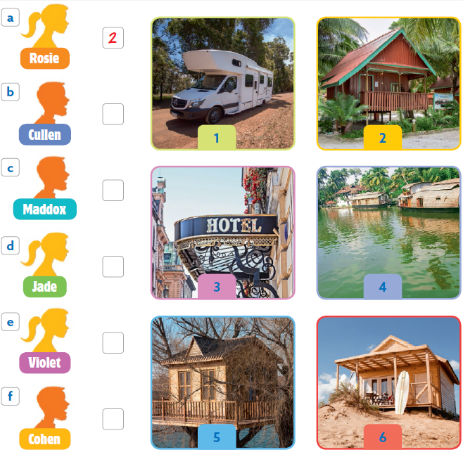

Reading and writing
- Look at the pictures and words. Write the correct word. Some words are not necessary.

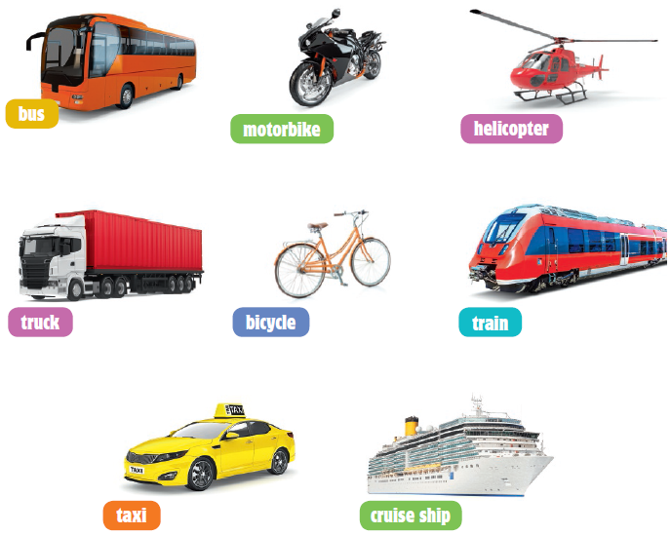

Example | This is a form of public transport in the city. bus .

Questions
a. It is very big and travels in the sea.
b. This transport is used to carry things from one
place to another.
c. This is a form of public transport by car.
d. This has two wheels and you ride it. It doesn’t
have a motor.
e. This has two wheels and it can go very fast.

- Read the story. Choose a word below. Write the correct word in each space 1-5. There is an example.

Lucas’s first trip
Lucas is travelling to London by plane . It is going to be his first trip alone!
“Good morning, I need a plane (1) leaving today and coming back on
Sunday.”
“Of course, what time do you want to leave?” said the man.
“I’m going to be here at (2) …. so I want to arrive in London at (3) … .”
“Alright. Where are you going to stay?” asked the man.
“At my grandparent’s (4) and then I’m going to visit famous places:
some monuments and the (5) where Henry VIII lived.”
“Have a nice trip, then!”

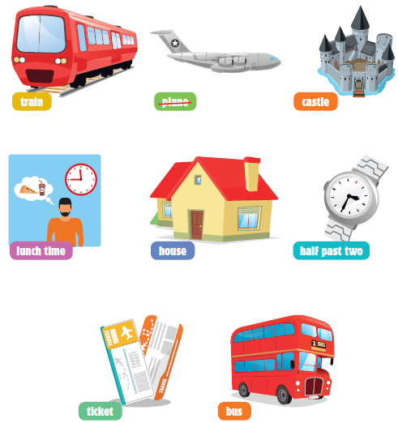

- Read the text and choose the correct option.


Excuse me…
“Excuse me. I need to go to Waterloo Station, but
I don’t know which train to take,” said Mica.
“Well, you have two trains that are going to
Waterloo this morning. One at 9:30 and another
at 11:30. No, sorry, the second one is at 14:30.”
“How much are the tickets?”
“Single or return?”
“Return please.”
“Well, the 9:30 train is £25.30, and the 14:30 train
is £15.60.”
“Really? Well, I’m going to take the 14:30 then
because the 9:30 is too expensive.”
“Okay, here is your ticket. You can get the train at
platform 15, not 13 as you see over there.”

Example | Mica wants to buy a ticket.  1. train 2. plane 3. bus

a. What time is the second train to Waterloo?
 | 1. 11:30. | 2. 9:30. | 3. 14:30.
b. What ticket does Mica buy?
 | 1. A return ticket. | 2. A single ticket. | 3. No ticket.
c. Which train journey is the most expensive?
 | 1. Both. | 2. The morning  journey. | 3. The afternoon  journey.
d. The cheapest ticket costs
 | 1. £15.30. | 2. £15.60. | 3. £25.30.
e. Which platform is the train leaving from?
 | 1. 13. | 2. 25. | 3. 15.

- Look at the pictures and read the story. Write some words to complete the sentences about the story.

Luna’s strange holiday!
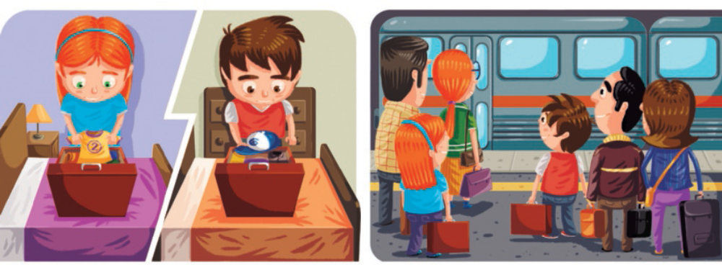
Luna is going on holiday with her parents and for the first time they are
going by train. They are going to stay in a campsite. Luna is so excited. Luna
packed her bag with all her favourite clothes and then they went to the
station by taxi. Luna and her parents got on the train and placed their bags
above them and sat down. Another family arrived and put their bags next to
Luna’s. Luna knew the boy. He was from her school.

Example | Luna and her parents are going to stay in a campsite .

Questions
a. Luna packed her bag with all her favourite …………… .
b. Luna is going to travel by …………… .
c. Luna and her family went to the station by …………… .

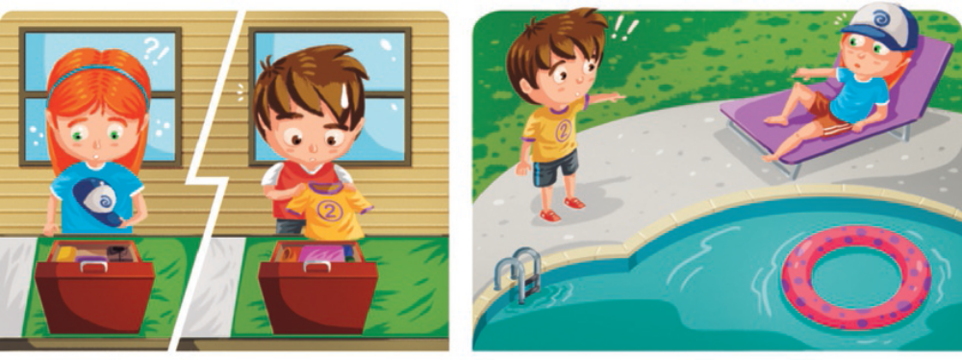
Luna and her parents arrived at the campsite and went to their bungalow.
Luna saw that the boy and his family were there too. When Luna opened her
bag she cried:
“Oh no, this is not my bag!”
“That’s terrible,” said her mother.
Later Luna went to the pool and she saw the boy again and was surprised.
“That’s my T-shirt!” she said to the boy.
“And that is my hat!” he said.

d. In the campsite they stayed in …………… .
e. At the pool Luna found out that the boy had …………… .

Writing
- Look at the pictures, read and write.
My SUMMER nightmare

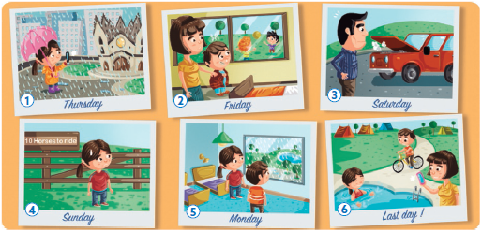

Examples | The girl went on a sightseeing tour, but the weather was terrible.
On Friday, her brother didn’t play with his friends because he
was sick .

1.1. Complete the sentences.
a. On Sunday the children wanted to ride .............................................................
b. On Saturday her father had problems with .......................................................
1.2. Answer the questions.
c. How many horses are there at the riding school?
....................................................................................................................
d. When did the girl take photos?
....................................................................................................................
e. Where did they go on the last day?
....................................................................................................................
1.3. Now write three sentences about picture number 6 (25 to 35 words).
mmmmmmmmmm mmmm mmmmmmmmmm mmmmmmmmmmmmmm mmmmmmmmmm mmmmmmmmmmm …m
mmmmmmmmmm mmmm mmmmmmmmmm mmmmmmmmmmmmmm mmmmmmmmmm mmmmmmmmmmm …m
mmmmmmmmmm mmmm mmmmmmmmmm mmmmmmmmmmmmmm mmmmmmmmmm mmmmmmmmmmm …m
mmmmmmmmmm mmmm mmmmmmmmmm mmmmmmmmmmmmmm mmmmmmmmmm mmmmmmmmmmm …m

Agrupamento …………………………………………………………………………………………………………………………………………………………………..
Name: ………………………………..………………………………..………………… Class: …………….. Number: ……………..
Date: ……………..……………..………………………………………………….……. Evaluation: ………………….………………………………………….……..
Teacher: ……………..……………..……………..……………..……………………. E.E.: ……………………………………………………………….……………..
Version C
Unit 5 · 6th grade
Listening
- Mason is talking to Sophia about his holiday. Listen and choose the correct option.

a. Where did Mason go? |  |  |  |  | d. What does Mason like to do  when he is in a new place?
1. Florida. |  |  |  |  | 1. Go swimming.
2. California. |  |  |  |  | 2. Take photos.
b. How did he travel while he was  there? |  |  |  |  | e. What did Mason do for the first time?
1. On a horse. |  |  |  |  | 1. Stayed in a campsite.
2. By car. |  |  |  |  | 2. Rode a horse.
c. What did he find exciting on  the second day? |  |  |  |  | f. Where did Mason go the last  week of his holiday?
1. Going sightseeing. |  |  |  |  | 1. To the swimming pool.
2. Going sailing. |  |  |  |  | 2. To a campsite.

- Choose the correct option about Sophia’s holiday.

a. Name of country | Croatia |  | Spain
b. What did she enjoy most? | horse riding |  | swimming
c. How did she get there? | by plane |  | by train
d. What did her brother do? | went sailing |  | went sightseeing
e. Where did she stay? | in a campsite |  | in a hotel
f. What didn’t she like? | sightseeing |  | swimming

Reading comprehension
Read about Mia’s summer holiday.
Mia’s summer holiday
Last summer I had the best holiday of my life! I went with my family to
Thailand. We visited the Temple of the Reclining Buddha – it was so
big! We stayed in a bungalow near the beach and we went swimming
every morning. We always ate fresh fruit for breakfast.
We travelled around Thailand in a camper van for two weeks. We spent
a day at the Ramayana Water Park and we all had so much fun!
We travelled to Koh Rok Island and we enjoyed the warm water and
swam all day! The best part of the holiday was the day at the Patara
Elephant Farm! We fed and played with the elephants. I will never
forget my holiday in Thailand!
- Read the text and choose the correct answer.

a. Mia had …………..….. for breakfast.
 | 1. bread and butter | 2. fresh fruit
b. The family stayed in a …………..…...
 | 1. water park | 2. bungalow
c. Mia visited the Reclining Buddha and it was very …………..…...
 | 1. big | 2. small
d. They travelled around Thailand for …………..…...
 | 1. two weeks | 2. every morning
e. In Koh Rok Island they went …………..…...
 | 1. fishing | 2. swimming
f. At Patara Elephant Farm they …………..….. with the elephants.
 | 1. fed | 2. fed and played

- Read the text and complete the sentences.

a. Mia and her …………..….. went to …………..….. for their holiday.
b. They travelled around in a …………..….. for two …………..….. .
c. The best part was the day at the Patara …………..….. Farm.

Vocabulary
- Label the pictures. Use the words below.

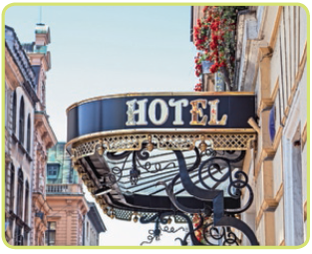 | 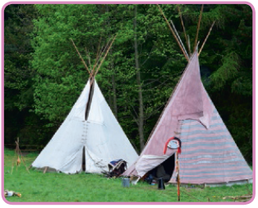 | 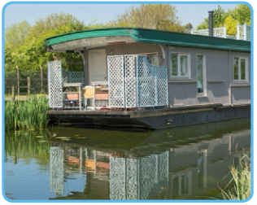
a. hotel . | b. …………………..…..…………..…..…..….. | c. ………………..…..…………..…..……..…..

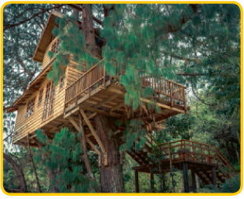 | 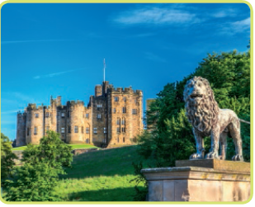 | 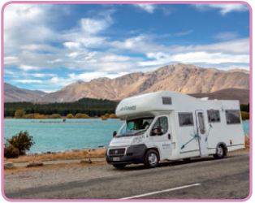
d. …………………..…..…………..…..…..….. | e. ………………..…..…………..…..……..….. | f. ………………..…..…………..…..……..…..

- Read and write the correct transport.

Example | This is a form of public transport in the city. B U S

a. This is used to travel by sea. C .… .… .… S .… S .… .… P
b. This transport is used to carry things
from one place to another. T .… .… C .…
c. You catch this at a station and it has
several carriages. T .… .… .… N
d. This has two wheels and you ride it. It
doesn’t have a motor. B .… .… E
e. This has two wheels and can go very fast. M .… .… .… .… B .… .… .…

Grammar
- Read the text and circle the correct word in the table below.

Last week we visited Google. What an experience! We had the chance
to see the office. We were all very (1) ………..…..…………..…..……..….. to be there.
It is not (2) ………..…..…………..…..……..….. to work at Google because you have to be very
(3) ………..…..…………..…..……..…... Only intelligent people work there!
(4) ………..…..…………..…..……..….., we got the chance to visit one of the best companies in the
world. Time went by very (5) ………..…..…………..…..……..….. and we had to be quiet because
they don’t like noise when they are concentrated. I want to work at
Google in the future!
 | a) look | b) see
1. | a) happily | b) happy
2. | a) easily | b) easy
3. | a) good | b) well
4. | a) Lucky | b) Luckily
5. | a) quickly | b) quick

- Complete the sentences with be going to.

Example | Tomorrow we are going to visit (are/visit) the art museum.

- Sam ..…..…………..….. (is/see) the doctor, so he ..…..…………..…..
(isn’t / do) any tests.
b. On Saturday we ..…..…………..….. (are/watch) a film at the cinema.
c. James ..…..…………..….. (isn’t / buy) a new tablet.
d. I ..…..…………..….. (am not / stay) in a hotel in Thailand.

Writing
How much is the ticket?
Is there a bus every hour?
Do you have a timetable for the shuttle bus?
What time is the last bus?
How long is the journey?
Where is the bus stop?
Complete the dialogue with the questions in the box.

Do you have a timetable for the shuttle bus?

- .….…….……………………………..…....….….….….….
- .….…….……………………………..….….….….….….….…
….…….….….….….….….….….…………………………...
- .….…….……………………………..….….….….….….….…
….…….….….….….….….….….…………………………...
- .….…….……………………………..….….….….….….….…
….…….….….….….….….….….…………………………...
- .…….……………………………….….….….….….….….
Yes, here it is. Read it carefully.

a. Yes, there is a bus every hour.
b. The bus is going to stop
at the train station near the festival.
c. The last bus gets back at 2:00
in the morning.
d. Each ticket is £5.00 one way or £8.00 return.
e. It takes about 1 hour to get
there.

