Test specifications | Units 0 + 1 | We’re back! / It’s my life
Version A (Traditional)
Metas Curriculares
Vocabulário  7.1 Descrever a família e pessoas  conhecidas (traços físicos e de  personalidade).  10.1 Comparar diferentes rotinas  diárias.  10.6 Comparar formas de  socialização familiar e convenções sociais: horários e refeições. | Gramática  Connectors  9.4 Usar then, later, after that.  Adverbs  9.5 Usar often, hardly ever, once, twice (frequency).  Pronouns  9.7 Usar myself, yourself, herself, himself, ourselves, yourselves,  themselves (reflexive).  Verbs  Present Simple  9.14 Usar o modal verb should/shouldn’t.  Language Awareness  Uso de do/make.
Metas / Skills | Questions | Marks |  | Answer key
Listening (10 minutos) |  | 20%
L6. Compreender, com ajuda,  discursos articulados de forma  clara e pausada.  6.1 Entender expressões  relacionadas com os seus  interesses.  6.3 Seguir conversas sobre  assuntos que lhe são familiares. | 1. Listen and choose the correct option. | 5 x 2 = 10 |  | b. 2; c. 3; d. 3; e. 2; f. 1
 | 2. Complete the information. | 5 x 2 = 10 |  | a. Martins; b. 15; c. brown;  d. green; e. smart (and cool)
Reading comprehension (10 minutos) |  | 25%
R6. Ler textos breves sobre  assuntos do seu interesse.  6.1 Identificar sinais e avisos em  locais públicos.  6.2 Interpretar instruções e  informação específica em  documentos.  6.3 Entender mensagens.  6.4 Identificar a ideia principal e a  informação essencial em textos  diversificados. | 1. True or false? Correct the false ones. |  | 5 x 2 = 10 | a. False – He is Scottish.  b. True  c. True  d. False – They go to school by bus.  e. True
 | 2. Answer the questions about the text. |  | 5 x 3 = 15 | a. She’s Tom’s sister.  b. She gets up at 7:30/half past seven.  c. Twice a week.  d. He does his homework in his bedroom.  e. After dinner, Tom plays video games.
Vocabulary (10 minutos) |  | 15%
10.1 Comparar diferentes rotinas  diárias.  10.6 Comparar formas de  socialização familiar e convenções sociais: horários e refeições. | 1. Look at the pictures and write the missing verb. |  | 5 x 1 = 5 | b. make; c. have; d. read;  e. go; f. do
 | 2. Write the opposites. |  | 10 x 1 = 10 | a. beautiful; b. shy;  c. lazy; d. dishonest;  e. unfriendly; f. nervous;  g. curly; h. old; i. short;  j. small

Test specifications | Units 0 + 1 | We’re back! / It’s my life
Grammar (10 minutos) |  | 20%
Adverbs  9.5 Usar often, hardly ever, once, twice (frequency).  Pronouns  9.7 Usar myself, yourself, herself, himself, ourselves, yourselves, themselves (reflexive).  Verbs  Present Simple  9.14 Usar o modal verb should/shouldn’t. | 1. Read the text and circle the  correct word. | 5 x 2 = 10 |  | 2. b; 3. c; 4. b; 5. b; 6. a
 | 2. Complete the sentences with the Present Simple of the verbs in  brackets. | 10 x 1 = 10 |  | 1. brushes; 2. has;  3. makes; 4. clean;  5. takes; 6. am;  7. isn’t; 8. loses;  9. puts; 10. gets
Writing (10 minutos) |  | 20%
7.1 Formular perguntas ou redigir respostas sobre temas estudados.  [Descrever a família e pessoas conhecidas (traços físicos e de personalidade).]  8.1 Descrever uma rotina diária. | 1. Answer these questions about  you. |  | 5 x 2 = 10 | Personal answers
 | 2. Look at the pictures and write  a short description of Peter’s daily  routine. |  | 10–8: Escreve entre 25 e 35 palavras, escreve sem erros ortográficos, usa o vocabulário adequado e não dá muitos  erros de gramática.  7–4: Escreve entre 15 e 20 palavras, escreve com alguns erros ortográficos, por vezes usa o vocabulário adequado e dá alguns  erros de gramática.  3–0: Não respeita o número de palavras, escreve com muitos erros ortográficos, não usa o vocabulário adequado e dá  muitos erros de gramática.
TOTAL | 100%

Speaking
Interação oral  7.1 Formular perguntas e dar respostas.  7.2 Exprimir sentimentos de agrado e desagrado.  Para avaliar: “Speaking in class – assessment grid”  (Teacher’s File – Tests, p. 125) | Produção oral  7.1. Descrever a família e pessoas conhecidas (traços físicos e de personalidade).  7.3 Comparar a sua rotina diária com a dos colegas.  Project work: I’m a Superhero(Coursebook, p. 39)  Para avaliar: “Oral presentation – assessment grid”  (Teacher’s File – Tests, pp. 126–128)
Listening scripts
Exercise 1  JANE: Look, this is my mother. Her name is Monica.  RACHEL: Which one is your mother?  JANE: The one with black hair.  RACHEL: Oh, the one with very long hair like yours.  JANE: No. She has got short hair.  RACHEL: Oh, I see her.  JANE: That’s her.  RACHEL: The photo is a bit small… Are her eyes black or brown?  JANE: I have brown eyes, but my mother has got black eyes.  RACHEL: Your mother looks great in that picture and  she looks very friendly.  JANE: But she is not. She is usually very bossy!  RACHEL: What is your mother doing in this photo?  JANE: She’s cooking dinner.  RACHEL: Do you help your mum cook?  JANE: No, I wash the dishes. | Exercise 2  RACHEL: Have you got any brothers or sisters, Jane?  JANE: Yes, I have. I’ve got a brother.  RACHEL: I haven’t got any brothers or sisters. How old is your brother?  JANE: He’s fifteen.  RACHEL: Oh… What colour hair has he got?  JANE: Brown. He’s got brown hair and green eyes.  RACHEL: Hum… What’s his name?  JANE: Tom.  RACHEL: And what’s your surname?  JANE: Martins. My name is Jane Martins and my brother is Tom Martins.  RACHEL: Martins? How do you spell that?  JANE: M-A-R-T-I-N-S. Martins.  RACHEL: Tom Martins… And what’s he like? Is he cool?  JANE: A little bit, and he’s very smart.

Test specifications | Units 0 + 1 | We’re back! / It’s my life
Version B (Cambridge)
Metas Curriculares
Vocabulário  7.1 Descrever a família e pessoas  conhecidas (traços físicos e de  personalidade).  10.1 Comparar diferentes rotinas  diárias.  10.6 Comparar formas de  socialização familiar e convenções sociais: horários e refeições. | Gramática  Connectors  9.4 Usar then, later, after that.  Adverbs  9.5 Usar often, hardly ever, once, twice (frequency).  Pronouns  9.7 Usar myself, yourself, herself, himself, ourselves, yourselves,  themselves (reflexive).  Verbs  Present Simple  9.14 Usar o modal verb should/shouldn’t.  Language Awareness  Uso de do/make.
Metas / Skills | Questions | Marks |  | Answer key
Listening (10 minutos) |  | 20%
L6. Compreender, com ajuda,  discursos articulados de forma  clara e pausada.  6.1 Entender expressões  relacionadas com os seus  interesses.  6.3 Seguir conversas sobre  assuntos que lhe são familiares. | 1. Listen and draw lines.  Match the name to the person. | 5 x 2 = 10 |  | Mr John is tall and has brown hair. He is wearing a grey sweater and green trousers.  Anna is the young girl wearing a dress and leggings.  Grace is the one with the hat standing next to Mr John.  Bob is the man with grey hair holding a glass.  Emma is cooking. She is wearing a striped top.
 | 2. Listen and choose the  correct answer 1, 2 or 3. | 5 x 2 = 10 |  | a. 1; b. 1; c. 3; d. 3; e. 2
Reading (10 minutos) |  | 30%
R6. Ler textos breves sobre  assuntos do seu interesse.  6.1 Identificar sinais e avisos em  locais públicos.  6.2 Interpretar instruções e  informação específica em  documentos.  6.3 Entender mensagens.  6.4 Identificar a ideia principal e a  informação essencial em textos  diversificados. | 1. Look and read. Write yes or no. |  | 5 x 3 = 15 | a. No  b. Yes  c. No  d. No  e. Yes
 | 2. Read the text. Choose words from the box. Write the correct word next to numbers 1-5. |  | 5 x 3 = 15 | 1. food  2. dishes  3. washing machine  4. toilet  5. rubbish
Reading and writing (20 minutos) |  | 20%
10.1 Comparar diferentes rotinas  diárias.  10.6 Comparar formas de  socialização familiar e convenções sociais: horários e refeições.  Adverbs  9.5 Usar often, hardly ever, once, twice (frequency).  Pronouns  9.7 Usar myself, yourself, herself, himself, ourselves, yourselves, themselves (reflexive).  Verbs  Present Simple  9.14 Usar o modal verb should/  shouldn’t. | Look at the pictures and  read the story. Write three  words to complete the  sentences about the story. |  | 10 x 2 = 20 | a. tidying up his  b. take the rubbish  c. have a lot  d. mum goes upstairs  e. he gets dressed / he gets up  f. washes the dishes  g. the rubbish out  h. the living room  i. with his dog  j. make his bed

Test specifications | Units 0 + 1 | We’re back! / It’s my life
Writing (10 minutos) |  | 30%
7.1 Formular perguntas ou redigir respostas sobre temas estudados.  [Descrever a família e pessoas conhecidas (traços físicos e de personalidade).]  8.1 Descrever uma rotina diária. | Look at the picture, read and write.  a. Complete the sentences.  b. Answer the questions. | 5 x 3 = 15 | 1. curly (black)  2. bed  3. He’s reading a book.  4. She is doing the ironing.  5. He is cooking (making dinner).
 | c. Now write three sentences about the picture (25 to 35 words). | 3 x 5 = 15 | Any sentence is correct as long as it is about the picture.  Suggestions:  1. There is a TV in the bedroom.  2. The boy has got short spiky hair.  3. The mother has got fair hair.  4. There is rubbish on the floor.
TOTAL | 100%

Speaking
Interação oral  7.1 Formular perguntas e dar respostas.  7.2 Exprimir sentimentos de agrado e desagrado.  Para avaliar: “Speaking in class – assessment grid”  (Teacher’s File – Tests, p. 125) | Produção oral  7.1 Descrever a família e pessoas conhecidas (traços físicos e de personalidade).  7.3 Comparar a sua rotina diária com a dos colegas.  Project work: I’m a Superhero (Coursebook, p. 39)  Para avaliar: “Oral presentation – assessment grid”  (Teacher’s File – Tests, pp. 126–128)
Listening scripts
Exercise 1  GIRL: Look, Mum, that’s Peter. He is at my school.  MOTHER: Which one is Peter?  GIRL: He’s the small boy wearing shorts and a T-shirt with stars.  1  GIRL: Look, my teacher, Mr John, is also here with his family. They are having a picnic.  MOTHER: Which one is Mr John?  GIRL: He’s tall and has got brown hair. He is wearing a grey sweater and green trousers.  2  GIRL: And that is Anna.  MOTHER: Is Anna wearing a hat?  GIRL: No, Anna has got long hair but no hat. She is the young girl wearing a dress and leggings.  MOTHER: Oh, I see her.  3  GIRL: That is Mr John’s sister, Grace. She also teaches at my school.  MOTHER: Which one? The one cooking?  GIRL: No, the one with the hat standing next to Mr John.  4  MOTHER: And who is the man with glasses?  GIRL: The man with grey hair who is holding a glass?  MOTHER: Yes.  GIRL: That is Mr Bob, Mr John’s father.  5  GIRL: That is Emma. She is in my class.  MOTHER: Which one is Emma?  GIRL: She is the one with the hat that is cooking. She is wearing a striped top. | Exercise 2  BOY: Thank you, Emma, for agreeing to be the person of the week for our school newspaper.  EMMA: Thank you for the invitation.  BOY: I’m going to ask you some questions, is that okay?  EMMA: Yes.  BOY: What time do you usually get up?  EMMA: I usually get up at a quarter past seven.  BOY: And what do you do after having breakfast?  EMMA: Before having breakfast I get dressed, but after breakfast I brush my teeth!  BOY: How do you come to school – by car, by bus or on foot?  EMMA: My father brings me on his way to work, so I come by car.  BOY: I know science is your favourite subject. When do you have science lessons?  EMMA: I have science lessons on Monday and Thursday.  BOY: What do you do after school?  EMMA: I usually go to my computer coding lessons.  They are great fun. I’m creating a computer game!  BOY: Really? Wow, that’s great. So now my last question. What do you usually do before going to bed?  EMMA: I like listening to music to relax.  BOY: Thank you so much, Emma!  EMMA: It was my pleasure. Can’t wait to see the newspaper!

Test specifications | Units 0 + 1 | We’re back! / It’s my life
Version C (NEE)
Metas Curriculares
Vocabulário  7.1 Descrever a família e pessoas  conhecidas (traços físicos e de  personalidade).  10.1 Comparar diferentes rotinas  diárias.  10.6 Comparar formas de  socialização familiar e convenções sociais: horários e refeições. | Gramática  Connectors  9.4 Usar then, later, after that.  Adverbs  9.5 Usar often, hardly ever, once, twice (frequency).  Pronouns  9.7 Usar myself, yourself, herself, himself, ourselves, yourselves,  themselves (reflexive).  Verbs  Present Simple  9.14 Usar o modal verb should/shouldn’t.  Language Awareness  Uso de do/make.
Metas / Skills | Questions | Marks |  | Answer key
Listening (10 minutos) |  | 16%
L6. Compreender, com ajuda,  discursos articulados de forma  clara e pausada.  6.1 Entender expressões  relacionadas com os seus  interesses.  6.3 Seguir conversas sobre  assuntos que lhe são familiares. | 1. Listen and choose the correct option. | 3 x 2 = 6 |  | b. 2  c. 2  d. 1
 | 2. Listen and circle the correct information. | 5 x 2 = 10 |  | b. Martins  c. 15  d. brown  e. green  f. smart
Reading comprehension (10 minutos) |  | 26%
R6. Ler textos breves sobre  assuntos do seu interesse.  6.1 Identificar sinais e avisos em  locais públicos.  6.2 Interpretar instruções e  informação específica em  documentos.  6.3 Entender mensagens.  6.4 Identificar a ideia principal e a  informação essencial em textos  diversificados. | 1. Write true or false. |  | 5 x 2 = 10 | a. False  b. True  c. True  d. False  e. True
 | 2. Match the questions to the answers. |  | 4 x 4 = 16 | b. 4  c. 1  d. 5  e. 3
Vocabulary (10 minutos) |  | 20%
10.1 Comparar diferentes rotinas  diárias.  10.6 Comparar formas de  socialização familiar e convenções sociais: horários e refeições. | 1. Look at the pictures and  write the missing verb. |  | 5 x 2 = 10 | b. make  c. have  d. read  e. go  f. do
 | 2. Write the opposites. |  | 5 x 2 = 10 | a. beautiful  b. relaxed  c. curly  d. short  e. small

Test specifications | Units 0 + 1 | We’re back! / It’s my life
Grammar (10 minutos) |  | 16%
Adverbs  9.5 Usar often, hardly ever, once, twice (frequency).  Pronouns  9.7 Usar myself, yourself, herself, himself, ourselves, yourselves, themselves (reflexive).  Verbs  Present Simple | 1. Read the text and circle the  correct word. | 4 x 2 = 8 |  | 2. make  3. myself  4. always  5. should
 | 2. Circle the correct verb. | 4 x 2 = 8 |  | b. go  c. plays  d. do  e. makes
Writing (10 minutos) |  | 22%
7.1 Formular perguntas ou redigir respostas sobre temas estudados.  [Descrever a família e pessoas conhecidas (traços físicos e de personalidade).]  8.1 Descrever uma rotina diária. | 1. Read about Jack’s daily  routine. Complete the text with one  word in each space. |  | 8 x 2 = 16 | 1. eleven / 11  2. eight  3. bed  4. home  5. shower  6. homework  7. nine  8. TV
 | 2. Answer about you. |  | 3 x 2 = 6 | Personal answers
TOTAL | 100%

Listening scripts
Exercise 1  JANE: Look, this is my mother. Her name is Monica.  RACHEL: Which one is your mother?  JANE: The one with black hair.  RACHEL: Oh, the one with very long hair like yours.  JANE: No. She has got short hair.  RACHEL: Oh, I see her.  JANE: That’s her.  RACHEL: The photo is a bit small… Are her eyes black or brown?  JANE: I have brown eyes, but my mother has got black eyes.  RACHEL: Your mother looks great in that picture and she looks very friendly.  JANE: But she is not. She is usually very bossy!  RACHEL: What is your mother doing in this photo?  JANE: She’s cooking dinner.  RACHEL: Do you help your mum cook?  JANE: No, I wash the dishes. | Exercise 2  RACHEL: Have you got any brothers or sisters, Jane?  JANE: Yes, I have. I’ve got a brother.  RACHEL: I haven’t got any brothers or sisters. How old is your brother?  JANE: He’s fifteen.  RACHEL: Oh… What colour hair has he got?  JANE: Brown. He’s got brown hair and green eyes.  RACHEL: Hum… What’s his name?  JANE: Tom.  RACHEL: And what’s your surname?  JANE: Martins. My name is Jane Martins and my brother is Tom Martins.  RACHEL: Martins? How do you spell that?  JANE: M-A-R-T-I-N-S. Martins.  RACHEL: Tom Martins… And what’s he like? Is he cool?  JANE: A little bit, and he’s very smart.


Units 0 + 1 · 6th grade
Version A
Agrupamento …………………………………………………………………………………………………………………………………………………………………..
Name: ………………………………..………………………………..………………… Class: …………….. Number: ……………..
Date: ……………..……………..………………………………………………….……. Evaluation: ………………….………………………………………….……..
Teacher: ……………..……………..……………..……………..……………………. E.E.: ……………………………………………………………….……………..
Listening

- Jane is talking to Rachel about her mother. Listen and choose the correct option.
a. What’s Jane’s mother’s name? |  |  | d. What is she like?
1. Lisa. |  |  | 1. Hardworking.
2. Monica. |  |  | 2. Friendly.
3. Tess. |  |  | 3. Bossy.
b. What does she look like? |  |  | e. What is she doing?
1. She’s got long black hair. |  |  | 1. She’s setting the table.
2. She’s got short black hair. |  |  | 2. She’s cooking.
3. She’s got long blonde hair. |  |  | 3. She’s drying the dishes.
c. What colour are her eyes? |  |  | f. What does Jane do at home to help?
1. Brown. |  |  | 1. She washes the dishes.
2. Blue. |  |  | 2. She tidies her bedroom.
3. Black. |  |  | 3. She takes the dog out.

- Complete the information about Jane’s brother.
First name | Tom
Surname
Age
Hair
Eyes
Personality

Reading comprehension
Read about Jane’s brother.

My name’s Tom and I’m Jane’s brother. We live in Glasgow, in Scotland. It’s
not the capital. The capital city is Edinburgh.
I always get up at eight o’clock, but my sister gets up thirty minutes before.
She takes a lot of time to get dressed. We have breakfast with our mum and
then we go to school by bus. We never go to
school by car because our mother doesn’t
have a car.
My sister and I help a lot at home: we both
make our beds, I set the table and my sister
dries the dishes. Twice a week I take the
rubbish out and my sister does it too.
After school, we do our homework in our
bedroom and then we have dinner. Before
going to bed, my sister enjoys chatting with her
girl friends and I always play video games.
- True (T) or false (F)? Correct the false ones.
- Tom is Spanish.
…………………………………………………………………………………………………………………
- Tom always gets up at 8 am.
…………………………………………………………………………………………………………………
- Tom gets up after his sister.
…………………………………………………………………………………………………………………
- They go to school by car.
…………………………………………………………………………………………………………………
- They do their homework before having dinner.
…………………………………………………………………………………………………………………

- Answer the questions about the text.
- Who is Jane? | Alexandermmmmmmdermmmmmmmddermmmmmmmddermmmmmmmddermmmmmm
- What time does Jane get up? |  | ermmmmmmmddermmmmmmmddermmmmmmmddermmmmmm
- How often does Tom take the rubbish out? |  |  |  |  | mmmmmmmddermmmmmmmddermmmmmm
- Where does Tom do his homework? |  |  |  | .mmddermmmmmmmddermmmmmmmddermmmmmm
- What does he do after dinner? |  |  | mmmmmmmddermmmmmmmddermmmmmmmddermmmmmm

Vocabulary
- Look at the pictures and write the missing verb.
 |  |  |  | 
a. do the washing up |  | b. mmmmmm the bed |  | c. mmmmmm breakfast
 |  |  |  | 
d. mmmmmm a book |  | e. mmmmmm to school |  | f. mmmm my homework

- Write the opposites.

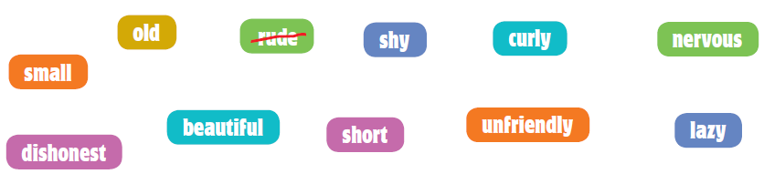

Personality
polite | rude
ugly
outgoing
hardworking
honest
friendly
confident
Physical appearance
straight
young
tall
big

Grammar
- Read the text and circle the correct word in the table below.



This is a photo of me and (1) mmmmmm brother cooking. We help a lot at home.
We always (2) mmmmmm our beds. I usually wash the dishes and (3) mmmmmm he
dries them.
He should put them in the cupboard, but I end up doing it (4) mmmmmm. We
never take out the rubbish, that is (5) mmmmmm our dad’s job because the bags
are heavy!
We like helping in the kitchen, but we don’t tidy up our bedrooms. My
mother is always telling us to tidy up our rooms. We (6) mmmmmm tidy up our
room every day, but we don’t and then we get in trouble.
1. | - you | - my | - myself
2. | - do | - make | - go
3. | - but | - or | - then
4. | - himself | - myself | - itself
5. | - never | - always | - every day
6. | - should | - do | - make

- Complete the sentences with the Present Simple of the verbs in brackets.

I have a little brother called Jack. He usually gets up (get up) at 7 o’clock. He
(1) mmmmmm (brush) his teeth and (2) mmmmmm (have) breakfast. Mum
(3) mmmmmm (make) breakfast, but we (4) mmmmmm (clean) the kitchen together.
Dad (5) mmmmmm (take) us to school. I (6) mmmmmm (be) always ready, but Jack
(7) mmmmmm (not be), because he always (8) mmmmmm (lose) his school bag.
He never (9) mmmmmm (put) it by the door and dad mmmmmm (10) (get) angry.

Writing
- Answer these questions about you. Write complete sentences.

- What’s the name of your best friend?
mmmmmm mmmmmm mmmmmm mmmmmm mmmmmm mmmmmm mmmmmm mmmmmm mmmmmm mmmmmm
- How old is your friend?
mmmmmm mmmmmm mmmmmm mmmmmm mmmmmm mmmmmm mmmmmm mmmmmm mmmmmm mmmmmm
- What does your friend look like?
mmmmmm mmmmmm mmmmmm mmmmmm mmmmmm mmmmmm mmmmmm mmmmmm mmmmmm mmmmmm
- What is your friend like?
mmmmmm mmmmmm mmmmmm mmmmmm mmmmmm mmmmmm mmmmmm mmmmmm mmmmmm mmmmmm
- Do you study together?
mmmmmm mmmmmm mmmmmm mmmmmm mmmmmm mmmmmm mmmmmm mmmmmm mmmmmm mmmmmm

- Look at the pictures and write a short description of Peter’s daily routine. (Write between 25 to 35 words.)
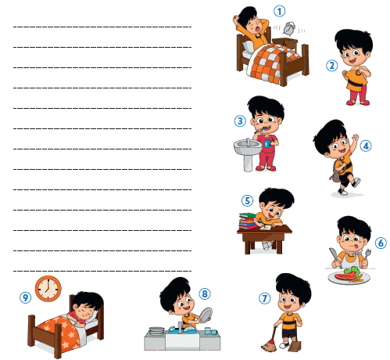
Units 0 + 1 · 6th grade
Version B
Agrupamento …………………………………………………………………………………………………………………………………………………………………..
Name: ………………………………..………………………………..………………… Class: …………….. Number: ……………..
Date: ……………..……………..………………………………………………….……. Evaluation: ………………….………………………………………….……..
Teacher: ……………..……………..……………..……………..……………………. E.E.: ……………………………………………………………….……………..
Listening
- Listen and draw lines. Match the name to the person.
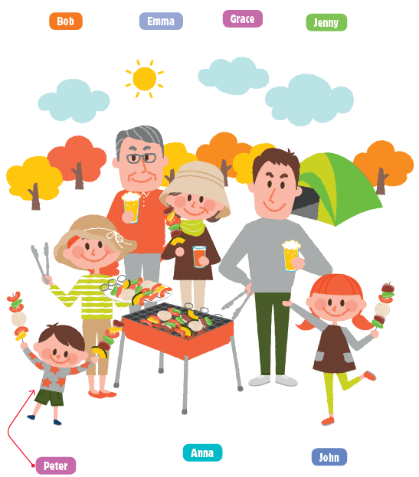

- Listen to Emma talking about her daily routine and choose the correct answer 1, 2 or 3.

Example What time does Emma wake up?

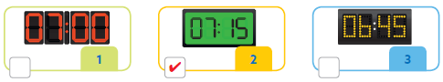

- What does she do after breakfast?

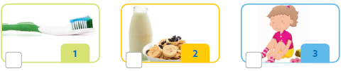

- How does Emma go to school?

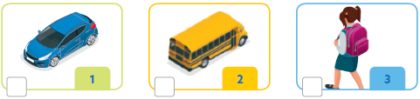

- When does Emma have science classes?

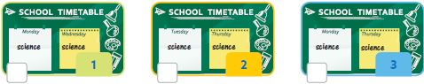

- What does Emma do after classes?

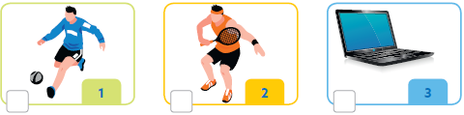

- What does Emma do before going to bed?



Reading
- Look at the picture and read the sentences. Write yes or no.
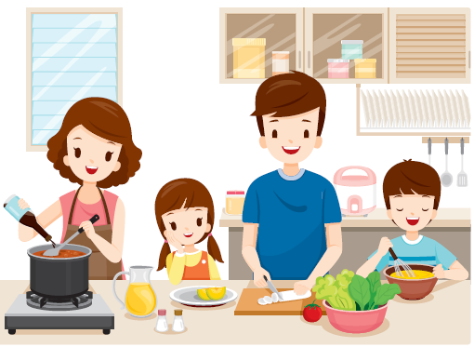

Examples The boy is helping his parents cook.. Yesmm mm
The father is eating.. No mm mm

Questions
a. The mother has short spiky hair. | mmmmmmmddermmmmmmmddermmmmmm
b. The girl has got long straight hair. | mmmmmmmddermmmmmmmddermmmmmm
c. The boy is making a pizza. | mmmmmmmddermmmmmmmddermmmmmm
d. The father is washing the dishes. | mmmmmmmddermmmmmmmddermmmmmm
e. The mother is making soup. | mmmmmmmddermmmmmmmddermmmmmm

- Read the text. Choose words from the boxes. Write the correct word next to the numbers 1-5. There is one example. There is one extra word.
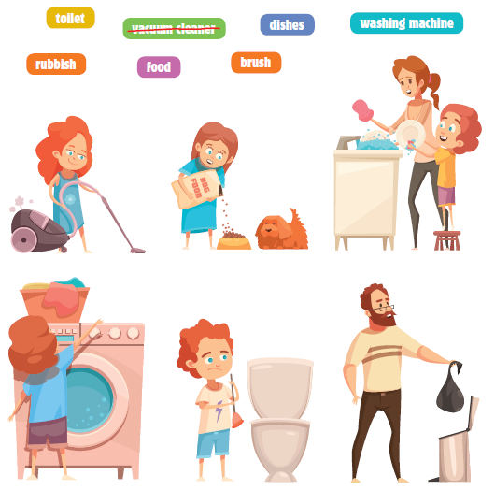

Sam’s family clean the house at the weekends.

Lana cleans the floor with the noisy vacuum cleaner . Sam gives the dog
his (1) mmmmmmmdde every day. Mum and Junior love washing the
(2) mmmmmmmdde after lunch.
Junior likes household chores, so he always puts the clothes in the
(3) mmmmmmmdde. He has one horrible chore, which is cleaning the
(4) mmmmmmmdde. He doesn’t like cleaning it!
Sam’s father always takes out the (5) mmmmmmmdde.

Reading and writing

Look at the pictures and read the story. Write three words to complete the sentences about the story.

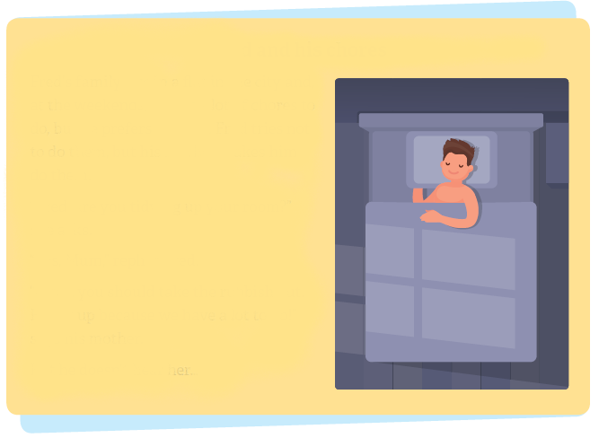
Fred and his chores
Fred’s family live in a flat in the city and,
at the weekends, he has a lot of chores to
do, but he prefers to sleep. Fred tries not
to do them, but his mother makes him
do them.
“Fred, are you tidying up your room?”
she asks.
“Yes, Mum,” replies Fred.
“Okay, you should take the rubbish out.
Hurry up because we have a lot to do!”
says his mother.
But he doesn’t hear her…

Examples Fred’s family live in a flat in the city.
Fred tries not to do his chores .
Questions
a. Fred’s mother asks if he is mmmmmmmdde mmmmmmmdde mmmmmmmdde room.
b. Fred should mmmmmmmdde mmmmmmmdde mmmmmmmdde out after tidying up his room.
c. Fred and his Mum mmmmmmmdde mmmmmmmdde mmmmmmmdde of chores to do.

Fred’s mother doesn’t hear any noise, so she goes
upstairs and finds Fred in bed!
“Get up, Fred. You have work to do!” she says in an
angry voice.
“I am sorry, Mum!” says Fred and he jumps out of bed.
“Get dressed and come and help me downstairs now.”
Fred gets dressed and runs downstairs.
“Have your breakfast, brush your teeth and then
wash the dishes,” says his Mum. Fred hates washing
the dishes, but he has to do them while his mother is
watching!
d. Fred’s mmmmmmmdde mmmmmmmdde mmmmmmmdde and finds Fred in bed.
e. Fred is very sorry, mmmmmmmdde mmmmmmmdde mmmmmmmdde and runs downstairs.
f. After brushing his teeth, Fred mmmmmmmdde mmmmmmmdde mmmmmmmdde.

“That’s great, Fred,” says his mother, “now
please take out the rubbish and clean the
living room.” “Okay, Mum!” says Fred.
Fred doesn’t like taking out the rubbish
because it smells bad. His father usually takes
it out, but he is working today. Fred gets the
vacuum cleaner and goes to the living room,
but it’s already clean!
“Yes, the living room is clean,” says his mother
smiling. “But you can feed the dog and then
play with him, but don’t forget your bed!”
“Great, I like doing that!” Fred feeds Rex, his dog, and plays with him for a
while.
“I have to go and make my bed now, Rex.”
g. First Fred’s mother asks him to take mmmmmmmdde mmmmmmmdde mmmmmmmdde.
h. Fred’s mother cleans mmmmmmmdde mmmmmmmdde mmmmmmmdde, so Fred is happy.
i. Fred plays mmmmmmmdde mmmmmmmdde mmmmmmmdde and feeds him.
j. After playing with his dog, Fred has to mmmmmmmdde mmmmmmmdde mmmmmmmdde.

Writing
Look at the pictures, read and write.

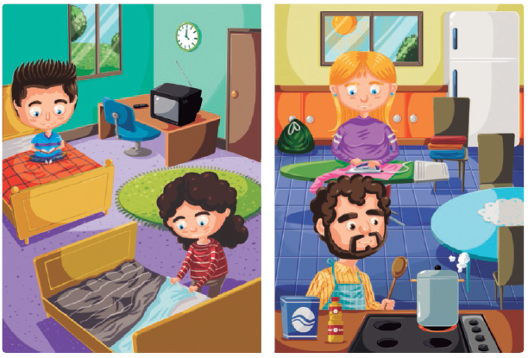

Examples It’s four o’clock.
Where are the children? They are in the bedroom.mm mm

a. Complete the sentences.
1. The girl has got long .mmmmmmmmmmm hair.
2. The girl is making the .mmmmmmmmmmm.

b. Answer the questions.
3. What is the boy doing?
…..mmmmmmmmmmm mmmmmm mmmmmm mmmmmm mmmmmm mmmmmm mmmmmm mmmmmm mmmmmm
4. What is the mother doing?
…..mmmmmmmmmmm mmmmmm mmmmmm mmmmmm mmmmmm mmmmmm mmmmmm mmmmmm mmmmmm
5. What is the father doing?
…..mmmmmmmmmmm mmmmmm mmmmmm mmmmmm mmmmmm mmmmmm mmmmmm mmmmmm mmmmmm

c. Now write three sentences about the picture (25 to 35 words).
mmmmmm mmmmmm mmmmmm mmmmmm mmmmmm mmmmmm mmmmmm mmmmmm mmmmmm mmmmmm
mmmmmm mmmmmm mmmmmm mmmmmm mmmmmm mmmmmm mmmmmm mmmmmm mmmmmm mmmmmm
mmmmmm mmmmmm mmmmmm mmmmmm mmmmmm mmmmmm mmmmmm mmmmmm mmmmmm mmmmmm
Units 0 + 1 · 6th grade
Version C
Agrupamento …………………………………………………………………………………………………………………………………………………………………..
Name: ………………………………..………………………………..………………… Class: …………….. Number: ……………..
Date: ……………..……………..………………………………………………….……. Evaluation: ………………….………………………………………….……..
Teacher: ……………..……………..……………..……………..……………………. E.E.: ……………………………………………………………….……………..
Listening
- Jane is talking to Rachel about her mother.
Listen and choose () the correct option.
a. What’s Jane’s mother’s name? |  |  | c. What is she like?
1. Lisa. |  |  | 1. Friendly.
2. Monica. |  |  | 2. Bossy.
b. What colour are her eyes? |  |  | d. What does Jane do at home to help?
1. Brown. |  |  | 1. She washes the dishes.
2. Black. |  |  | 2. She takes the dog out.

- Listen and circle the correct information about Jane’s brother.

a. | First name | Tom * Sam
b. | Surname | Marvins * Martins
c. | Age | 15 * 16
d. | Hair | black * brown
e. | Eyes | green * blue
f. | Personality | shy * smart

Reading comprehension
Read about Jane’s brother.
My name’s Tom and I am Jane’s brother.
We live in Glasgow, in Scotland. I always get up at eight o’clock,
but my sister gets up 30 minutes before.
We have breakfast with our mum and
then we go to school by bus.
I help a lot at home: I make my bed, I set
the table and my sister dries the dishes.
Twice a week I take the rubbish out.
After school, we do our homework in our
bedroom and then we have dinner.
Before going to bed, I always play video
games.
- Write true (T) or false (F).
a. Tom is Spanish. mmmmmmmddermmmmmmmddermmmmmm
b. Tom always gets up at 8 am. mmmmmmmddermmmmmmmddermmmmmm
c. Tom has breakfast with his mother. mmmmmmmddermmmmmmmddermmmmmm
d. They go to school by car. mmmmmmmddermmmmmmmddermmmmmm
e. They do their homework before having dinner. mmmmmmmddermmmmmmmddermmmmmm

- Match the questions to the answers.
a. Who is Jane? |  |  | 1. Twice a week.
b. What time does Jane get up? |  |  | 2. She’s Tom’s sister.
c. How often does Tom take the rubbish out? |  |  | 3. He plays video  games.
d. Where does Tom do his homework? |  |  | 4. She gets up at 7:30/  half past seven.
e. What does he do after dinner? |  |  | 5. In his bedroom.

Vocabulary
- Look at the pictures and write the missing verb.
a. do the washing up |  | b. mmmmmm the bed |  | c. mmmmmm breakfast
d. mmmmmm a book |  | e. mmmmmm to school |  | f. mmmm my homework

- Write the opposites.



Personality
polite | rude
ugly
nervous
Physical appearance
straight
tall
big

Grammar
- Read the text and circle the correct word in the table below.

This is a photo of me and (1) mmmmmm brother cooking. We help a lot at
home.
We always (2) mmmmmm our beds. I usually wash the dishes and then he
dries them.
He doesn’t put them in the cupboard, but I end up doing it (3) mmmmmm .

Taking out the rubbish is (4) mmmmmm dad’s job because the bags are
heavy!
My mother is always telling us to tidy up our rooms. We (5) mmmmmm tidy
up our room every day, but we don’t and then we get in trouble.
1. | you | my
2. | go | make
3. | myself | himself
5. | never | always
6. | should | do

- Circle the correct verb.

a. My mother does / makes my bed in the morning.
b. I go / goes to school by car.
c. John play / plays football on Saturdays.
d. They do / does their homework in the bedroom.
e. My father usually does / makes dinner.

Writing
- Read about Jack’s daily routine. Complete the text with one word in each space.
Name | Age
Jack Cruise | 11

Hi! My name is Jack Cruise and I’m (1) mmmmmm years old.
I usually wake up at (2) mmmmmm  o’clock and I have
breakfast with my family.
After that, I always make my (3) mmmmmm  and I go
to school.

I have lunch in the school canteen every day.
Later, at five o’clock, I go (4) mmmmmm  with my father
and I have a (5) mmmmmmv .
I always do my (6) mmmmmm  or I study.
We have dinner at (7) mmmmmm  o’clock and then I watch
(8) mmmmmm .
I usually go to bed at half past ten.

- Answer about you.

a. What’s your name? mmmmmmmddermmmmmmmddermmmmmm
b. How old are you? mmmmmmmddermmmmmmmddermmmmmm
c. Where are you from? mmmmmmmddermmmmmmmddermmmmmm

