5th Form
Name: _____________________________________________N: _____ Class:_____
Date: _______________________________________________________________________

- Match the pictures with the words.
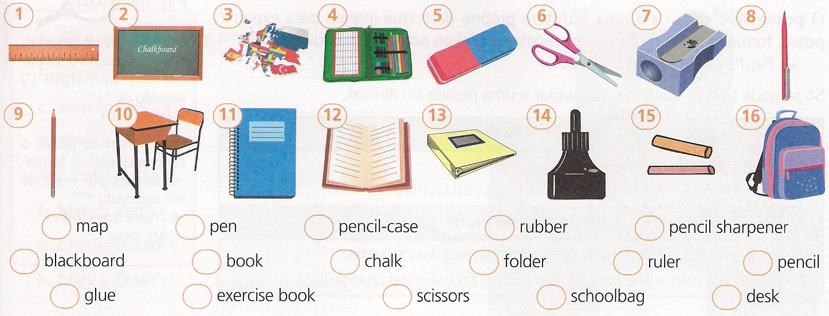
(Liga as imagens às palavras).

Usa:
lion / panda / giraffe kangaroo / crocodile
- Write the names of the animals.
(Escreve os nomes dos animais).

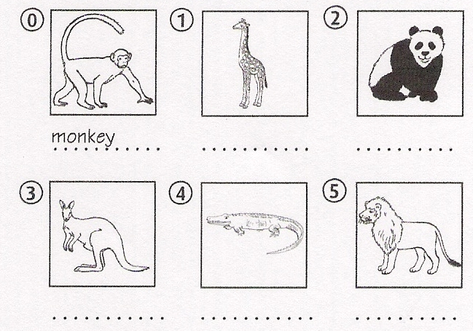

- Right () or wrong ()?
(Certo () ou errado ())

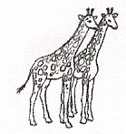 | 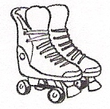 | 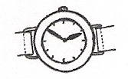
- giraffe | - comic | - watch
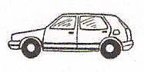 | 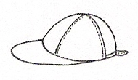 | 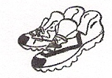
- bike | - baseball cap | - trainers

- Complete the crossword puzzle.
(Completa o crucigrama).
Usa:
garage / bedroom / kitchen / hall bedroom / bathroom / attic / study garden / livingroom / diningroom

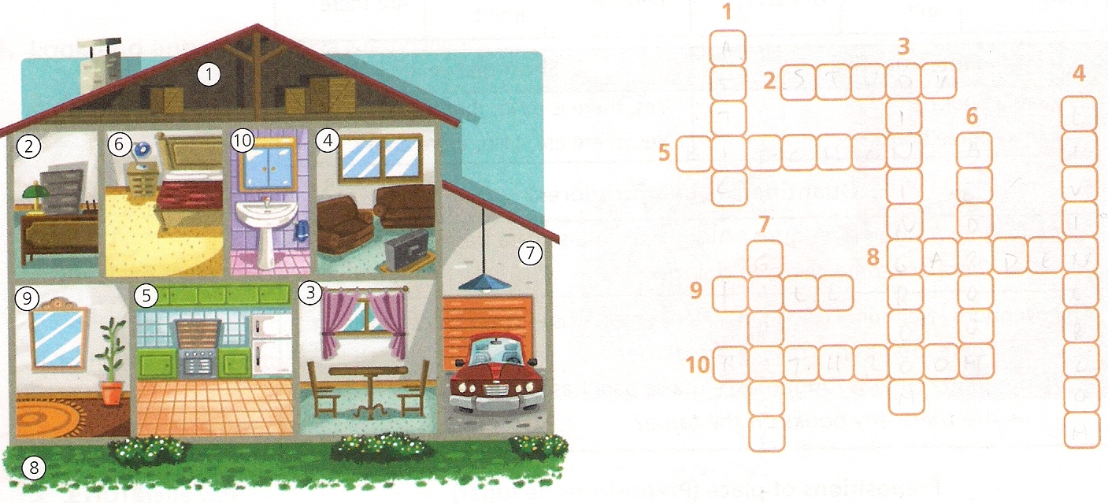

Good work!!!!

