Aprendizagens Essenciais
Áreas temáticas:  - Means of transport  - Places in a city  - Shops  - Types of buildings | Compreensão oral:  - Compreender discursos muito simples articulados de forma clara e pausada  - Seguir conversas sobre assuntos que lhe são familiares  - Identificar o contexto do discurso, a ideia principal e informação simples | Compreensão escrita:  - Compreender textos simples com vocabulário limitado  - Identificar a ideia principal e a informação essencial em textos diversificados | Interação escrita:  - Preencher um formulário simples (online ou em formato papel) com informação pessoal e sobre áreas de interesse básicas  Produção escrita:  - Escrever um pequeno texto com informação sobre as férias, com a ajuda de tópicos ou imagens

Listening test
Objetivos | Conteúdos | Estrutura | Cotações | Critérios de classificação
Listening 20%  L6 – Compreender, com ajuda, discursos articulados de forma clara e pausada | Textos relacionados com os tópicos da unidade 4: Places in a city and means of transport | - Assinalar vários locais de acordo com o texto áudio.  - Associar os nomes de pessoas ao meio de transporte favorito. | 5 x 2 = 10  5 x 2 = 10 | 2 pontos por cada resposta correta  2 pontos por cada resposta correta
Test
Objetivos | Conteúdos | Estrutura | Cotações | Critérios de classificação
Reading 30%  R6 – Ler textos breves sobre assuntos do seu interesse | Texto relacionado com os tópicos da unidade 4: Means of transport and places in a city | 1. Identificar e escolher a opção correta de acordo com o texto. | 6 x 3 = 18 | 3 pontos por cada resposta correta
 |  | 2. Responder a perguntas de interpretação sobre o texto. | 4 x 3 = 12 | 3 pontos por cada resposta correta
Vocabulary 10%  LG9 – Compreender formas de organização do léxico e conhecer algumas estruturas frequentes do funcionamento da língua | Vocabulário relacionado com os tópicos da unidade 4: Shops and types of buildings | - Identificar lojas de acordo com as descrições das mesmas. | 5 x 1 = 5 | 1 ponto por cada resposta correta  -0,5 por erros de ortografia
 |  | - Legendar imagens sobre diferentes tipos de edifícios. | 5 x 1 = 5 | 1 ponto por cada resposta correta  -0,5 por erros de ortografia
Grammar 20%  LG9 – Compreender formas de organização do léxico e conhecer algumas estruturas frequentes do funcionamento da língua | The Imperative | - Completar espaços com palavras fornecidas para dar as direções corretas. | 5 x 1 = 5 | 1 ponto por cada resposta correta
 | Prepositions of movement | - Identificar e escolher a preposição de movimento correta na frase. | 5 x 1 = 5 | 1 ponto por cada resposta correta
 | Past Simple | 5. Completar as frases com os verbos no Past Simple. | 5 x 1 = 5 | 1 ponto por cada resposta correta
 | Past Simple | 6. Ordenar palavras, de modo a escrever frases na forma interrogativa no Past Simple. | 5 x 1 = 5 | 1 ponto por cada resposta correta  NOTA: Em cada resposta -0,5 por erros de ortografia
Writing 20%  W8 – Produzir textos de 25 a 35 palavras | Respostas a perguntas.  Tema: Writing a postcard about a trip | 1. Responder a perguntas pessoais sobre os temas da unidade. | 5 x 2 = 10 | 2 pontos por cada resposta correta
Writing 20%  W8 – Produzir textos de 25 a 35 palavras |  | 2. Produzir um texto com dados relativos a uma viagem. | 5 x 2 = 10 | 2 pontos por cada frase correta

LISTENING TEST
/10
Listen and tick () the places that you hear in the city.
1

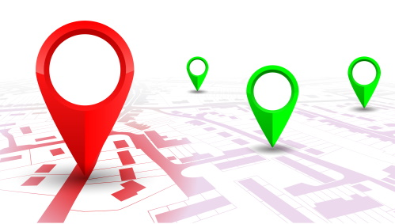
- theatre
- museum
- hotel
- church
- fire station
- post office
- hospital
- railway station
- town hall
Listen and match the people to their favourite means of transport.
2
/10

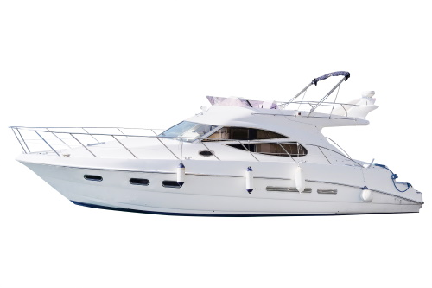 | 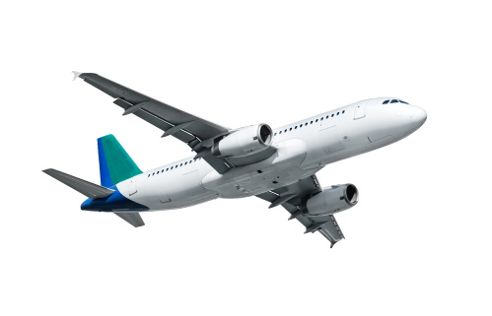 | 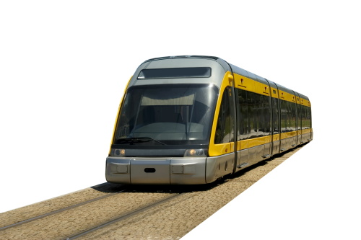
a. | b. | c.

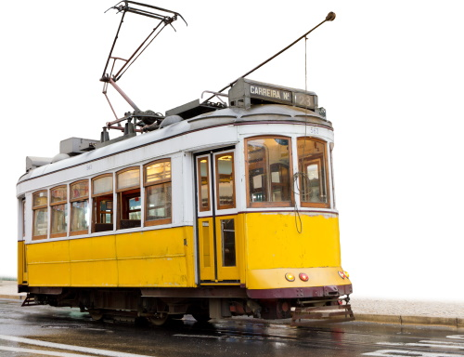 | 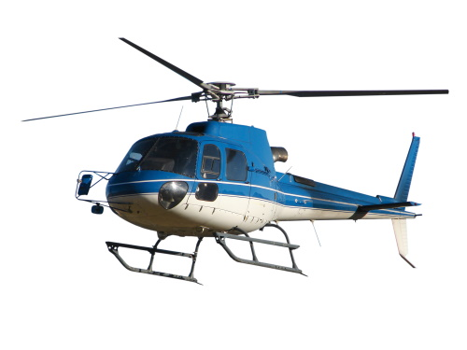
d. | e.

1. Mike | 2. Anna | 3. Sally | 4. Tom | 5.Grace

READING
Read the text.
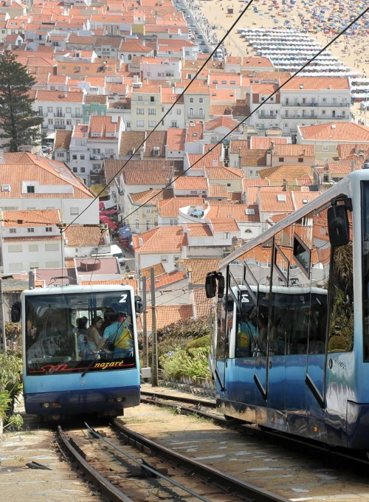
My name is Rui and last year I went to Nazaré, which is in the district of Leiria, with my family on holiday. We had a great time! We travelled by car and stayed at a cool hotel. There were lots of surfers there. Do you know why? Well, let me explain: Nazaré is a very popular surfing destination because of its very big waves.
A famous Brazilian surfer won the Quiksilver XXL Biggest Wave prize there. He entered the Guinness World Records because he broke the previous record. The wave he surfed was 24.4 m high. It was the biggest wave ever surfed! Isn’t that awesome¹?
There were also good restaurants with delicious fish there. Nazaré is a fishing village and the fishermen’s wives wear traditional seven coloured flannel² skirts and sell souvenirs. I bought a magnet for my grandmother’s collection.
Nazaré is not very big but there are lots of places to visit nearby. I went to Sítio. It is an old village on the top of a cliff³ and you can catch a funicular railway to get down to a small place called Praia. Do you know what a funicular is? It’s like a tram but it has a strong cable that pulls³ it up a mountain. It was my first time in a funicular. I loved it!
Word box:
¹ awesome: incrível; ² flannel: flanela (tecido);
³ cliff: penhasco; ⁴ pulls: puxa.

Circle the correct option according to the text.
1
a. Rui spent his holidays in … .
1. Coimbra 2. Lisboa 3. Nazaré
/18
b. There are lots of … there.
1. habitants 2. tourists 3. surfers
c. Its beaches are famous because of … .
1. the great weather 2. the very big waves 3. the sand
d. The fishermen’s wives wear a traditional outfit that has got … .
1. seven coloured skirts 2. six coloured skirts 3. seven coloured scarfs
e. At the restaurants you can eat delicious … .
1. fish 2. meat 3. snacks
f. Sítio is … .
1. on the beach 2. at the top of a cliff 3. at the top of a mountain
Answer the questions.
2
/12
- Where is Nazaré?

- Did Rui travel by train?

- Where did he stay?

- What is a funicular?

VOCABULARY AND GRAMMAR
Read the sentences and write the names of the correct shops.
1
/5

- You can buy trousers and t-shirts there. | corner shop
- You can buy magazines and newspapers there. | clothes shop
- You can buy eggs and yoghurts there. | chemist’s
- You can buy some medicine there. | florist’s
- You can buy beautiful bouquets of flowers there. | newsagent’s
Label the pictures of the buildings.
2
/5

 |  |  |  | 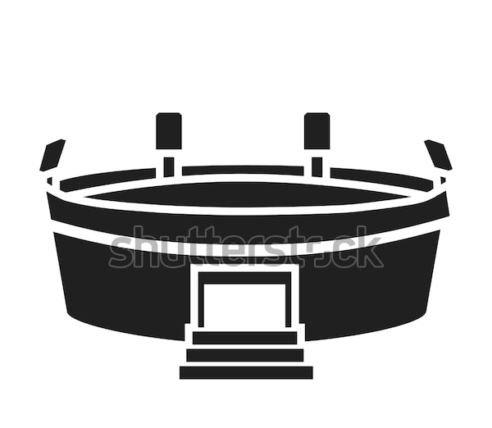
/5
Complete the gaps with the directions to the theatre with the verbs in the box.
3

To get to the theatre, a. ________________ to the roundabout. b. __________ the second exit and c. ___________ straight ahead. Then d. __________ right into King’s Avenue and e. ________________ at the traffic lights. The theatre is on your left, next to the bus stop. | take  stop  go (x2)  turn
Circle the correct preposition of movement.
4
/5
- They walked to / across the train station and bought our tickets.
- Anna, you have to walk into / across the bridge and then you will find me on the other side.
- We went towards / into the theatre and looked for our seats.
- He climbed onto / into the tram.
- I walked across / towards the ticket office to ask about the bus timetable.

Complete the gaps with the Past Simple of the verbs in brackets.
5
/5

- Yesterday they (buy) tickets for the train.
- I (not / go) on holiday to Los Angeles last year.
- We (travel) by coach last weekend.
- Kate (have) a lot of fun in New York.
- John (not / eat) the local food.
Write questions using the Past Simple.
6
/5
- he / watch / the football match / yesterday ?
- you / use / a map / to find the restaurant ?
- What / famous places / you / see / in Italy ?
- Where / you / stay ?
- How many / museums / you / visit? ?
WRITING
Answer the questions about you.
1
/10
- Where is your favourite place in town?
- Did you go to school on foot today?
- What’s your favourite means of transport?
- Is there a tram in your town?
- What did you do yesterday after dinner?
/10
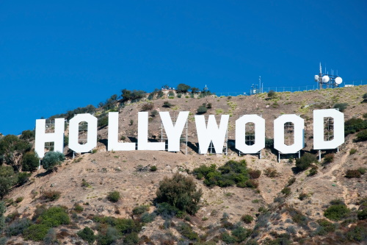

Write a postcard (25-35 words) about your imaginary trip to Los Angeles last summer.
Mention the topics in the box.
see: Hollywood sign
visit: Warner Bros Studious; La Brea Tar Pits and Museum; Hollywood Boulevard
walk along: beaches of Santa Monica
your opinion of the trip: fantastic
2

Listening script
Exercise 1
Mother: TOM… It’s time to wake up! Let’s go!
Tom: Oh mum, it’s Saturday! Can’t I sleep a bit more? Oh, please…
Mother: No, it’s your father’s birthday and we have a lot to do. I need your help! Come on sleepy head!
Tom: Ok… ok… give me an hour…
Mother: An hour? I don’t have an hour! Hurry up! I need you to come with me to a few places…
Tom: Places… what places?
Mother: Well, first we have to go to the theatre to pick up the tickets I bought for the show next weekend… it’s a present for your dad. He will love the surprise! Then, we have to pick up my medical exams at the hospital. Next, we have to go to the Garden Hotel.
Tom: To the hotel? Why?
Mother: Because your grandparents are coming for your father’s birthday and they want to stay at the hotel. I have to book it for them. Well, after that we have to collect a package at the post office. It’s another present for your father!
Tom: Oh, wow! He is very lucky! But… mum, why do you need me to go with you?
Mother: Because it’s very difficult to park at the theatre and at the post office… so I will stay in the car and you can go inside and run my errands…
Tom: Oh, I see… That makes sense.
Mother: Well, finally, at about 1h00 pm we have to pick up your grandparents at the railway station… and you know them… we have to be there on time... so… HURRY UP! It’s going to be a long day!

Exercise 2
Mike: Hi! My name is Mike. I like travelling by boat but my favourite means of transport is travelling by plane. I love being up in the clouds!
Anna: Hello, I’m Anna. My favourite means of transport is the metro. I really enjoy to travel around a city by metro. It’s easy and practical I guess.
Sally: Hi, I’m Sally! I go everywhere by car… just as most people do… but my favourite means of transport is the tram. I think the tram is a very romantic way to travel from one place to another.
Tom: My name is Tom and I’m an adventurous boy, so my favourite means of transport is travelling by helicopter. Did you ever travel by helicopter? I think that must be super cool.
Grace: Hi, my name is Grace and I love the ocean! So, can you guess what my favourite means of transport is? Yes, of course it is the boat! I love the sound of the ocean and the smell of the salty air. Travelling by boat is my favourite means of transport!
Answer key
Listening test
- a. (theatre) c. (hotel) f. (post office) g. (hospital) h. (railway station)
- a. Grace b. Mike c. Anna d. Sally e. Tom
Test
Reading
- a. 3 b. 3 c. 2 d. 1 e. 1 f. 2
- a. It is in the district of Leiria. b. No, he didn’t. He travelled by car. c. He stayed at a cool hotel. d. It is a means of transport that is like a tram, but it has got a strong cable that pulls it up a mountain.
Vocabulary and grammar
- a. clothes shop b. newsagent’s c. corner shop d. chemist’s e. florist’s
- a. lighthouse b. castle c. farmhouse d. factory e. stadium
- a. go b. Take c. go d. turn e. stop
- a. to b. across c. into d. onto e. towards
- a. bought b. didn’t go c. travelled d. had e. didn’t eat
- a. Did he watch the football match yesterday? b. Did you use a map to find the restaurant? c. What famous places did you see in Italy? d. Where did you stay? e. How many museums did you visit?
Writing
1. Personal answers: a. My favourite place in town is… b. Yes, I did. / No, I didn’t. I went to school by… c. My favourite means of transport is… d. Yes, there is. / No, there isn’t. e. Yesterday I…
2. Last summer I went to Los Angeles. I saw the famous Hollywood sign. I also visited the Warner Bros Studios, the La Brea Tar Pits and Museum and Hollywood Boulevard. Then, I walked along the beaches of Santa Monica. My trip was fantastic!

