Aprendizagens Essenciais:
Áreas temáticas:  Escola:  - School subjects  - Places  - Clubs | Compreensão oral:  - Compreender discursos muito simples articulados de forma clara e pausada  - Seguir conversas sobre assuntos que lhe são familiares  - Identificar o contexto do discurso, a ideia principal e informação simples. | Compreensão escrita:  - Compreender textos simples com vocabulário limitado  - Identificar a ideia principal e a informação essencial em textos diversificados | Interação escrita:  - Preencher um formulário (online) ou em formato papel simples, com informação pessoal e sobre áreas de interesse básicas  Produção escrita:  - Escrever um pequeno texto com informação sobre a escola, com a ajuda de tópicos ou imagens.

Listening test
Objetivos | Conteúdos | Estrutura | Cotações | Critérios de classificação
Listening 20%  L6 – Compreender, com ajuda, discursos articulados de forma clara e pausada | Textos relacionados com os tópicos da unidade 2: School subjects, places and clubs | - Associar os nomes aos clubes escolares  - Escrever verdadeiro ou falso. | 5 x 2 = 10  5 x 2 = 10 | 2 pontos por cada resposta correta  2 pontos por cada resposta correta
Test
Objetivos | Conteúdos | Estrutura | Cotações | Critérios de classificação
Reading 30%  R6 – Ler textos breves sobre assuntos do seu interesse | Texto relacionado com os tópicos da unidade 2: School subjects, and clubs | - Completar frases com uma palavra.  - Responder a perguntas de interpretação sobre o texto. | 6 x 3 = 18  4 x 3 = 12 | 3 pontos por cada resposta correta  3 pontos por cada resposta correta
Vocabulary 10%  LG9 – Compreender formas de organização do léxico e conhecer algumas estruturas frequentes do funcionamento da língua | Vocabulário relacionado com os tópicos da unidade 2: School subjects and places | - Completar espaços com as palavras dadas.  - Legendar imagens. | 5 x 1 = 5  5 x 1 = 5 | 1 ponto por cada resposta correta  -0,5 por erros de ortografia  1 ponto por cada resposta correta
Grammar 20%  LG9 – Compreender formas de organização do léxico e conhecer algumas estruturas frequentes do funcionamento da língua | Present Continuous – affirmative, negative and interrogative  Present Simple – affirmative, negative and interrogative  Prepositions: at, in, on The comparative  The superlative | - Completar espaços com os verbos no Present Continuous na afirmativa, negativa e interrogativa.  - Circundar os verbos no Present Continuous ou no Present Simple na afirmativa e negativa corretos. | 5 x 1 = 5  5 x 1 = 5 | 1 ponto por cada resposta correta  1 ponto por cada resposta correta
 |  | 5. Completar espaços com as prepositions: at, in, on. | 5 x 1 = 5 | 1 ponto por cada resposta correta
 |  | 6. Completar espaços com o comparative do adjetivo fornecido. | 3 x 1 = 3 | 1 ponto por cada resposta correta
 |  | 7. Completar espaços com o superlative do adjetivo fornecido. | 2 x 1 = 2 | 1 ponto por cada resposta correta
NOTA: Em cada resposta
-0,5 por erros de ortografia
Writing 20%  W8 – Produzir textos de 25 a 35 palavras | Responder a perguntas  Tema: School subjects, places and clubs | 1. Responder a perguntas pessoais sobre os temas da unidade. | 5 x 2 = 10 | 2 pontos por cada resposta correta
 |  | 2. Produzir um texto com informação sobre a escola. | 5 x 2 = 10 | 2 pontos por cada frase correta

LISTENING TEST
Listen and match the names to the school clubs.
1
- Ken ________________  - Sandy ________________  - Thomas ________________  - Anna ________________  - Philip ________________ |                     4  5  3  2  1

/10
Listen to the dialogue and write TRUE (T) or FALSE (F).
2


- On Monday the first subject the children have is French. _____
- On Tuesday they have history before lunch. _____
- On Wednesday the children end the day with maths. _____
- The children don’t have science on Thursday. _____
- The children adore English. _____

READING

Read the text.
Hi. My name’s Jack and I go to a boarding school in Kent in England. It’s called The King’s School. There are thirteen boarding houses at my school. It is big and very traditional. Some of the buildings are from the thirteenth century. Isn’t that amazing? I think it’s a beautiful school! There are around one thousand students in my school. There are two main buildings at my school. The biggest one has got most of the classrooms, the principal’s office, the secretary’s office, the tuck shop, the library, the assembly hall and the school stationary shop. The canteen and the student rooms where we hang out and watch TV are in another building so that we don’t make too much noise. There are also some houses where some of my teachers live at my school. My history teacher has a really cute dog called Rex.
Lessons start at 9:00 a.m. sharp and end at two every day. Then, we have lunch. There is lots of delicious food to choose from in the canteen. You can choose to eat meat, fish, vegetarian, vegan or diet food every meal. In the afternoon we do sports or any of the school club activities that we are in and our homework of course. I belong to the drama club. I love acting. I also like playing football and basketball, so I am in the football and basketball teams too. Dinner is at 6:00 p.m. and we have to be back in our rooms by 8:00 p.m. at the latest. We have to be in bed by 11:00 p.m. This is called lights out.
I love going to boarding school. It’s true that I miss my family, but I skype them every day and see them every holiday.
Word box:
boarding school: colégio interno
/18

Complete the gaps with ONE word.
1

- Jack’s school is an ______________________ school in Kent.
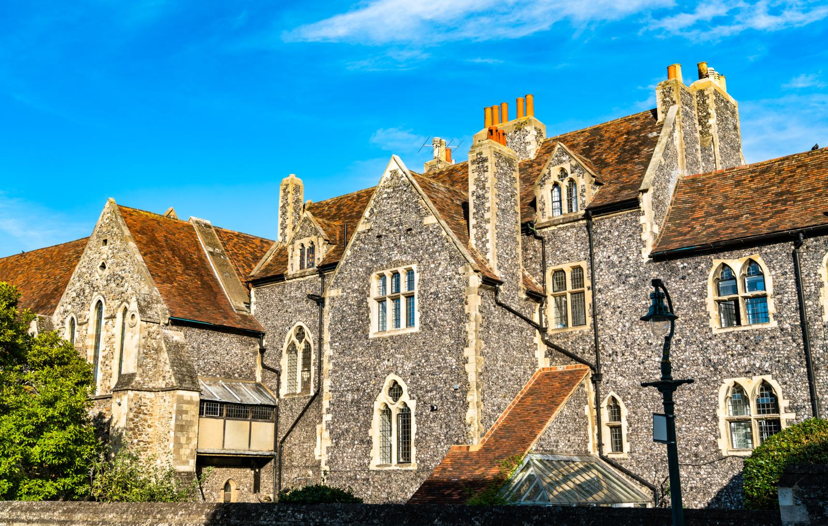
- His school isn’t very modern. It’s ______________________.
- The principal’s office is in the ______________________ building.
- Jack likes the ______________________ teacher’s dog very much.
- Lessons at Jack’s school are only in the ______________________.
- Jack loves playing football and ______________________.

Answer the questions.
2
/12

- Is the food good at Jack’s school? ________________________________________________.
- How many students are there at Jack’s school? _____________________________________.
- Which club is Jack in? ______________________________________________________.
- What time does Jack go to sleep every day? _______________________________________.
VOCABULARY AND GRAMMAR
Complete the gaps with a subject in the boxes below.
1
/5

IT |  | history |  | physical education |  | art |  | maths
- You play sports in this subject.
- You work with numbers in this subject.
- You learn to draw and paint in this subject.
- You learn about kings and queens in this subject.
- You work with computers in this subject.

Label the places at school.
2
/5







- ____________ b. c. d. _ e. ___
____
/5
Complete with the verbs in brackets in the Present Continuous.
3

- Sarah and I (do) our homework now.
- you (watch) TV at the moment?
- John (sing) in the choir at present.
- Tim (not / write) a code for my robot in the robotics club now.
- Anne (study) for the English test now.
Circle the correct answer.
4
/5
- We have / are having French every Monday at 9:00 a.m.
- The children eat / are eating lunch in the canteen at the moment.
- Tom doesn’t read / isn’t reading a book in the library now.
- I always go / am going to school on foot.
- The boys don’t play / aren’t playing football now.

Write the correct prepositions at, in, on for each word or expression.
5
/5

- Thursday
- 7:30 p.m.
- the morning
- winter
- Easter
Complete the gaps with the comparative form of the adjective in brackets.
6
/3
- Maths is _______ (nice) than science.
- The choir is (popular) than the Environmental club.
- My mother is (busy) than your aunt.
Complete the gaps with the superlative form of the adjective in brackets.
7
/2
- My school is (good) school in my city.
- This exercise is (easy) exercise in my book.
WRITING
Answer the questions about you.
1
/10
- What’s your favourite subject? ___________________________________________________
- Is there a canteen in your school? ________________________________________________
- What is your favourite school club? _______________________________________________
- What subjects are easy for you? __________________________________________________
- Do you go to the library at your school? ____________________________________________
Write about Kate Johnson (25-35 words). Use the information in the box to help you.
2
/10

Name: Kate Johnson
Age: 12
Favourite subjects: History and Science
Crazy about: sports

Top school clubs:
sports club and the chess club
School: love it!



Keep calm and work hard! Merry Christmas!
Your teacher, ________________________
Listening script
Exercise 1

- Hi! My name’s Ken and I’m what you call a techy guy. I love anything that is about technology. That’s why I’m part of the robotics club. I’m learning to code so that I can build a robot that does exactly what I want it to. Perhaps one day I’ll be the President of the robotics club. Doesn’t that sound cool?
- I’m Sandy, Sandy the photographer. At least that’s what people call me here at school. I can’t go anywhere without my camera. I love taking photos. Everyone in my class knows that. That’s why they call me Sandy the photographer and I’m in the photography club!
- Hi, my name’s Thomas but everyone calls me Tom. I love drama and acting. One day I want to be an actor. So, I guess that’s why I go to the drama club every Tuesday and Friday after school. Acting is a wonderful way to relax. At least that’s what I think!
- My name’s Anna and I hate singing and acting. I prefer things that are more logical like science and stuff like that. That’s why the environmental club is the perfect club for me!
- I’m Philip and I love singing. I love it so much that I belong to the choir at my school. At the moment we are learning to sing a classical version of a popular song on the radio. You know, the one that everyone is listening to? Why don’t you come to choir practice so that you can learn to sing it with me?

Exercise 2

So, class as you know you have a new timetable this semester. Some things are the same but some subjects change. Please write the changes in your notebooks.

On Monday morning your first lesson is Science. This is the perfect way to start the week. I know that you like the science teacher very much so that’s good news!

Now pay attention because on Tuesday you have history before lunch. Did you hear that you have history and not geography on Tuesday before lunch?

Wednesday stays the same because at the end of the day you still have maths. Remember to bring your maths exercise book on Wednesday or your maths teacher will be angry.

On Thursday you have science after lunch. That’s right. Science is after lunch on Thursday. I have some good news for you. We end the week with English on Friday afternoon. I know that you adore our English lesson, so this is a great way for you to start the weekend. Don’t forget to ask your parents to check their emails so they know about your new timetable. Any questions?

Answer key
Listening test
1.
a. Ken – robotics club
b. Sandy – photography club
c. Thomas – drama club
d. Anna – environmental club
e. Philip – choir

2.
a. False
b. True
c. True
d. False
e. True
Test
Reading
1.
a. English
b. traditional
c. main
d. history
e. morning
f. basketball

2.
a. Yes, it is.
b. There are around one thousand students at Jack’s school.
c. Jack is in the drama club.
d. He goes to bed at 11:00 p.m. every day.
Vocabulary and grammar
1.
a. physical education
b. maths
c. art
d. history
e. IT

2.
a. canteen
b. gym
c. art room
d. library
e. music room

3.
- are doing
- Are (you) watching
- is singing
- isn’t writing
- is studying
4.
a. have
b. are eating
c. isn’t reading
d. go
e. aren’t playing

5
a. on
b. at
c. in
d. in
e. at

6.
a. nicer
b. more popular than
c. busier

7.
a. the best
b. the easiest

WRTITING
1. Personal answers
a. My favourite subject is…
b. Yes, there is. / No, there isn’t.
c. My favourite school club is…
d. …, … and… are easy for me.
e. Yes, I do. / No, I don’t.

2. My name is Kate Johnson and I am 12 years old. My favourite subjects are history and science. I’m crazy about sports. My top school clubs are the sports club and the chess club. I love my school.

