Unit 1 History – Portuguese mid-XIX century lifestyles

Name No. Class
Date / / Mark Teacher
Read and underline the important facts about the lifestyle of the Portuguese bourgeoisie and nobility in the XIX century.
A
In the mid-19th century the Portuguese rich nobility live in luxurious mansions with beautiful gardens on the outskirts of the cities. The high bourgeoisie have money, so they live comfortably like the nobility.
They dress like the nobles. The nobles and the bourgeoisie follow French fashion and buy their clothes from famous big shops in Lisbon called “Armazéns do Chiado”, the “Grandela” or the “Casa Africana” that are very popular at this time.
Read and underline the WRONG information. Then, correct it.
B
- The high nobility live in small mansions.
- The high bourgeoisie don’t have a lot of money.
- The bourgeoisie and the nobles follow Italian fashion.
- There aren’t any big shops in Lisbon at this time.
Label the nobles and bourgeoisie’s freetime routines with an expression below.
C
- walking in parks
- going to the theatre/opera
- going to balls
- going to cafés

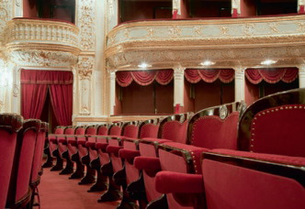 |  | 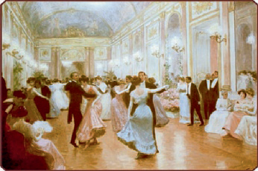
a |  | b

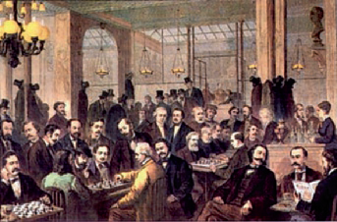 |  | 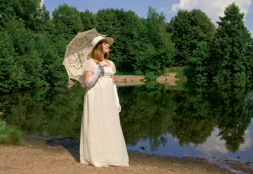
c |  | d

Unit 2 History – School reform in the 1st Republic

Name No. Class
Date / / Mark Teacher
Read and underline the important facts.
A
Why do Republicans think that school reform is important?
Republicans consider that education is important. They defend that education makes people better. So, the Republic governments start passing laws to reform education in Portugal in 1910.

Secondary and vocational
(to prepare people for jobs) education
More high schools and vocational (agricultural, commercial and industrial) schools are opened.
Nursery and Primary education
Nursery schools are created for children between the ages of 4-7.
Primary school becomes obligatory and free for every child. They teach children to read, write and count.
More primary schools are opened. Colleges are opened to train teachers.
Tertiary (university) education
The Universities of Lisbon and Oporto are created.
Portugal now has three universities (Coimbra, Lisbon and Porto).

Look at the graph and answer the questions.
B
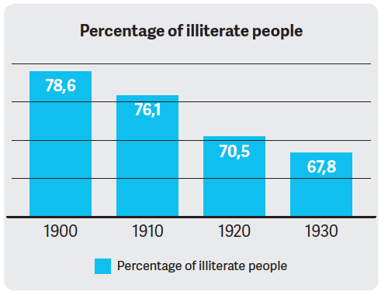
- In which year is the percentage of illiterate people the highest?

- In which year is the percentage of illiterate people the lowest?

- Do you think the 1st Republic’s educational reform was successful? Why?

Unit 3 History – The modern economy

Name No. Class
Date / / Mark Teacher
Read and underline the important facts.
A
The modern economy is divided into three sectors: the primary, the secondary and the tertiary sectors. The primary sector involves activities that are linked to the land and getting nature’s products. The secondary sector involves transforming natural and primary products like wood into new products. The tertiary sector involves all jobs that supply services to others so that people can live more comfortable lives.
Look and label the jobs according to the economic sector they belong to.
B
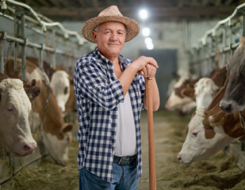 |  | 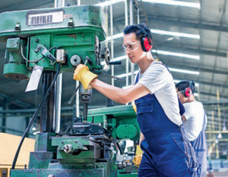
farmer  1. | teacher  2. | factory worker  3.
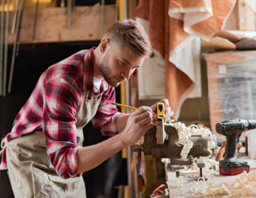 |  | 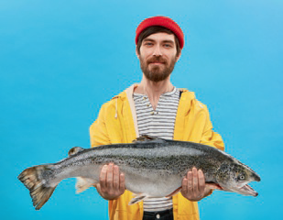
carpenter  4. | doctor  5. | fisherman  6.
 | 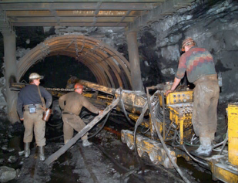 | 
sales assistant  7. | miner  8. | civil construction worker  9.

Unit 4 History – The importance of public transport

Name No. Class
Date / / Mark Teacher
Match the sentences to find out more about the importance of public transports in our society.
A

- Public transports
- There are
- The transportation network
- The best transportation networks are
- The Portuguese railway system
- Eﬀorts to modernise railway tracks
- High speed trains
- An alternative to travelling by train
- Water transportation is
- 90% of Portuguese trade
- three types of transportation: land, air and water.
- already circulate between Lisbon and Oporto.
- relies on water transportation.
- are mainly confined to coastal areas.
- is to travel by coach which is cheaper and can access more remote areas of the country.
- belong to the tertiary sector.
- mainly used for transporting big heavy goods.
- near the cost where the majority of people live.
- is a network of roads, streets, railways, canals and airports in an area.
- is still practically the same as it was in the beginning of the 20th century.

1 | 2 | 3 | 4 | 5
6 | 7 | 8 | 9 | 10

Look and label the means of transportation.
B

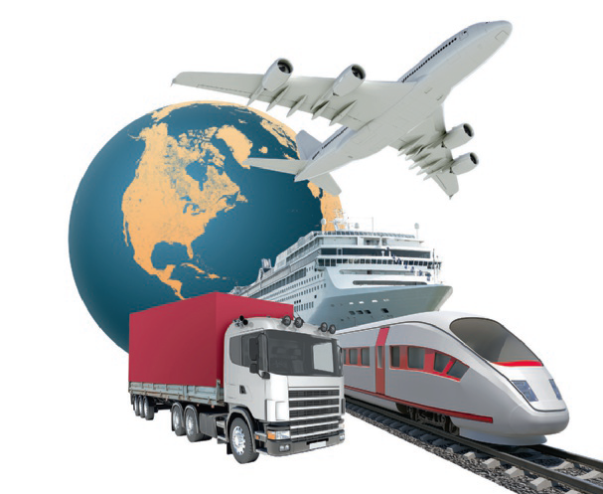

Unit 5 History – Tourism in Portugal

Name No. Class
Date / / Mark Teacher
Look and label the different types of tourism in Portugal with an expression below.
A
cultural tourism | sports tourism | religious tourism
rural tourism | recreational tourism | adventure tourism

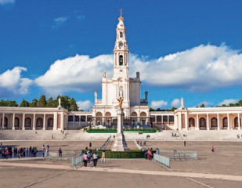 | 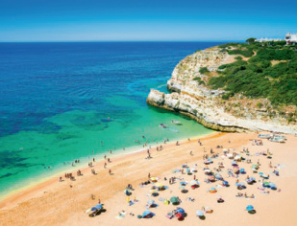 | 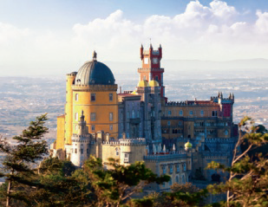
Fátima Sanctuary – Fátima  1. | Beach in Portimão – Algarve  2. | Pena Palace – Sintra  3.
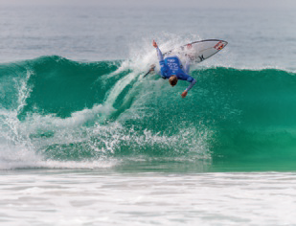 | 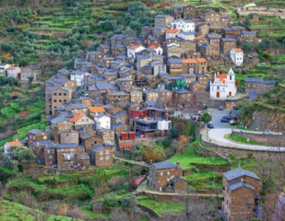 | 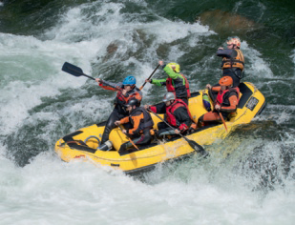
Beach in Peniche  4. | Village of Piódão  5. | Paio River – Arouca  6.
Read and write TRUE (T) or FALSE (F).

B
- Tourism is usually associated with the holiday period.
- Portugal has many natural characteristics that promote tourism.

- People only come on holiday to Portugal for recreational reasons.

- Tourism doesn’t create new jobs.

- The most popular tourist destinations in Portugal are Lisbon, Porto, the Algarve and Madeira.

- Tourism doesn’t generate a lot of money for the country.

- Tourism is dependent on many services.

- Portugal has many cultural characteristics that promote tourism.

Unit 1 Science – Habits to keep your skin healthy

Name No. Class
Date / / Mark Teacher
Read and find more about our skin.
A
Our skin is our biggest organ. We constantly expose it to the environment and its challenges like solar radiation, diﬀerent temperatures, humidity, physical contact, chemical products and bacteria and fungi that can provoke a number of reactions on our skin. To keep our skin healthy, we should follow 6 basic precautions.
Match the sentence halves to find out how we can protect our skin.
B

- Have a bath/shower every day
- Drink a lot of water
- Moisturise your skin (especially our faces, elbows and knees) with creams
- Avoid exposing your skin to direct sunlight
- Apply sun cream when going to the beach
- Avoid wearing very tight clothes
- to avoid it from getting very dry.
- to protect it and avoid sunburn.
- to protect your skin from the harmful rays from the sun.
- to get rid of dirt, microorganisms and bad odours.
- to allow your skin to breathe properly.
- to compensate water you lose when you perspire.

1 | 2 | 3 | 4 | 5 | 6
Match the images below to the skin routines in exercise .
C
B
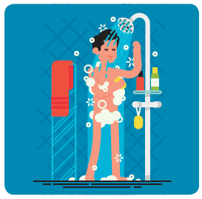 | 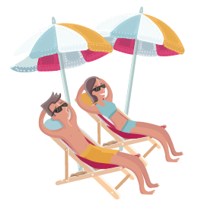 | 
a | b | c
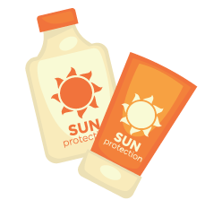 | 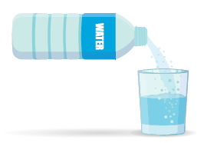 | 
d | e | f

Unit 2 Science – Protecting our forests

Name No. Class
Date / / Mark Teacher
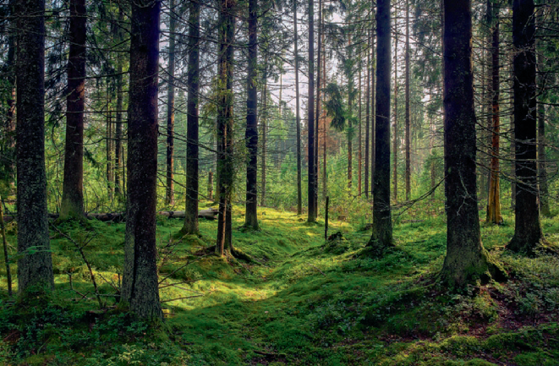
Read and find more about the importance of our forests.
A
Why do we care about deforestation?
Our forests help maintain the quality of the air we breathe and control the temperature. Plants perform photosynthesis. Photosynthesis involves plants absorbing gases like carbon dioxide and producing oxygen for us to breathe. Forest fires consume a lot of oxygen, so the amount of carbon dioxide in the air increases drastically when there is a forest fire. Carbon dioxide can be negative because it increases the greenhouse effect, which can be responsible for causing global warming.
Say if the following sentences are TRUE (T) or FALSE (F).
B
- Forests help look after the Environment.

- Plants produce carbon dioxide.

- Forest fires decrease the amount of carbon dioxide in the air.

- Carbon dioxide is a major cause of the greenhouse eﬀect.

Read and tick (✓) the measures we should take to protect our forests from forest fires.

C
- Cut down all the trees.
- Reforest burnt areas by planting new trees from that region.

- Clean up our forests all year round.

- Reforest burnt areas by planting new trees from other regions.

- Plant trees that are more resistant to fires.

- Plant lots of pine trees.

- Control the number of trees that are chopped down to produce paper and other products for human consumption.

- Invest in the fire brigade and a wildfire plan.

- Clean up our forests every two years.

- Don’t reforest the burnt areas.

Unit 3 Science – Child health care

Name No. Class
Date / / Mark Teacher
Read and find more about important child care habits.
A
Babies and infants need special health care to stay strong and healthy. Pregnant women need to start looking after their unborn babies during their pregnancies. After babies are born, parents need to continue looking after them so that they can grow up and be healthy.
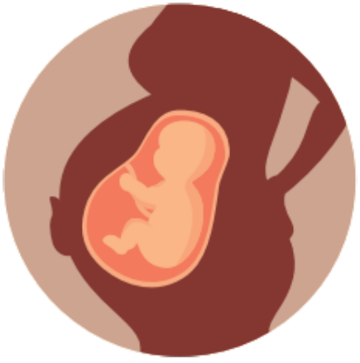
Read and circle what pregnant mothers should do to look after their unborn children.
B
- They should / shouldn’t eat a healthy balanced diet.
- They should / shouldn’t forget to go to the doctor for regular check-ups.
- They should / shouldn’t stop doing exercise.
- They should / shouldn’t drink alcohol or smoke.
- They should / shouldn’t have a calm lifestyle and they should / shouldn’t sleep a lot.
Read and label the child care habits that parents should have with their toddlers and infants.
C

- breast feed babies
- vaccinate babies
- promote a healthy diet
- have regular hygiene habits
- have a stable family environment

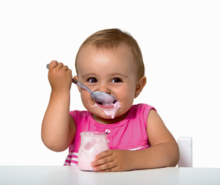 | 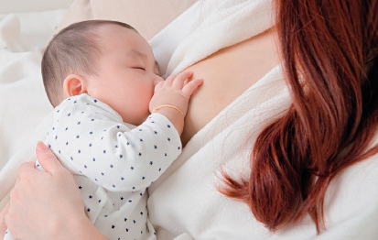 | 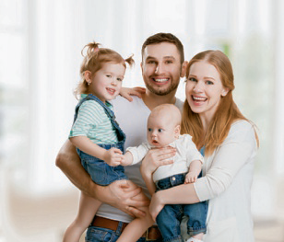
a | b | c

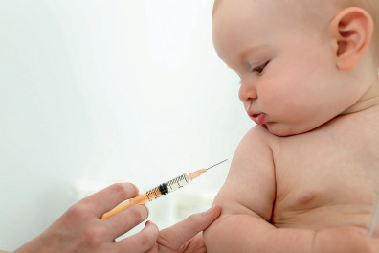 | 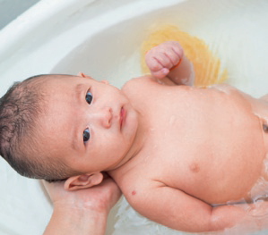
d | e

Unit 4 Science – Environmental pollution

Name No. Class
Date / / Mark Teacher
Read and find more about how humans are polluting the environment.
A
Humans are polluting the environment to get raw materials, energy and land to grow food and build houses on.

What is pollution?
It’s the introduction of substances or energies that alter the environment and harm living organisms, our natural habitat and human health.

What types of pollution are there?
  - Air pollution
Air pollution is caused by the emission of gases like carbon dioxide into the atmosphere. This happens when we burn fossil fuels (coal, petrol and natural gas) and when means of transport and industries emit gases into the air. Farmers also pollute the air with nitrous oxide and methane.
  - Water pollution
Releasing domestic and industrial waste in our rivers pollutes our water. Water pollution is also caused by pesticides and fertilizers that infiltrate the soil.
  - Soil pollution
Deforestation and urbanisation also pollute the land. Cities produce a lot of rubbish and waste that pollute the soil. Agriculture is also a major polluter by releasing pesticides and fertilizers in the soil.
Read again and underline the causes and effects of pollution in the text. Then complete the table.
B

causes | effects

Look and label the types of pollution.
C

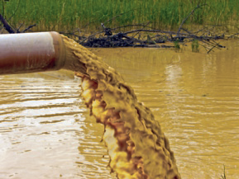 | 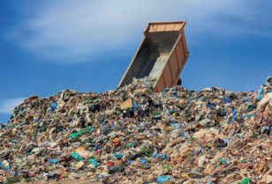 | 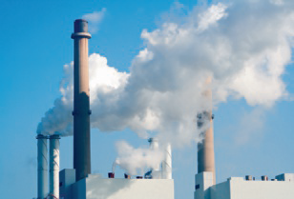
1. | 2. | 3.

Unit 5 Science – Pollination

Name No. Class
Date / / Mark Teacher
Read the definition for pollination and write TRUE (T) or FALSE (F).
A
Pollination occurs when insects like bees and butterflies, birds, bats, small animals, the wind or water transport pollen from the anther to a flower’s stigma.
Look and label the parts of the flower with the words in the box.
B
stigma | anther | ovule | style
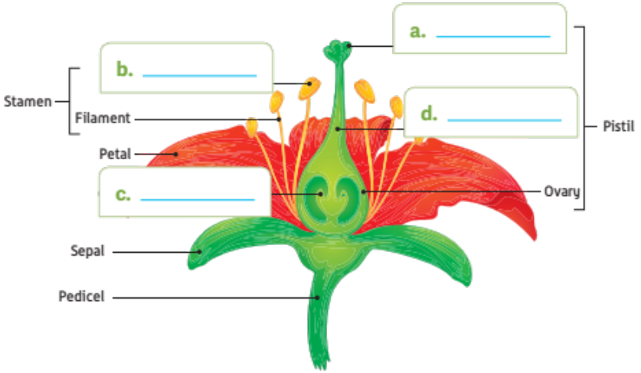
Look and label the pollination agents.
C
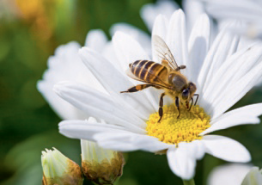 | 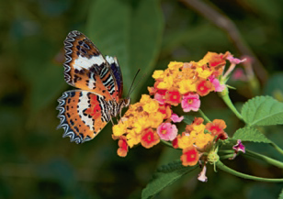 | 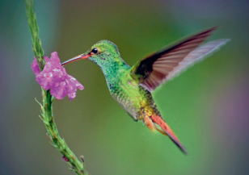
1. | 2. | 3.
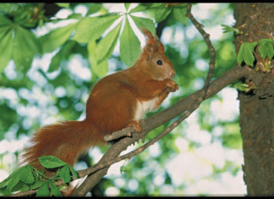 | 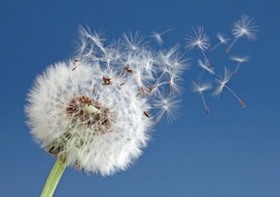 | 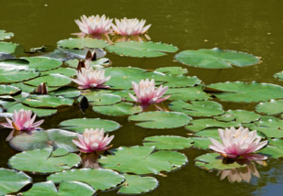
4. | 5. | 6.

