There to be – Present Simple

Complete the gaps with there to be in the Present Simple.
A
 | Hello. My name is Tim and I am in year six this year. I am at a new school. It is very different from my school last year.  (1) three big main buildings at my school.  (2) three floors in each building and (3) ten classrooms on each floor so (4) thirty classrooms in each building.  (5) a big playground and (6) a canteen in the main building. (7) yummy food for lunch every day.  (8) juice too! It’s delicious!
Complete the gaps with there to be in the aﬃrmative, negative and interrogative forms in the Present Simple.
B
This is a school in Great Britain. (1) forty classrooms at this school and (2) thirty students in each class. (3) a library in the yellow building.
– (4) any computers in the library?
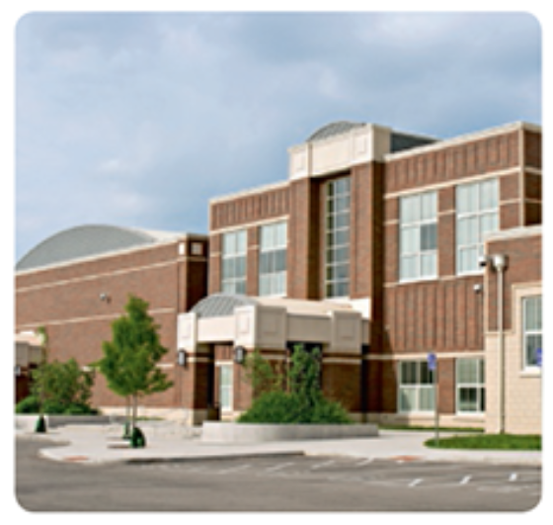
– Yes, (5) .
– (6) two floors in the main building?
– Yes, (7) _______________. It’s a big building.
– (8) a swimming pool?
– No, (9) .
– (10) an auditorium?
– Yes, (11) .
– (12) a big sports field?
– Yes, (13) .

