Present Simple – Affirmative
Put the verbs in the 3rd person singular (he, she, it) in the Present Simple and write them in the correct box. There is one example.
A
kiss try help play watch finish tidy fly
fix brush study like dance sing do

-s | -es | -ies
 | kisses

Circle the correct option.
B
- My sister love / loves reading.
- I go / goes to school at 8 o’clock.
- She like / likes rock music.
- We play / plays the piano every day.
- John go / goes to school by bus.
- We wake / wakes up at 7 o’clock.
Fill in the gaps with a verb in the box in the Present Simple.
C
have get up brush leave ride help play go watch
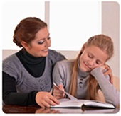
- I always my hair before I to bed.
- My friends and I football on Saturdays.
- My teachers lunch in the canteen.
- I at 11 o’clock on Sundays.
- My father TV after dinner.
- We home at ten past seven to go to school.
- My brother his bike every weekend.
- My mother me with my homework.

