Reflexive pronouns

Complete the table.
A
Personal pronoun | Reflexive pronoun
I  you (singular)  he  she  it  we  you (plural)  they | myself  (1)  himself  (2)  itself  (3)  (4)  themselves
- Read and fill in the gaps with a reflexive pronoun.
B

- My mum talks to .
- Look. The dog is licking .
- We clean our room .
- You have to look after and eat
healthy food.
- I do my homework every day.
- They make breakfast at the weekend.

Look at the pictures and complete the sentences with a reflexive pronoun. There is one example.
B
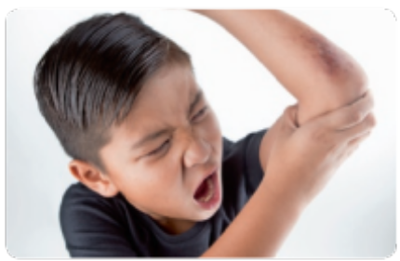 | 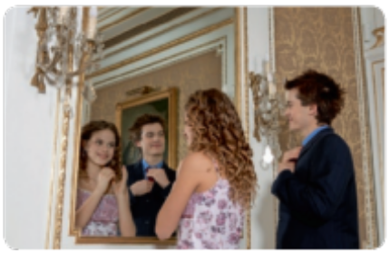
He’s hurting himself. | - They are looking at in the mirror.
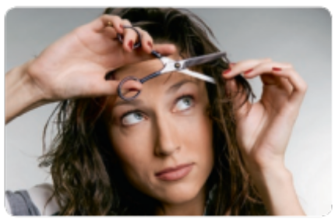 | 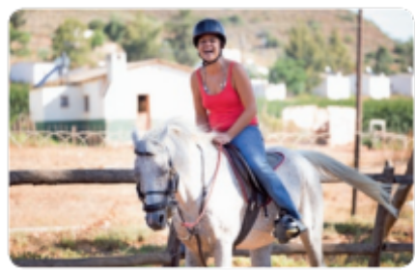
- Sally always cuts her hair . | - I am enjoying .

