The comparative
Write the comparative form of the adjectives in the table. There is one example.
A
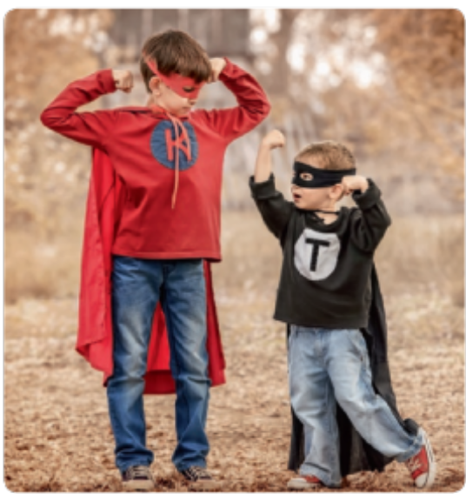
 | Adjective | Comparative
 | strong | stronger
1. | big
2. | good
3. | nice
4. | easy
5. | fat
6. | small
7. | old
8. | bad
9. | tall
10. | thin

Write sentences with the comparative form of the adjective in brackets. There is one example.
B
This backpack / that backpack (expensive)
This backpack is more expensive than that backpack.
- Your pencil case / my pencil case (beautiful)
.
- English / maths (easy)
.
- Holidays / schooldays (good)
.
- A car / a bus (comfortable)
.
- The drama club / the chess club (exciting)
.
- Grace / Lucy (friendly)
.

