The superlative
Write the superlative form of the adjectives in the table. There is one example.
A

 | Adjective | Superlative
 | funny | the funniest
1. | thin
2. | rich
3. | comfortable
4. | ugly
5. | fat
6. | beautiful
7. | old
8. | bad
9. | lucky
10. | short
Complete the sentences. Use the superlative form of the adjectives in brackets.
B
- She is (good) maths teacher I know.
- Peter is (tall) boy in his class.
- English is (easy) language to learn.
- This girl is (pretty) girl in the school.
- My cousin William is (young) child in our family.
- This book is (important) book for our project.
Write true sentences about these T-shirts. Use the superlative form of the adjectives in the box.
C
big small expensive

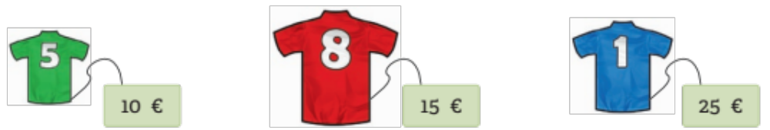

- T-shirt nº. 1 is .
- T-shirt nº. 5 is .
- T-shirt nº. 8 is .

