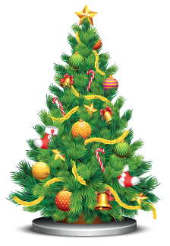
To be – Past Simple
Fill in the gaps with the verb to be in the Past Simple: was or were.
A
- Last Christmas I on holiday with my family.
- It cold but we very happy.
- We in London.
- Two years ago we in Paris.
- My friend Tom at his sister’s graduation ceremony.
Rewrite the sentences in the negative and interrogative forms. There is one example.
B
My mother was born in April.
My mother wasn’t born in April.
Was my mother born in April?
- Last summer it was very hot.
.
?

- The family barbecue was fun.
.
?

- My cousin’s baptism was last week.
.
?

- Last month you were at your grandmother’s birthday party.
.
?
Write about you.
C

- When were you born?

.

- What time were you born?
.

- Where were you born?
.

