Be going to – Negative
Complete with the verbs in brackets in the negative form with be going to.
A
- He (brush) his dog tomorrow.
- I (travel) by plane next holiday.
- We (do) the cooking this evening.
Rewrite the sentences in the negative form. There is one example.
B
He is going to watch a 3D film tomorrow.
He isn’t going to watch a 3D film tomorrow.
- They are going to swim in the wave pool next summer.

- Tom is going to visit the horror house.

- I am going to make lots of videos.

Look at the images and make negative and aﬃrmative sentences. Use be going to. There is one example.
C

  They / (X) visit a farm / (√) have a picnic
  They are not going to visit a farm.
  They are going to have a picnic.

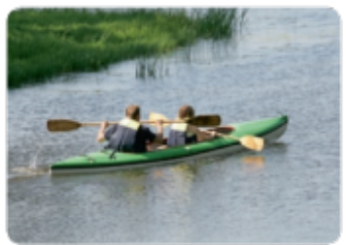 |  | 
- They / (X) go sailing /  (√) go canoeing | - She / (X) buy a snack /  (√) relax in the pool |   - They / (X) cut the grass /  (√) pick fruit

