Should / Shouldn’t

Remember

We use should / shouldn’t to give
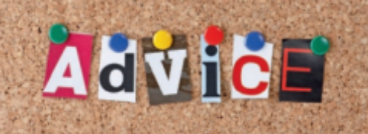

Read and complete the sentences with should or shouldn’t.
A
- When someone gives you a present, you say thank you.
- You talk with food in your mouth.
- In English you say “bless you” when someone sneezes.
- You look tired. You go to bed.
- I don’t think he work so hard.
- You believe everything you read in the newspapers.
- There is going to be a party this Saturday. You come.
- It’s a difficult decision. What I do?
- You see a doctor if you are sick.
- It’s very cold this morning. You wear that T-shirt.
You wear something with sleeves instead.
- In China you eat with chopsticks.
- You forget to say “please” and “thank you” to people.
- You swear. It’s very rude.
- You steal. The police can arrest you!
- You eat vegetables. They are very healthy and good for you.
- You recycle. It’s good for the planet.
- We only tell the truth.
- You worry because I’m here to help you.
- I study more because I want to be a doctor.
- You read that book. It’s very good!

