Adverbs of manner
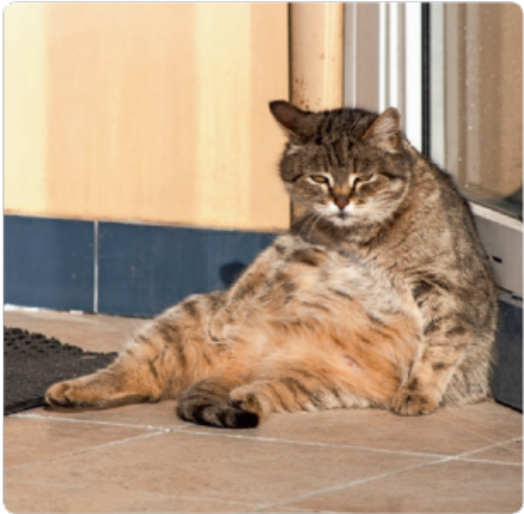
Write the adverbs for the adjectives in the table. There is one example.
A
 | Adjective | Comparative
 | careful | carefully
1. | strange
2. | late
3. | lazy
4. | slow
5. | quick
6. | fast
7. | polite
8. | good
9. | nervous
10. | bad
11. | rude

Write an adverb with the adjective in brackets. There is one example.
B
My brother is playing football terribly. (terrible)
- I can’t hear you! Speak please! (loud)
- Don’t forget to speak in the library. (quiet)
- She looked at Ben . (angry)
- We arrived home . (safe)
- They are going to find the answer. (easy)
- You like to drive very . (quick)
- Carry my things please! (careful)
- Lily is dancing very . (slow)
- Anna is going to sing . (wonderful)
- My cousin is playing . (happy)
- The car was (extreme) useful.
- John is going to do it very . (fast)
- She is going to play the violin . (beautiful)

