Prepositions of time
Write the expressions under the right preposition in the table.
A
Monday the moment half past eleven June 2015 spring
5th September Christmas the morning my birthday

in | on | at

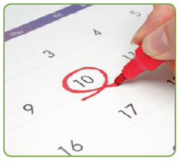
Circle the correct preposition.
B
- I was born on / in / at 2006.
- My birthday is on / in / at May.
- Come and see me on / in / at nine o’clock.
- I don’t sleep late on / in / at weekdays.
- We go out for dinner on / in / at Friday evenings.
- I often drink a glass of water on / in / at night.
Complete with in, on or at.
C

- Saturday morning, I went to the cinema.
- I had cereal breakfast.
- Susan arrived six o’clock.
- My parents got married 1998.
- We are going to visit my grandparents 10th August.
- They got married May.
- I’ve got swimming lessons Saturday morning.
- summer I usually go to a waterpark.
- They met Christmas Day.
- We are always together the end of the day.

