Telling the time
What time is it? Match the watches to the correct time.
A
1. 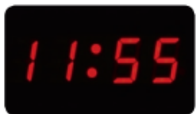 | 2. 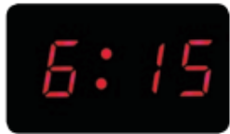 | 3. 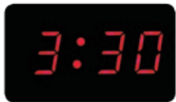
a. It’s half past three.  1 | b. It’s five to twelve.  2 | c. It’s a quarter past six.  3
Draw the time on the clocks. Then ask and answer the question. There is one example.
B
2:30 | 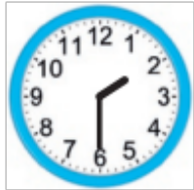 | What time is it? It’s half past two.
- 11:45 | 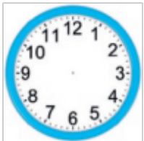
- 7:00 | 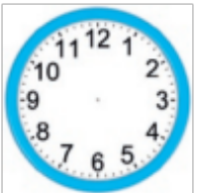
- 9:35 | 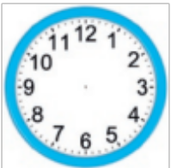
- 3:20 | 