Nationalities
Match the flags with the countries. Then, find the nationalities in the wordsearch. There is one example.
A
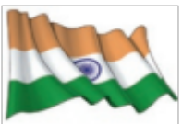  1. | 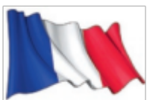  2. | 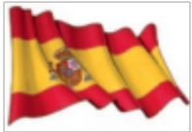  3. | 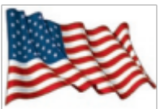  4.
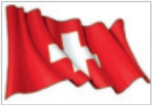  5. | The Usa 4  Brazil  Russia  England  China  Japan  Mexico  Germany | Australia  India  Italia  The United  Kingdom  Spain  Portugal  France  Switzerland | 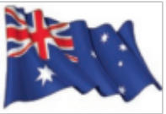  6.
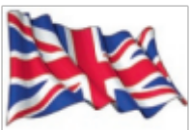  7. |  |  |   8.
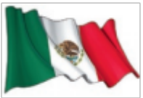  9. |  |  | 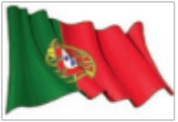  10.
H | J | G | S | H | S | M | J | V | R | T | Z | E | G | V
U | F | A | P | P | E | H | D | J | X | Q | E | C | E | Y
H | A | N | P | X | A | E | D | F | U | S | U | J | R | L
H | W | V | I | A | N | N | H | U | E | Q | Z | V | M | F
D | W | C | T | G | N | B | I | U | I | B | I | Z | A | B
L | A | W | L | V | R | E | G | S | F | R | N | A | N | A
N | I | I | B | I | Y | U | S | R | H | A | D | M | R | U
E | S | O | T | P | T | R | E | E | L | Z | I | E | B | S
H | P | I | I | R | U | N | S | I | X | I | A | R | A | T
S | S | J | O | S | C | S | F | T | T | L | N | I | I | R
H | D | P | S | H | I | C | Z | A | D | I | O | C | L | A
P | O | I | L | W | J | V | K | L | Y | A | F | A | B | L
R | A | L | S | U | L | K | V | I | T | N | L | N | S | I
N | K | Q | V | O | F | J | P | A | J | U | G | R | N | A
C | C | H | I | N | E | S | E | N | I | R | W | U | P | N

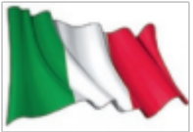  11. |  |  | 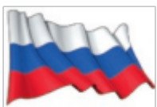  12.
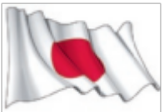  13. |  |  | 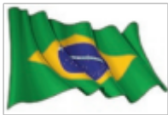  14.
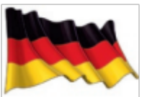  15. |  |  | 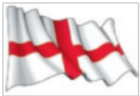  16.

