Physical features
Write the words in the box in the correct column.
A
ugly chubby middle-aged thin long attractive tall fat
wavy pretty round (×2) curly medium-height small (×2)
medium-lenght old oval long (×2) straight slim short (×2)

appearance | age | height | weight | hair | eyes | face
Match the descriptions and the pictures. Then, write the names.
B
- I am tall and slim. I have got a long face. I am bald. | - I am medium-height and slim. I have got long wavy blonde hair. My face is long. | - I am short and fat. I have got short black hair. I have got a round face and a beard.
I’m | I’m | I’m
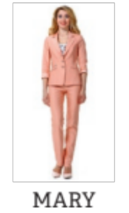 | 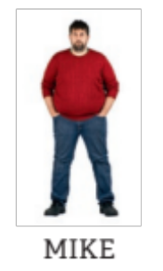 | 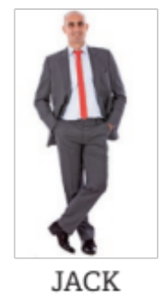
What about you? What do you look like?
C

