School supplies
Complete the crossword puzzle.
A
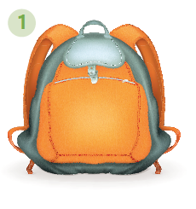 | 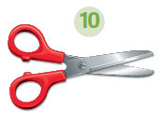 |  | 
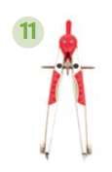 |  |  | 
   |  |  |  |  |  |  |  | 2
   |  |  | 1 |  |  |  |  |  |  |  |  | 4
   |  | 3
   | 5
  6
   |  |  |  | 7
   |  |  |  |  |  | 10
  9 |  |  |  |  | 8
  11
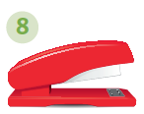 |  |  | 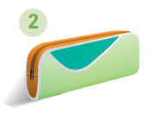
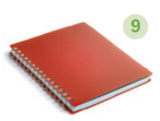 | 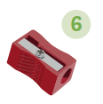 |  | 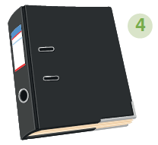
Write about you. Write a short paragraph (25-35 words) about what your pencil case is like.
B

My pencil case is (colour(s)). It is (size).
In my pencil case there is
.
I think it is is (your opinion).

