Places at school
Look and find the names of the places at school in the wordsearch. Then, label the pictures.
A
 | 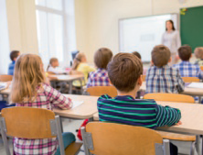 | 
1. | 2. | 3.
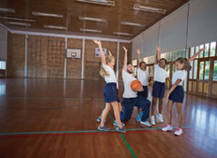 |  | 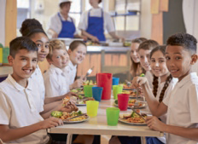
  F | D | G | O | B | F | E | Q | Q | C | E | Y | O | Z | R
  B | Z | F | K | J | Q | P | L | B | F | X | J | O | K | N
  H | F | O | I | O | H | Y | C | D | L | O | Y | A | L | C
  S | V | S | D | N | D | H | D | A | Y | Q | X | K | G | B
  Y | T | Q | J | U | R | Z | K | S | N | R | B | L | T | K
  D | Z | A | L | R | B | Y | K | O | X | T | W | I | Z | I
  L | G | F | F | J | V | R | V | E | T | Y | E | Z | W | J
  P | X | M | I | F | J | L | F | J | R | Z | L | E | R | A
  Y | Y | I | U | J | R | O | I | Y | Z | M | C | K | N | U
  G | W | T | F | M | P | O | X | B | Y | A | T | Z | B | X
  F | A | T | D | N | G | U | O | J | R | F | J | A | F | A
  M | O | O | R | C | I | S | U | M | S | A | O | N | W | Q
  Q | I | C | L | A | S | S | R | O | O | M | R | U | P | F
  C | O | M | P | U | T | E | R | R | O | O | M | Y | Z | V
  R | G | W | M | A | F | B | R | E | S | Z | L | M | Q | H
4. |  | 5.
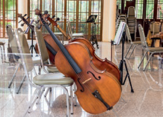 |  | 
6. |  | 7.
Read and write the names of the places at school. There is one example.
B
You can read a book here. library
- You can have a meeting with the principal here.
- You can wash your hands here.
- You can play outdoor sports here.
- You can play with your friends here.
- Your can draw and paint here.
- Your can buy a snack here.

