School clubs
Write the names of the school clubs.
A

 |  | 
 |  | 
 | 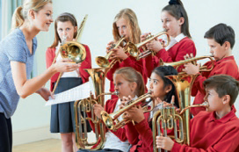 | 
Read, find out and complete the sentences.
B
- I like acting. I’m in the club.
- I like singing. I’m in the .
- I like computers. I’m in the club.
- I like eating delicious food. I’m in the club.
- I like taking photos. I’m in the club.
Write about you.
C
- What school clubs are there in your school?

- What is your favourite school club?

