Jobs
Look at the pictures and complete the crossword puzzle. There is one example.
A
-  | -  | -  | - 
-  |  |  | - 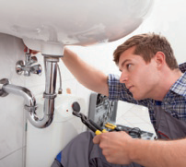
  1. | T | E | A | C | H | E | R
  2. | D
  3. | V
  4. | D
  5. | P
  6. | P
  7. | C
  8. | C
-  |  |  | - 
Read and complete the sentences with a job. Use the words below. There is one example.
B
I cut people’s hair. I’m a hairdresser.
- I stop fires. I’m a .
- I work on a farm. I’m a .
- I serve customers in a restaurant. I’m a .
- I design buildings. I’m a .
- I repair cars. I’m a .
- I work with judges and law. I’m a .
- I deliver letters. I’m a .

