Family picnic
Look and label the pictures.
A
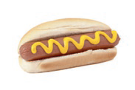 | 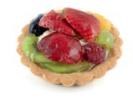 |  | 
Look at the table and complete the sentences. There is one example.
B
 | 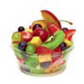 | 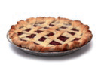 | 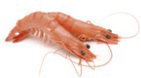 | 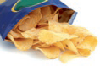
Kim | √ | X | √ | √
Nick | X | √ | X | √
Sue | √ | √ | X | X

Sue likes fruit.
- Nick and Sue like (a) but they don’t like (b) .
- Kim doesn’t like (a) but she likes (b) ,
(c) and (d) .
- Kim and Nick like (a) .
Look and match.
C
- picnic basket  - spoonful of butter  - bowl  - tea cup  - tasty food | a. | b.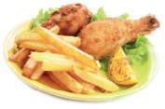
c.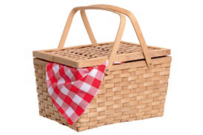 | d.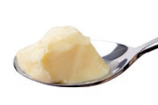 | e.

