Food
Look and label the pictures.
A
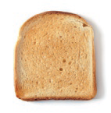 | 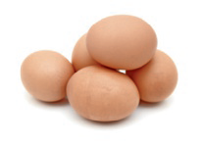 | 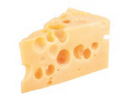 | 
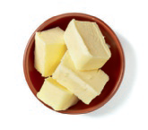 | 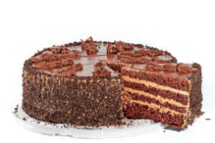 | 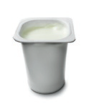 | 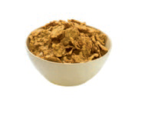
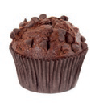 | 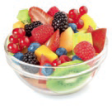 | 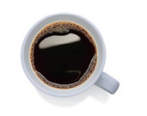 | 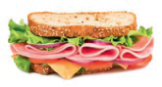

Look at the images and complete the gaps about Jim’s diet.
B

Every day I have (1) 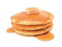and (2) 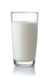 for breakfast.
My morning snack is always an (3) .
For lunch I sometimes eat roast (4) 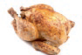, (5) 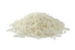, and a (6) .
At tea time I usually eat (7) 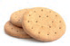and drink (8) 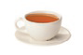.
In the evening I always have a (9) 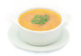, and I sometimes eat
(10) 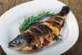 with (11) 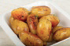 for dinner.

